FAST GRAMMAR WORKSHEET | 13 | UNIT 3 | GRID A

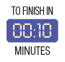
Name ___________________________________________________ No. _______ Class _______

PAST SIMPLE: IRREGULAR VERBS

Tick the correct option.
1. Sam …… to school on foot. She …… the bus.
(A) didn’t go … taked

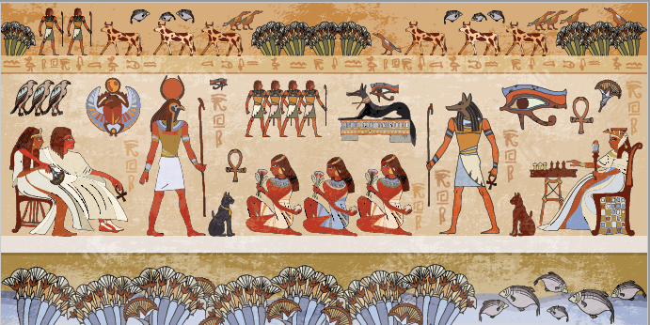
(B) didn’t go … took

(C) didn’t went … tooks

(D) didn’t went … taked

2. What …… at school today?
(A) did you do

(B) did you did

(C) do you did

(D) you did

3. The history teacher …… the class very interesting today.
(A) mades

(B) maked

(C) make

(D) made

4. Rachel …… two books last week. She …… three books.
(A) didn’t buyed … bought

(B) didn’t buy … buyed

(C) didn’t buy … bought

(D) didn’t buys … bought

5. …… in the school canteen?
(A) Did they ate

(B) Did they eat

(C) They eat

(D) They ate

