FAST GRAMMAR WORKSHEET | 16 | UNIT 4 | GRID B


Name ___________________________________________________ No. _______ Class _______

PREPOSITIONS OF PLACE

Tick the correct option.
1. Hugh is jumping …… his bed while playing the guitar.
(A) in

(B) below

(C) under

(D) on

2. There are some photos and posters …… the wall.
(A) in

(B) on

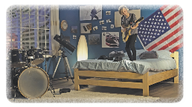
(C) between

(D) over

3. There’s a lamp …… his bed.
(A) between

(B) in front of

(C) next to

(D) among

4. There’s a telescope …… the window.
(A) beside

(B) on

(C) under

(D) between

5. There’s a rug …… the floor.
(A) in

(B) on

(C) below

(D) under

