FAST GRAMMAR WORKSHEET | 2 | UNIT 1 | GRID D


Name ___________________________________________________ No. _______ Class _______

PERSONAL PRONOUNS AND POSSESSIVE DETERMINERS

Tick the correct option.
1. Hermione and Ron are …… friends. Do you know who …… am?
(A) our … we

(B) my … I

(C) your … you

(D) my … they

2. Hogwarts is …… school. …… is a school of witchcraft and wizardry.
(A) your … It

(B) our … She

(C) my … She

(D) our … It

3. Professor Dumbledore is …… favourite teacher. …… is a very wise man.
(A) our … He

(B) our … It

(C) your … She

(D) my … It

4. Hermione is a bit arrogant, but …… is incredibly intelligent. …… knowledge is encyclopaedic.
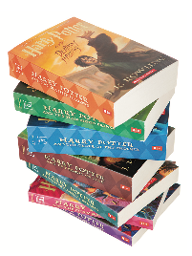
(A) she … Her

(B) it … Her

(C) he … Your

(D) she … Your

5. Ron often proves …… bravery. …… is a loyal friend.
(A) his … He

(B) its … He

(C) its … She

(D) their … It

