FAST GRAMMAR WORKSHEET | 21 | UNIT 5 | GRID B


Name ___________________________________________________ No. _______ Class _______

COMPARATIVES

Tick the correct option.
1. I think this book is …… than that one.
(A) not so interesting

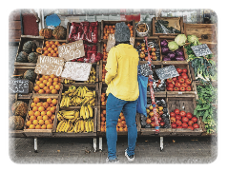
(B) interesting

(C) as interesting

(D) more interesting

2. You will find …… vegetables at the greengrocer’s.
(A) fresher than

(B) fresher

(C) as fresh as

(D) more fresh

3. The shops in the high street close …… than the ones in the shopping centre.
(A) more early

(B) as early

(C) earlier

(D) not so early

4. Having lunch at this Italian restaurant is much …… having lunch at the school canteen.
(A) better than

(B) as good

(C) good than

(D) better

5. A hotel is …… than a youth hostel.
(A) as comfortable

(B) more comfortable

(C) not so comfortable

(D) comfortable as

