FAST GRAMMAR WORKSHEET | 22 | UNIT 5 | GRID D


Name ___________________________________________________ No. _______ Class _______

SUPERLATIVES

Tick the correct option.
1. Our chefs use only the …… produce available.
(A) most fresh

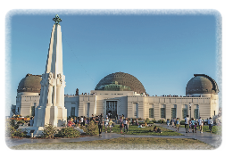
(B) freshest

(C) most freshest

(D) least fresh

2. …… shops are in the high street.
(A) Best

(B) Goodest

(C) The goodest

(D) The best

3. Go to the planetarium and have a look at Sirius, …… star in the night sky.
(A) the brightest

(B) brightest

(C) the most bright

(D) most bright

4. This clothes shop has …… clothes in town.
(A) the most fashionable

(B) most fashionable

(C) fashionablest

(D) the fashionablest

5. That petrol station over there sells …… petrol in the city.
(A) the cheapest

(B) the most cheap

(C) cheapest

(D) most cheap

