FAST GRAMMAR WORKSHEET | 23 | UNIT 5 | GRID C


Name ___________________________________________________ No. _______ Class _______

COMPARATIVES AND SUPERLATIVES

Tick the correct option.
1. Our local library is …… our school library.
(A) bigger than

(B) biggest than

(C) more big than

(D) biger than

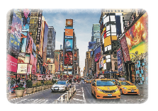
2. This railway station is …… than the one in my town.
(A) most modern

(B) more modern

(C) as modern

(D) modern as

3. New York is …… city in the world.
(A) as busy

(B) the busier

(C) the busiest

(D) busiest

4. We ate …… hamburgers ever at Hard Rock Café.
(A) the more delicious

(B) as delicious

(C) the most delicious

(D) most delicious

5. Big cities are …… small towns.
(A) quieter than

(B) least quiet than

(C) the least quiet than

(D) less quiet than

