FAST GRAMMAR WORKSHEET | 27 | UNIT 6 | GRID D


Name ___________________________________________________ No. _______ Class _______

FIRST CONDITIONAL

Tick the correct option.
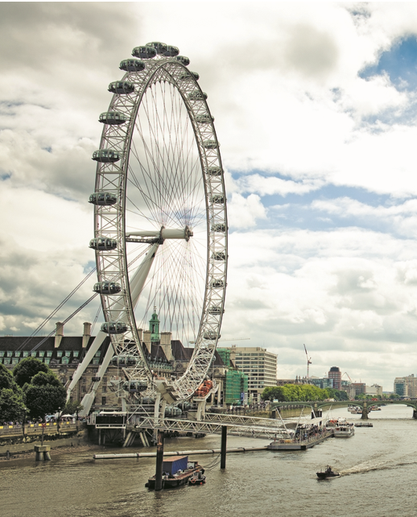
1. If Tom and Kelly don’t hurry, they …… their flight to Brazil.
(A) miss

(B) will miss

(C) misses

(D) don’t miss

2. Sally …… the London Eye if she goes to London. She is
not afraid of heights.
(A) miss

(B) misses

(C) will miss

(D) won’t miss

3. Vincent and Marion will eat delicious hamburgers if they …… to Hard Rock Café.
(A) go

(B) don’t go

(C) doesn’t go

(D) goes

4. Helen will visit the Eiffel Tower if she …… to Paris.
(A) travels

(B) don’t travel

(C) travel

(D) doesn’t travel

5. If Charles …… the hotel early, he will be late for his meeting.
(A) doesn’t leave

(B) leaves

(C) don’t leave

(D) leave

