FAST GRAMMAR WORKSHEET | 30 | UNIT 6 | GRID A


Name ___________________________________________________ No. _______ Class _______

FUTURE: WILL / BE GOING TO

Tick the correct option.
1. I think our holidays …… super fun!
(A) are going to be

(B) will be

(C) is going to be

(D) going to be

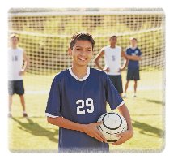
2. On Saturday morning Mark …… football with his friends.
(A) is going to play

(B) is go to play

(C) is go to playing

(D) will play

3. When I’m a famous chef, I …… you a delicious meal.
(A) going to prepare

(B) am preparing

(C) will to prepare

(D) will prepare

4. The students …… the museum next week.
(A) are going to visiting

(B) will go to visit

(C) are going to visit

(D) are go to visit

5. I …… you with those bags.
(A) will to help

(B) will help

(C) am going to help

(D) going to help

