FAST GRAMMAR WORKSHEET | 7 | UNIT 2 | GRID A


Name ___________________________________________________ No. _______ Class _______

OBJECT PRONOUNS

Tick the correct option.
1. We are going for a walk. Do you want to come with ……?
(A) me

(B) us

(C) her

(D) them

2. These cupcakes are delicious! Do you usually bake …… yourself?
(A) them

(B) it

(C) us

(D) you

3. Don’t leave the rubbish there. Take …… out, please.
(A) me

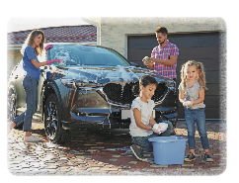
(B) her

(C) him

(D) it

4. I’m going to wash the car. Can you help …… ?
(A) her

(B) him

(C) me

(D) it

5. Your brother needs some help with his science project. Will you help ……, please?
(A) her

(B) him

(C) it

(D) me

