GRAMMAR WORKSHEET | 13 | Unit 2 – Make my day!

Name ___________________________________________________ No. _______ Class _______
Date ______________________ Mark _________________________ Teacher ________________

Present simple / Present continuous
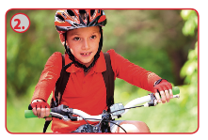


A. Complete the sentences. Put the verbs in brackets into the present simple or continuous.

Look! Carol ___________ (take) a selfie.
Tom ___________ (like) jogging, but he ___________ (prefer) cycling.
Turn off the TV, please. I ___________ (study) history.





I ___________ (eat) spaghetti. It’s delicious!
What time ___________ (Pam / usually / get up)?
They ___________ (run) in the park now.




Lucy ___________ (visit) her grandmother tomorrow.
We ___________ (watch) TV at the moment.
They usually ___________ (go) to the beach on Sundays.

B. Make sentences. Use the present simple or present continuous.
1. Sophie and Ann / go / to the park / every Sunday /.
__________________________________________________________
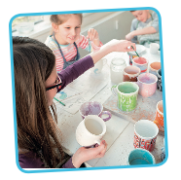
2. My brother / not play / the piano / at the moment /.
__________________________________________________________
3. he / do / his homework / now /?
__________________________________________________________
4. the children / ride / their bikes / on Saturdays /?
__________________________________________________________
5. We / not study / on Sundays /.
__________________________________________________________

6. Today / you / attend / an art workshop /.
__________________________________________________________

