GRAMMAR WORKSHEET | 14 | Unit 2 – Make my day!

Name ___________________________________________________ No. _______ Class _______
Date ______________________ Mark _________________________ Teacher ________________

Word formation: prefixes and suffixes
A. Find the opposites by adding a prefix.

1. happy
2. responsible
3. legal
4. polite
5. loyal
6. friendly
7. formal
8. lucky
9. correct
10. tolerant
11. patient
12. possible
B. Add a suffix and change these words to nouns.



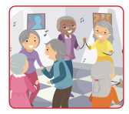

happy __________
inform __________
act __________
teach __________

C. Add a suffix and change these words to adjectives.


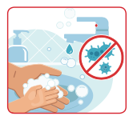


beauty __________
fame __________
care __________
danger __________

