GRAMMAR WORKSHEET | 18 | Unit 3 – School and friends

Name ___________________________________________________ No. _______ Class _______
Date ______________________ Mark _________________________ Teacher ________________

Past simple: regular verbs (affirmative)
A. Write the past simple of the verbs below.




watch – __________
help – __________
carry – __________


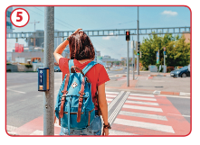


study – __________
stop – __________
travel – __________

B. Use the past simple of the verbs above to complete the sentences.
1. Yesterday, Jim’s father __________ him do the maths homework.
2. Harry __________ hard for the English test.
3. Kate __________ TV after coming back home from school.
4. Last Thursday, my friends and I __________ to the city centre by bus.
5. I __________ a box full of stuff to my new bedroom.
6. Mary __________ at the zebra crossing because the traffic light was red for pedestrians.
C. Mark the sentences true (T) or false (F).
1. We use the past simple for things in the past that have finished.

2. We use the past simple for things that are happening now.

3. We use the past simple for single events or situations in the past.

