GRAMMAR WORKSHEET | 2 | Unit 1 – Teen space

Name ___________________________________________________ No. _______ Class _______
Date ______________________ Mark _________________________ Teacher ________________

Personal pronouns / Possessive determiners

A. Replace the words in bold by the correct personal pronoun.
1. Vin Diesel is from California. __________
2. Peter and I are Swedish. __________
3. Lisa is from Switzerland. __________
4. Kyle and Betty are at school. __________
5. These dogs are very cute. __________
6. This car is quite expensive. __________
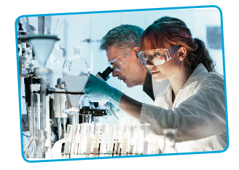
7. Are you and Angela in class 7B? __________
B. Complete with the possessive determiners.
1. Harry is doing __________ homework.
2. Lucy’s swimming with __________ mother.
3. I need to brush __________ teeth.
4. We are visiting __________ relatives tomorrow.
5. Kim, I trust __________ opinion.
6. The scientists are doing __________ best.
C. Complete the sentences with personal pronouns or possessive determiners.
1. Madeira has __________ own traditions.
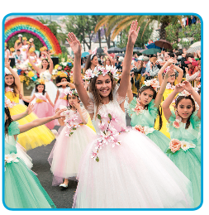
2. Are __________ from Denmark, Anton?
3. The hotel has __________ own pool. __________ is very big!
4. __________ am in class 7B. __________ name is Leonor.
5. Tom has got a little sister. __________ name is Karen.
6. We are happy. __________ team won the Tour de France.
7. They are Portuguese, but __________ cousins are Brazilian.
8. Daniel is Spanish, but __________ stepfather is German.
Spring Flower Festival, Madeira

