GRAMMAR WORKSHEET | 23 | Unit 4 – Home life

Name ___________________________________________________ No. _______ Class _______
Date ______________________ Mark _________________________ Teacher ________________

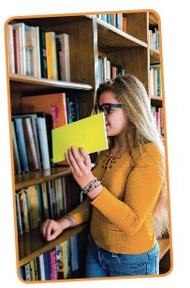
Some / any / no
A. Complete the sentences with some, any or no.
1. Have they got _________________ children?
2. I like flowers, but there are _________________ flowers in my garden.
3. There aren’t _________________ pens in my bag.
4. Look! There are _________________ exercise books on the floor.
5. There aren’t _________________ books on this topic in the library.
6. Don’t close the door. There are still _________________ students outside.
7. I’m looking for _________________ good music.
8. Look! There are _________________ nice postcards in that souvenir shop.
9. I’m afraid I have _________________ magazines for you.
10. George hasn’t got _________________ pencils on his desk.
11. Shall I bring _________________ drinks to the party?
12. I’d like to have a cup of coffee, but we've got _________________ coffee left.
13. Do you want _________________ groceries from the shop?
14. Are there _________________ problems with your work?
15. I will have _________________ good news next week.
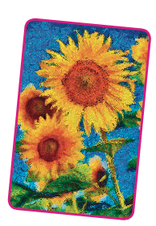
16. She’s rich, but she has _________________ valuable paintings in her house.
17. Philip wants _________________ help with his exams.
18. I want to bake a cake, but there is _________________ butter in the fridge.
19. We need _________________ cheese if we want to make a fondue.
20 Would you like _________________ help?
21. Will you have _________________ more cake? – No, thank you.
22. She doesn't want _________________ books for birthday present.
23. They don't want _________________ help with their schoolwork.
24. There are _________________ roses in the garden. They’ve all gone.

