GRAMMAR WORKSHEET | 24 | Unit 4 – Home life

Name ___________________________________________________ No. _______ Class _______
Date ______________________ Mark _________________________ Teacher ________________

Prepositions of place
A. Vincent van Gogh was a Dutch painter. Look at the picture of his bedroom and complete the sentences with the right preposition of place.
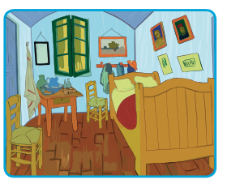
1. There are many pictures _____________ the wall.
2. The bed is _____________ the wall.
3. There’s a small table _____________ the window.
4. There’s a chair _____________ the bed and the table.
5. There’s a picture _____________ the table.
6. There are many things _____________ the table.
7. There’s no one _____________ the room.
B. Choose the correct alternative.
1. Carol is sitting _____________ her desk.
a) at b) on c) in

2. The picture is hanging _____________ the wall.
a) between b) on c) behind
3. People normally watch TV _____________ the living room.
a) at b) under c) in
4. Hilary and Alan live _____________ 510 Portland Street.
a) on b) at c) in
5. You shouldn’t rest your elbows _____________ the table.
a) under b) at c) on
6. I put the tablecloth _____________ the table.
a) over b) in c) above
7. When flying in an airplane, I enjoy watching the clouds _____________ me.
a) behind b) under c) below
8. In a thunderstorm you should never stand _____________ a tree.
a) under b) above c) below
9. My house is hidden _____________ the trees.
a) opposite b) among c) between
10. At dinner table, I always sit _____________ my father and my mother.
a) between b) above c) among

