GRAMMAR WORKSHEET | 26 | UNIT 4 – Home life

Name ___________________________________________________ No. _______ Class _______
Date ______________________ Mark _________________________ Teacher ________________

Past simple / Past continuous
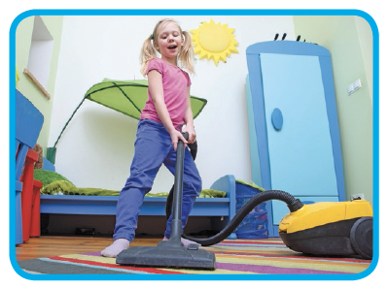
A. Complete the sentences with when or while.
1. Jill was tidying her room ___________ her mother came home.
2. ___________ Mum was cooking, I was talking on the phone.
3. We were really sorry ___________ we heard about your accident.

4. ___________ we were having breakfast, Paul knocked at the door.
5. ___________ we were playing basketball, I hurt my leg.
6. Vicky was wearing a red dress ___________ we saw her last night.
7. She was working on her computer ___________ it crashed.
B. Put the verb in brackets into the past simple or past continuous.
1. Yesterday afternoon, most of the time we ___________________________ (sit) in the park.
2. They __________________ (walk) in the park when they __________________ (hear) a loud cry.
3. While Gil _________________ (study) in his room, his friends ________________ (swim) in the pool.
4. She ________________ (not pack) her schoolbag when I _________________ (come) into her room.
5. Fiona __________________ (look) for her ring when I __________________ (see) her.
6. My brother __________________ (feed) the cat while I __________________ (do) the dishes.
7. Cindy __________________ (have) a shower when the telephone __________________ (ring).
8. Daniel and James __________________ (run) down the street when the accident ________________ (happen).


