GRAMMAR WORKSHEET | 3 | Unit 1 – Teen space

Name ___________________________________________________ No. _______ Class _______
Date ______________________ Mark _________________________ Teacher ________________

Present simple: to be and have got
A. Complete the sentences with the correct form of the verb to be or have got.
1. Carol’s birthday __________ on 29th March.
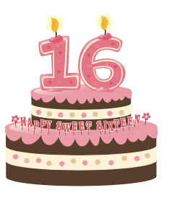
a) has got b) are c) is
2. She __________ sixteen years old.
a) is b) are c) has got
3. My cousins __________ big dark eyes.
a) have got b) has got c) are
4. What colour __________ their hair?
a) are b) has got c) is
5. I __________ from Spain.
a) have got b) am c) are
6. Peter __________ an older brother.
a) is b) are c) has got
7. I __________ cold.
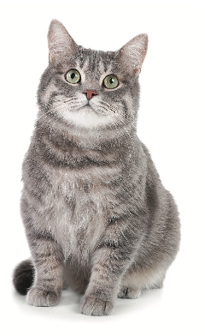
a) am b) have got c) has got
B. Fill in the gaps with the verbs to be and have got.
My name is George and I (1) __________ 12 years old.
I (2) __________ an amazing family. My mother
(3) __________ medium-height and thin. She (4) __________, brown, wavy hair and small eyes. My father (5) __________ a tolerant and kind person.
I (6) __________ a younger brother, Alex. He (7) __________ freckles.
We (8) __________ a cute cat, Smiley.

