GRAMMAR WORKSHEET | 30 | Unit 5 – Around town

Name ___________________________________________________ No. _______ Class _______
Date ______________________ Mark _________________________ Teacher ________________

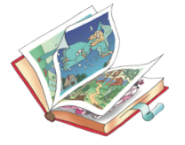
Comparatives / Superlatives
Circle the right answer.
1. This is ______________ book in this bookshop.
a) more expensive b) the most expensive c) most expensive

2. That shirt is ______________ than the other one.
a) dirtier b) the most dirty c) dirtiest
3. John is ______________ boy I know.
a) more handsome b) the most handsome c) most handsome
4. You are ______________ you think.
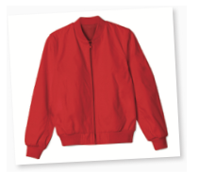
a) prettier than b) the prettiest c) prettiest
5. I’ll take this jacket. It’s cool and it’s ______________ that one.
a) as cheap as b) the cheapest c) cheaper
6. For me, you are ______________ person in the world.
a) more important b) as importan c) the most important
7. My car is ______________ of all.
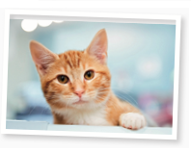
a) faster b) as fast as c) the fastest
8. That is ______________ song of all time!
a) better b) the best c) best
9. Your cat is ______________ than ours.
a) smaller b) the smallest c) as small

10. Out of all the films I have, this one is ______________.
a) sadder b) saddest c) the saddest
11. This film isn’t ______________ the film we saw yesterday.
a) as long as b) the longest c) longer
12. I thought this exercise would be difficult, but it’s ______________ exercise of all.
a) as easy as b) easier c) the easiest

