GRAMMAR WORKSHEET | 31 | Unit 5 – Around town

Name ___________________________________________________ No. _______ Class _______
Date ______________________ Mark _________________________ Teacher ________________

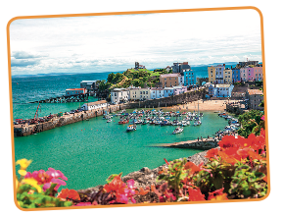
Future: will
A. Complete these sentences, using will and the verbs in brackets.
1. I _________________ (do) my homework, I promise.
2. I hope you _________________ (visit) me one day.
3. Do you think Meg _________________ (phone) me tonight?
4. I think I _________________ (paint) my bedroom blue.
5. A: ‘What do you think _________________ (you / do) over the summer?’
B: ‘We _________________ (probably / spend) it in Wales.’
6. I think he _________________ (win) the race.
7. I promise I _________________ (give) you your favourite video game.
8. _________________ (you / lend) me your mobile phone?
9. _________________ (you / invite) Henry to your party?
B. Use the notes to write about what will happen or won’t happen next weekend.
1. It / be / cloudy / on Saturday ______________________________________
2. William / not study / all weekend ___________________________________
3. Mike’s party / be / fun ____________________________________________
4. Judy / not do / any housework _____________________________________
5. John / watch / the football match / on TV _____________________________
C. Read the prompts and match them with the correct spontaneous decisions.
It’s starting to rain. | 1 |  | a | OK. Bye, I’ll see you tomorrow.
I’d like to give a party. | 2 |  | b | Don’t worry. I’ll help you.
I need to go now. | 3 |  | c | Thank you. I’ll send you a postcard.
Enjoy your holiday. | 4 |  | d | Good idea. We’ll have a barbecue.
I can’t do this exercise. | 5 |  | e | Don’t worry. I’ll lend you an umbrella.

