GRAMMAR WORKSHEET | 32 | Unit 6 – Sport and holidays

Name ___________________________________________________ No. _______ Class _______
Date ______________________ Mark _________________________ Teacher ________________


Connectors
A. Read the sentences and choose the correct option.
1. I went for a walk ______________ the sun was shining.
a) but b) because c) however
2. I like going to the beach, ______________ I never go at midday.
a) or b) therefore c) but
3. It was raining, ______________ we decided not to go to the beach.
a) so b) but c) because
4. It will rain either today ______________ tomorrow.
a) and b) so c) or
5. I was listening to music; ______________, I didn’t hear the doorbell ring.
a) however b) therefore c) because
6. I was tired; ______________, I still went out with my friends.
a) therefore b) however c) and
B. Join these sentences, using the connector given in brackets.
1. John went to Disneyland. He visited a theme park. (and)
John went ________________________________________
2. Paula wants to visit New York. She wants to visit Hollywood. (or)
Paula ___________________________________________
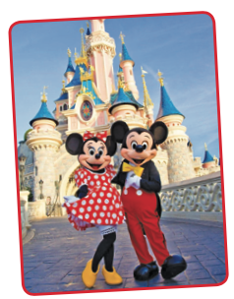
3. There are some shops in her hometown. There are no shopping centres. (but)
There ___________________________________________
4. Paula went to the café. Her friends were not there. (however)
Paula ____________________________________________
5. They like holidays. They don’t go to school. (because)
They ____________________________________________
6. John has a motorbike now. He can travel more. (so)
John ____________________________________________
7. John had a motorbike accident. He hurt his knee. (therefore)
John ____________________________________________

