GRAMMAR WORKSHEET | 33 | Unit 6 – Sport and holidays

Name ___________________________________________________ No. _______ Class _______
Date ______________________ Mark _________________________ Teacher ________________

Zero conditional

A. Match the sentence halves to make zero conditional sentences.
If you heat metal, | 1 |  | a | if it rains.
If you press the button, | 2 |  | b | if we make too much noise.
The ground gets wet | 3 |  | c | it expands.
Babies wake up | 4 |  | d | you dehydrate.
If you sweat too much, | 5 |  | e | I always get a headache.
If I listen to loud music, | 6 |  | f | the television turns on.
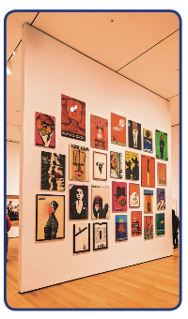
B. Complete the zero conditional sentences with the correct form of the
verb in brackets.
1. If I am in a new city, I ____________ (like) to visit the museums.
2. If I visit a museum, I ____________ (not / take) photos.
3. If Carol ____________ (come) with me, she usually asks to go to the shopping centre.
4. If Carol ____________ (go) shopping, she buys expensive clothes.
5. If Carol ____________ (not / wear) a hat, she gets sunstroke.
6. If she gets up early, her father ____________ (not / drive) her to school.
7. Lots of people come if Carol ____________ (give) a party.
C. Answer these questions.
1. What happens if you don’t study for a test?
____________________________________________________________________________
2. What happens if you play video games for a long time?
____________________________________________________________________________

