GRAMMAR WORKSHEET | 4 | Unit 1 – Teen space

Name ___________________________________________________ No. _______ Class _______
Date ______________________ Mark _________________________ Teacher ________________

Present continuous (affirmative)
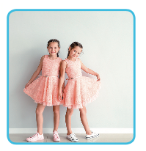
A. What are these people doing? Complete the crossword.
 |  |  |  |  |  |  |  |  |  | 1.
 |  |  |  |  |  |  |  |  |  |  |  |  |  | 2. |  |  |  | 3.
 |  |  |  |  |  |  |  | 4.
 |  |  |  |  |  |  |  | 5.
 |  |  |  |  |  |  |  |  |  |  |  |  |  |  |  | 7.
 |  |  |  |  |  |  |  |  |  |  | 6.
 |  |  |  |  |  | 8.
 |  |  |  |  |  | 10.
 | 9. |  |  |  |  |  |  |  |  |  |  | 11.
 |  |  |  |  |  |  |  |  | 12.
13.





DOWN
1. We are… a magazine.
2. Mia is… a glass of water.

3. Daisy is… golf with her friends tomorrow.
5. I’m… to the radio.
7. I’m… my friends at the park.
10. I’m… a shower.
ACROSS
4. We are… the Eiffel Tower.

6. Luke is… in the sea.
8. We are… maths.
9. She is… her teeth.
11. They are… fast food.
12. The twins are… similar clothes.
13. They are… TV.

