GRAMMAR WORKSHEET | 5 | Unit 1 – Teen space

Name ___________________________________________________ No. _______ Class _______
Date ______________________ Mark _________________________ Teacher ________________

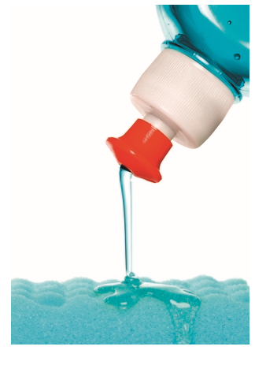
Present continuous
A. Complete the sentences with the verbs in the present continuous.
1. Dad, ____________________ (you / wash) the dishes?
2. We ____________________ (visit) my aunt tomorrow.
3. ____________________ (Sue / have) dinner with us tonight?
4. “What ____________________ (he / do)?” “He ____________________ (run).”
5. The children ____________________ (not / dance) because they hate country music.
6. I ____________________ (not / cook); I ____________________ (set) the table.
B. Write about the pictures in the present continuous. Use ✓ ✗? to help you.
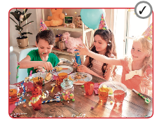




a) they / have a party
__________________
b) I / listen to music
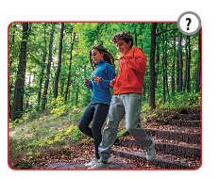

__________________
c) Peter / swim
__________________

d) we / cook
__________________
e) you / watch TV
__________________
f) you / run slowly
__________________


C. Order the words and write sentences in the present continuous.
1. chemistry / she / study /. ________________________________________
2. read / she / newspaper / the / not /. ________________________________
3. not/ a / write / poem / he /. _______________________________________
4. to / music / listen / Sam /? _______________________________________
5. Sheila / homework / do / her /? ___________________________________

