GRAMMAR WORKSHEET | 6 | Unit 1 – Teen space

Name ___________________________________________________ No. _______ Class _______
Date ______________________ Mark _________________________ Teacher ________________

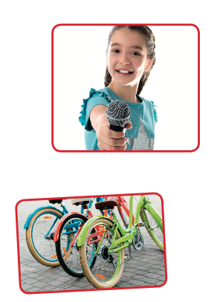
Possessive case / Whose / Possessive pronouns
A. Circle the correct option.
1. Kate’s / Kates’ microphone is new.
2. James’ / James’s car is silver.
3. The boys / boys’ skates are red and grey.
4. These are my childrens’ / children’s books.
5. Pat’s and Mary’s / Pat and Mary’s computer is new.
B. Circle the correct option.
1. Who’s / Whose singing?
2. Who’s / Whose book is this?
3. Who’s / Whose that girl?
4. Who’s / Whose bikes are these?
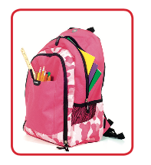
C. Complete the sentences with possessive pronouns.
1. A: Is this my glass?
B: No, it’s not ___________. It’s mine.
2. A: Is this your brother’s ball?
B: Yes, I think it’s ___________.
3. This is not my sister’s schoolbag. ___________ is the pink one.
4. This laptop belongs to me and my sister. It is ___________.
5. Is that your parents’ car? No, ___________ is grey.

D. Fill in the gaps with possessive determiners or possessive pronouns.
1. Susan, that book isn’t ___________.
2. Simon loves ___________ new sunglasses.
3. Jane and Sally like to go out with ___________ friends.
4. This isn’t our umbrella. ___________ is blue.
5. That is not my ruler. ___________ is in my pencil case.
6. We love singing but ___________ favourite hobby is dancing.

