PROGRESS TEST | 11B

Name ___________________________________________________ No. _______ Class _______
Date ______________________ Mark _________________________ Teacher ________________

 LISTENING
1. Listen to the dialogue and circle the correct option.
1. Millie’s plan for tomorrow is ______________.
a) to watch a film
b) to cycle in the park
2. Sarah is fond of______________ .
a) indoor activities
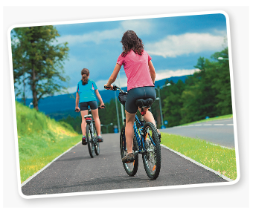
b) outdoor activities
3. Two of Millie’s favourite activities are ______________.
a) reading and doing some exercise
b) reading and listening to music
4. The two friends decide ______________.
a) to take their bikes and have a picnic
b) to bake cookies
5. They are going to invite ______________.
a) a friend
b) two friends
2. Are these sentences true or false?
a) Sarah phoned Millie to make plans for the next day.

b) Sarah prefers indoor activities.

c) She is taking some sandwiches for the picnic.

d) Millie agrees to go cycling.

e) Sarah wants to take Millie to the beach.

PROGRESS TEST | 11B

Name ___________________________________________________ No. _______ Class _______
Date ______________________ Mark _________________________ Teacher ________________

READING, GRAMMAR AND WRITING
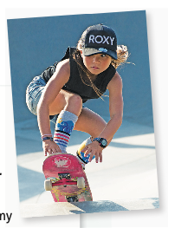
PART 1
Skateboarding star Sky Brown
Skateboarding is a new sport at The Olympic Games! Let’s meet Sky Brown, a young prodigy and member of the Great Britain national team.
Interviewer: Tell me about yourself. Where are you from?
Sky: Well, I was born in Japan, but I live in the US with my parents and my younger brother Ocean. My Mum is Japanese and my Dad is British.
Interviewer: What sports can you do?
Sky: I can skateboard, surf and dance! I want to learn to climb, too.
Interviewer: Which sport is your favourite?
Sky: I love surfing and I get up at 5 a.m. most mornings to go surfing. But my favourite sport is skateboarding! I love skating at Venice Beach in California because at the same time I can hear the ocean.
Interviewer: How did you start skateboarding?
Sky: I was influenced by my family – all of them are skateboarders – and my preschool had a skate park.
Interviewer: Do you win many competitions?
Sky: I win lots of competitions! I’m the UK skateboarding champion… and I’ve got a bronze medal from the 2019 World Championships. I can do difficult tricks!
Interviewer: What’s your goal?
Sky: I want to win a gold medal at the next Olympic Games.
Interviewer: What’s your message?
Sky: Be brave, be strong, have fun. Sometimes girls are too afraid to do things… but I say you can do anything!
Click (adapted)

1. Find in the text words that mean the following.
1. ______
2. ______
3. ______
prodigy | 1. |  | a. | objective
trick | 2. |  | b. | a special skill
goal | 3. |  | c. | a young person having extraordinary talent or ability

3. Find the following information in the text.
a) Girl’s name: _________________________________________________________________________
b) Where she lives: _____________________________________________________________________
c) Favourite sports: _____________________________________________________________________
d) Medals: _____________________________________________________________________________

PART 2
1. Complete these sentences with the words below.
• however • and • because • or • therefore

a) I had to stop skateboarding ___________________ I broke my leg.
b) She enjoys skateboarding ___________________ surfing.
c) Jim would like to surf; ___________________, he is afraid of water.
d) Do you know her address ___________________ her telephone number?
e) There was a storm coming; ___________________, the football match was cancelled.
2. Complete the sentences with the correct verb forms.
a) If you mix yellow and blue, you ___________________ (get) green.
b) If you press this button, the machine ___________________ (turn) on.
c) If she ___________________ (practise) a lot, she will win more medals.
d) If I go abroad, I ___________________ (bring) you a souvenir.
e) He will be angry if you ___________________ (not / tell) him the truth.
f) We ___________________ (order) a pizza if you don’t feel like cooking.

3. What are they going to do at the weekend? Complete the sentences with the verbs read, play (2), swim, visit and walk.

- She ________________
a book.

b) They ________________ football.

c) She ________________ in the pool.



d) They ________________ their grandparents.
e) They ________________ the dogs.
f) They ________________ video games.

PART 3
You want to make plans for the weekend with your friend.
Order the email.
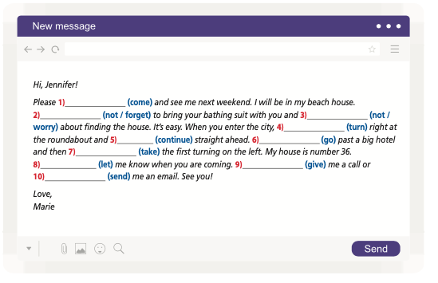

Do you have any plans for the weekend?
Drop me a line soon and let me know what you think.
The weather will be great.
Hi Adam,
I can pick you up at home at – let’s say – 2:30 p.m.
Take care,
How are you doing?
What do you think about going to the beach on Saturday?
Justin

____________________________________________________________________________________
____________________________________________________________________________________
____________________________________________________________________________________
____________________________________________________________________________________
____________________________________________________________________________________
____________________________________________________________________________________
____________________________________________________________________________________
____________________________________________________________________________________
____________________________________________________________________________________
____________________________________________________________________________________

PROGRESS TEST 11B

SCRIPT

1.
Sarah: Hi, Millie. It’s Sarah. What are you doing tomorrow afternoon?
Millie: Hi, Sarah. I was thinking of watching a movie on TV.
Sarah: What? It’s such nice weather… We should go out and cycle in the park…
Millie: You know I prefer staying at home. I am not as keen on outdoor activities as you are.
Sarah: Yes, I know you prefer reading, watching TV or listening to music, but you should leave it for the winter, not for a sunny afternoon… Don’t you agree it’s better to get some fresh air and exercise?
Millie: Well… Do you think Nick and Alice will go with us?
Sarah: I’m sure they will. I’ll give them a call. We can all take our bikes and have a picnic. I will ask Mum to make some sandwiches.
Millie: OK, you’re right. We shouldn’t waste a sunny day. I’ll bring some fruit and the cookies I made yesterday.
Sarah: Of course, you also like cooking…
Millie (laughs): Yes, I do. Well… See you tomorrow.
Sarah: See you! I bet I’ll take you camping one of these days…
Millie: Oh, no…

ANSWERS
LISTENING
1.
1. a
2. b
3. b
4. b
5. b
2.
a) True
b) False
c) True
d) True
e) False

READING, GRAMMAR AND WRITING
PART 1
1.
1. c
2. b
3. a
2.
a) Sky Brown
b) USA
c) Skateboarding, surfing and dancing
d) Bronze medal from the 2019 World Championships

PART 2
1.
a) because
b) and
c) however
d) or
e) therefore
2.
a) get
b) turns
c) practises
d) will bring
e) don’t tell
f) will order
3.
a) is going to read
b) are going to play
c) is going to swim
d) are going to visit
e) are going to walk
f) are going to play

PART 3
Hi Adam,
How are you doing?
Do you have any plans for the weekend?
What do you think about going to the beach on Saturday?
The weather will be great.
I can pick you up at home at – let’s say – 2:30 p.m.
Drop me a line soon and let me know what you think.
Take care,
Justin

MATRIZ PROGRESS TEST 11B

MATRIZ LISTENING

Aprendizagens essenciais | Conteúdos | Estrutura | Cotações | Critérios de classificação
Identificar o conteúdo principal do que se ouve e vê, os intervenientes e a sequência do discurso assim como informações específicas. | Texto e vocabulário relacionados com os tópicos da unidade | 1. Assinalar opção correta. | 5 × 10p = 50p | Resposta correta: 10 pontos  Resposta incorreta: 0 pontos
 | Texto e vocabulário relacionados com os tópicos da unidade | 2. Distinguir frases verdadeiras de falsas. | 5 × 10p = 50p | Resposta correta: 10 pontos  Resposta incorreta: 0 pontos

MATRIZ READING, GRAMMAR AND WRITING

Aprendizagens essenciais | Conteúdos | Estrutura | Cotações | Critérios de classificação
Parte 1  Compreender textos sobre temas abordados no domínio intercultural; identificar informação essencial em textos adaptados de jornais e revistas. | Texto e vocabulário relacionados com os tópicos da unidade | 1. Ligar palavras às definições. | 3 × 3p = 9p | Resposta correta: 3 pontos  Resposta incorreta: 0 pontos
 | Texto e vocabulário relacionados com os tópicos da unidade | 2. Identificar informação no texto. | 4 × 5p = 20p | Resposta correta: 5 pontos  Resposta incorreta: 0 pontos  Desconto máximo para incorreções:  3 pontos
Parte 2  Aplicar itens gramaticais tratados. | Conectores | 1. Completar espaços. | 5 × 4p = 20p | Resposta correta: 4 pontos  Resposta incorreta: 0 pontos
Parte 2  Aplicar itens gramaticais tratados. | If clauses (zero and first conditional) | 2. Completar frases. | 6 × 2p = 12p | Resposta correta: 2 pontos  Resposta incorreta: 0 pontos
Parte 2  Aplicar itens gramaticais tratados. | Futuro be going to | 3. Completar frases com base em imagens. | 6 × 2p =12p | Resposta correta: 2 pontos  Resposta incorreta: 0 pontos  Desconto máximo para incorreções:  1 ponto
Parte 3  Descrever planos para o futuro. | Temático:  Atividades e desportos | Ordenar email. | 9 × 3p = 27p | Resposta correta: 3 pontos  Resposta incorreta: 0 pontos

