PROGRESS TEST | 12B

Name ___________________________________________________ No. _______ Class _______
Date ______________________ Mark _________________________ Teacher ________________

 LISTENING
You will hear a guide talking at the beginning of a city tour.
1. Listen and complete the table.
1. ______
2. ______
3. ______
4. ______
5. ______

Guide’s name | 1. |  | a. | Orlando
City | 2. |  | b. | Restaurant
Meeting point | 3. |  | c. | Souvenir shop
Lunch/place | 4. |  | d. | Sam
Last stop | 5. |  | e. | Church Street
2. Listen again and circle the right option.

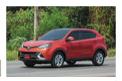
1. What type of tour is it?
a) b)


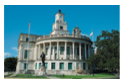
2. What are they going to visit?
a) b)



3. Where are they having lunch?
a) b)


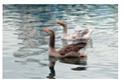
4. What can they see in Lake Eola?
a) b)

5. At the end of the tour, what are they going to eat?
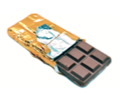

a) b)

PROGRESS TEST | 12B

Name ___________________________________________________ No. _______ Class _______
Date ______________________ Mark _________________________ Teacher ________________

READING, GRAMMAR AND WRITING

PART 1

5  10  15 | Best summer holiday  Hello. My name is George and I would like to tell you all about my last summer holiday. I know I will never forget it! Some people have their favourite place to visit and now I’ve got mine.  This summer I went to Florida with my parents and my sister to visit some relatives and I didn’t think I would have so much fun. Florida is like a combo of all my favourite things.  First, going to the beach. Everyone there loves the beach because of all the things to do there like snorkelling, swimming, surfing and looking for wildlife. We went on a boat trip to spot dolphins… and we did! It was the most amazing experience to see them jumping from the water and getting so close to us. I never took so many pictures in my life!  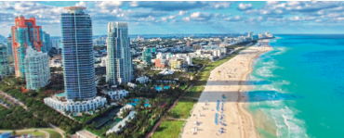  The other great thing about Florida is the big theme parks: Disney World and Universal Studios. This time, we did Disney World and all I can say is that it was so much fun. From the water parks to the adventure rides, from the 4D movies to the parade with all the Disney characters, we loved every minute of it. It is really magical and everybody had a smile on their face.  Family, beach and theme parks were the perfect combination to make this holiday the best of my life. I can’t wait to return to Florida and enjoy new experiences.

1. Mark these statements true or false.
a) George went to Florida to be with some members of his family.

b) He enjoyed his holiday although he didn’t like some things.

c) He saw some dolphins when he was on the beach.

d) He visited Disney World and Universal Studios.

e) He wants to go back to Florida on holiday.

2. Answer the questions.
a) Did George like Florida? ____
b) Did he take any pictures? ____
c) Did he see any whales? ____
d) Did he have fun at Disney World? ____

PART 2
1. Circle the correct option.
1. In summer I like going to the beach _____________ swimming in the sea.
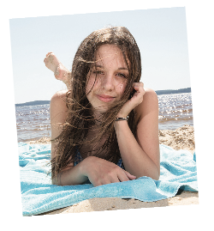
a) but b) and
2. She is 13 years old _____________ she looks older.
a) so b) but
3. I left the party early _____________ I wasn’t feeling well.
a) therefore b) because
4. I sent Claire an email; _____________, she didn’t answer me.
a) however b) so
5. My knee started hurting; _____________, I stopped running.
a) however b)therefore
6. Yesterday she was sick, _____________ she didn’t go to school.
a) so b) because
2. Complete the sentences with the verbs below.
• moves • are • treat • will go • don’t eat • will take

a) If you are a doctor, you _____________ people.
b) If you are a vegetarian, you _____________ meat.
c) If he _____________ house, his friends will be very sad.
d) We _____________ a taxi if it rains.
e) If you _____________ late, your teacher will be angry.
f) They _____________ skiing if it snows tomorrow.
3. Complete these short dialogues with be going to.
A: Have you done your homework?
B: Not yet. I 1) __________________________ (do) it now.
A: Do you need a ride to the airport?
B: No, thanks. John 2) __________________________ (take) me.
A: Are you feeling well?
B: No. I think I 3) __________________________ (faint).
A: What 4) __________________________ (you / do) with that computer?
B: It isn’t working. I 5) __________________________ (get) it repaired.
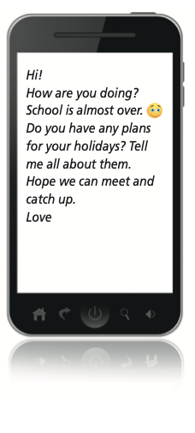
PART 3
A friend you haven’t seen for some
time has sent you this message.
Hi!
How are you doing? School is almost over.
Do you have any plans for your holidays? Tell me all about them.
Hope we can meet and catch up.
Love

Choose the right answer to the message.
A
Hi.
I’m so happy you are doing well at school. I spent my summer holiday with my family on the beach and I had a lot of fun.
Hope you also enjoyed your holidays.
Love

B
Hello. Everything’s fine. And you?
I think my parents want to go to the same beach spot. Are you going there again this year? That would be great!
Write soon

C
Hi there. I’m doing great.
It’s a pity that the holidays are almost over, but I hope we can meet again next year. Now it’s time to forget the time off and start working…
Have a nice school year!
Bye
Hi.
I’m so happy you are doing well at school. I spent my summer holiday with my family on the beach and I had a lot of fun.
Hope you also enjoyed your holidays.
Love

PROGRESS TEST 12B

SCRIPT

Exercises 1 and 2
Hello and welcome. My name is Sam and I will be your guide through this walking tour of historic downtown Orlando.
Central Florida has a fascinating history and an enriching cultural identity. It has more tourism than any other city in North America, but the majority of visitors only go the theme park and attractions area. This tour is designed to show you a small part of the region’s notable history, art and culture.
We are starting here, in Church Street, next to SunRail station, in the heart of downtown Orlando, where it is easier for you to park your car. On this 4-hour walk, we will go through the streets of downtown, and we will stop at various points of interest along the way.
About half way through our journey, we will stop and sit to enjoy a delicious lunch from a locally owned restaurant.
On the second half of our walk we will head to beautiful
Lake Eola, where we will stroll on the paved path around
the lake, stopping at public art installations and historic sites along the way. Lake Eola is the home of our swans and you will have the opportunity to feed them while we are there.
And finally, towards the end of the tour, we will stop to enjoy a homemade popsicle – the famous ice lolly – and to buy some gifts at a souvenir shop, before we work our way back towards your car.
During the tour, please ask all the questions you want and I’ll be happy to answer them. Ready? Let’s go.
https://www.toursbylocals.com/orlando-private-historic-
downtown-walking-tour (adapted)

ANSWERS
LISTENING
1.
1. d
2. a
3. e
4. b
5. c

2.
1. b
2. b
3. a
4. a
5. b

READING, GRAMMAR AND WRITING

PART 1
1.
a) True
b) False
c) False
d) False
e) True
2.
a) Yes.
b) Yes.
c) No.
d) Yes.

PART 2
1.
1. b
2. b
3. b
4. a
5. b
6. a
2.
a) treat
b) don’t eat
c) moves
d) will take
e) are
f) will go
3.
1. am going to do
2. is going to take
3. am going to faint
4. are you going to do
5. am going to get

PART 3
B

MATRIZ PROGRESS TEST 12B

MATRIZ LISTENING

Aprendizagens essenciais | Conteúdos | Estrutura | Cotações | Critérios de classificação
Identificar o conteúdo principal do que se ouve e vê, os intervenientes e a sequência do discurso assim como informações específicas. | Texto e vocabulário relacionados com os tópicos da unidade | 1. Completar tabela. | 5 × 10p = 50p | Resposta correta: 10 pontos  Resposta incorreta: 0 pontos
 | Texto e vocabulário relacionados com os tópicos da unidade | 2. Assinalar a opção correta. | 5 × 10p = 50p | Resposta correta: 10 pontos  Resposta incorreta: 0 pontos

MATRIZ READING, GRAMMAR AND WRITING

Aprendizagens essenciais | Conteúdos | Estrutura | Cotações | Critérios de classificação
Parte 1  Compreender textos narrativos sobre temas abordados no domínio intercultural. | Texto e vocabulário relacionados com os tópicos da unidade | 1. Distinguir frases verdadeiras de falsas. | 5 × 3p = 15p | Resposta correta: 3 pontos  Resposta incorreta: 0 pontos
 | Texto e vocabulário relacionados com os tópicos da unidade | 2. Responder a questões com sim  ou não. | 4 × 4p = 16p | Resposta correta: 4 pontos  Resposta incorreta: 0 pontos
Parte 2  Aplicar itens gramaticais tratados. | Conectores | 1. Assinalar a opção correta. | 6 × 3p =18p | Resposta correta: 3 pontos  Resposta incorreta: 0 pontos
Parte 2  Aplicar itens gramaticais tratados. | If clauses (zero and first conditional) | 2. Completar frases. | 6 × 3p = 18p | Resposta correta: 3 pontos  Resposta incorreta: 0 pontos
Parte 2  Aplicar itens gramaticais tratados. | Futuro be going to | 3. Completar pequenos diálogos. | 5 × 3p =15p | Resposta correta: 3 pontos  Resposta incorreta: 0 pontos
Parte 3  Descrever planos  para o futuro. | Temático:  Férias | Selecionar a resposta certa a uma mensagem. | 18p | Resposta correta: 18 pontos  Resposta incorreta: 0 pontos

