PROGRESS TEST | 5B

Name ___________________________________________________ No. _______ Class _______
Date ______________________ Mark _________________________ Teacher ________________

 LISTENING

1. Listen to a boy talking about his school and circle the correct answer.
1. When this boy thinks of school, he thinks of…

a) buildings and classrooms.

b) bells and uniforms.

2. He likes his school although…
a) it is very old.

b) it is like a hospital.

3. After some years, school becomes…
a) a place to meet your friends.

b) a second home.

4. In this school you can’t…
a) bring your mobile phone.

b) sing in the classroom.

5. He likes the fact that…
a) there are reading rooms.

b) everybody knows each other.

2. Listen again and complete the sentences.

This school is | 1. |  | a. | like a very extended family.
The more he gets involved, | 2. |  | b. | 110 years old.
School is not just a place | 3. |  | c. | the more he loves his school.
In that school they are | 4. |  | d. | to meet your friends and study.
1. ______ 2. ______ 3. ______ 4. ______

PROGRESS TEST | 5B

Name ___________________________________________________ No. _______ Class _______
Date ______________________ Mark _________________________ Teacher ________________

READING, GRAMMAR AND WRITING
PART 1
Your new school is… a football club?
Imagine going to school at your favourite football club!
Pupils at Everton Free School in the UK do just that!
Everton Free School is a new type of school. The Premier League football club Everton runs the school. The school’s crest is the same as Everton football club and it has the same club motto: ‘Nothing but the best is good enough’. The school aims to help pupils with their education through football.
The school has 120 pupils, so it’s smaller than many secondary schools! The classes are smaller too. Pupils come to the school for many reasons. Some have special needs and others have problems like bullying or violence, which makes it difficult to study at regular schools.
Pupils have to wear a uniform but many of them find it much nicer and more comfortable than at a regular school. A lot of pupils are fans of the football club and are proud to go to school every day in their team’s colours.
So, what can you study at this school? Well, not just football. The school teaches English, maths and science, and other practical subjects which will help pupils get jobs when they leave school.
The school has teachers for all the subjects, but the pupils can meet their football heroes too. They come to visit the school and even join in with lessons. How great is this school?
Team (shortened and adapted)

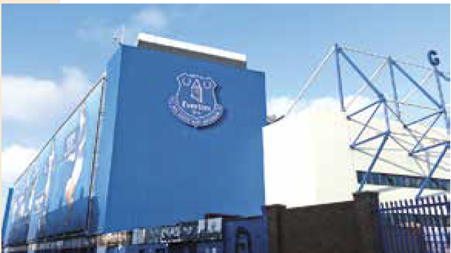

1. Fill in the table in note form.

1. Name of school
2. Country
3. School motto
4. Number of pupils
5. Subjects

2. These sentences are false. Correct them.
a) Everton Free School is very big.

b) Some pupils who attend this school have special needs.

c) They usually like the school uniform.

d) In this school you only learn about football.

e) The teachers are football players.

PART 2
1. Complete the sentences with the modal verbs can, may and might.
a) I _______________ speak English fluently.
b) I’ll talk to Helen. She _______________ agree with my plan.
c) Peter _______________ come to the party. He is not sure yet.
2. Complete the text with there was, there wasn’t, there were or there weren’t.
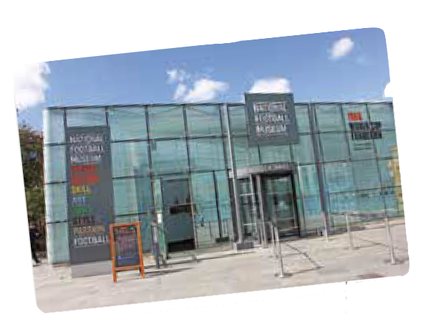
Yesterday, the students went on a field trip to England’s National Football Museum. 1) There was / There were a room with all the trophies. 2) There was / There were many types of cups and medals won by England’s national team. 3) There were / There weren’t also many different shirts, but 4) There wasn’t / There weren’t any shorts. 5) There was / There were pictures and videos, but 6) There wasn’t / There weren’t any statues. 7) There was / There wasn’t any guide, but the teacher helped the students understand most of it.

3. Complete the dialogue with the past simple of the verbs in brackets.
John: Hi, Peter. Where 1) _______________ (you / go) on your field trip yesterday?
Peter: We 2) _______________ (go) to the National Football Museum.
John: Really?! What 3) _______________ (you / like) the most?
Peter: I 4) _______________ (enjoy) seeing the evolution of the players’ equipment and the cups, of course.
John: 5) _______________ (you / have) a guide to show you the museum?
Peter: No, we 6) _______________ (not). But the teacher 7) _______________ (explain) some things to us and 8) _______________ (there to be) videos about the players and the championships. It 9) _______________ (be) great!
John: I would like to visit it too.

PART 3
Anne’s friend Susan went on a field trip to a natural park and Anne wants to find out about it.
Order the dialogue between them.
Susan: What did you see?
Anne: I loved it!
Susan: Hi, Anne. Where did you go yesterday?
Anne: We visited the museum and took a trip around the park.
Anne: Hi, Susan. I went on a field trip to a national park.
Susan: What did you do there?
Susan: Did you like the trip?
Anne: We saw some wild animals like deer and eagles.

____________________________________________________________________________________
____________________________________________________________________________________
____________________________________________________________________________________
____________________________________________________________________________________
____________________________________________________________________________________
____________________________________________________________________________________
____________________________________________________________________________________
____________________________________________________________________________________
____________________________________________________________________________________
____________________________________________________________________________________
____________________________________________________________________________________
____________________________________________________________________________________
____________________________________________________________________________________
____________________________________________________________________________________
____________________________________________________________________________________

PROGRESS TEST 5B

SCRIPT

Exercises 1 and 2 – Why I love school
School. Bells and uniforms. I like school. My school is old, in fact 110 years old this year. Some of the buildings were used as a hospital during the Second World War. However, it is good because it’s kind of in my blood. I think that the more you get involved, the more you love it. Obviously it isn’t perfect, but I think we’re pretty all right.
School is more than a place to meet your friends and study. It’s supposed to be a second home, and after some years, you start acting like it’s your home. No, you can’t bring phones in, but you can sing and bang on the desks in free periods, eat everyone else’s lunch, know everyone else’s secrets, and basically act like a very extended family.
You get to a point where everybody knows you, at least by sight, and unknown people come up randomly and say ‘your sister is running around waving a broom’ or ‘you left your lunchbox in the Reading Rooms.’ You know, homey stuff. That’s why I love my school.
https://www.teenink.com/opinion/school_
college/article/625658/Why-I-Love-School (shortened)

ANSWERS

LISTENING

1.
1. b
2. a
3. b
4. a
5. b
2.
1. b
2. c
3. d
4. a

READING, GRAMMAR AND WRITING

PART 1
1.
1. Everton Free School
2. UK
3. Nothing but the best is good enough
4. 120
5. Football, English, maths, science and practical subjects
2.
a) False
b) True
c) True
d) False
e) False

PART 2
1.
a) can
b) may / might
c) may / might
2.
1. There was
2. There were
3. There were
4. there weren’t
5. There were
6. there weren’t
7. There wasn’t
3.
1. did you go
2. went
3. did you like
4. enjoyed
5. Did you have
6. didn’t
7. explained
8. there were
9. was

PART 3
Susan: Hi, Anne. Where did you go yesterday?
Anne: Hi, Susan. I went on a field trip to a national park.
Susan: What did you do there?
Anne: We visited the museum and took a trip around the park.
Susan: What did you see?
Anne: We saw some wild animals like deer and eagles.
Susan: Did you like the trip?
Anne: I loved it!

MATRIZ PROGRESS TEST 5B

MATRIZ LISTENING

Aprendizagens essenciais | Conteúdos | Estrutura | Cotações | Critérios de classificação
Identificar o conteúdo principal do que se ouve e vê, os intervenientes e a sequência do discurso assim como informações específicas. | Texto e vocabulário relacionados com os tópicos da unidade | 1. Assinalar a opção correta. | 5 × 8p = 40p | Resposta correta: 8 pontos  Resposta incorreta: 0 pontos
 | Texto e vocabulário relacionados com os tópicos da unidade | 2. Ligar frases. | 4 × 15p = 60p | Resposta correta: 15 pontos  Resposta incorreta: 0 pontos

MATRIZ READING, GRAMMAR AND WRITING

Aprendizagens essenciais | Conteúdos | Estrutura | Cotações | Critérios de classificação
Parte 1  Compreender textos sobre temas abordados no domínio intercultural; identificar informação essencial em textos adaptados de jornais e revistas. | Texto e vocabulário relacionados com os tópicos da unidade | 1. Completar tabela. | 5 × 3p = 15p | Resposta correta: 3 pontos  Resposta incorreta: 0 pontos  Desconto máximo para incorreções: 2 pontos
 | Texto e vocabulário relacionados com os tópicos da unidade | 2. Distinguir frases verdadeiras de falsas. | 5 × 2p = 10p | Resposta correta: 2 pontos  Resposta incorreta: 0 pontos
Parte 2  Aplicar itens gramaticais tratados. | Verbos modais: can, may, might | 1. Preencher espaços. | 3 × 5p = 15p | Resposta correta: 5 pontos  Resposta incorreta: 0 pontos
Parte 2  Aplicar itens gramaticais tratados. | Past simple: there to be | 2. Assinalar opção correta. | 7 × 2p = 14p | Resposta correta: 2 pontos  Resposta incorreta: 0 pontos
Parte 2  Aplicar itens gramaticais tratados. | Past simple:  verbos regulares e irregulares | 3. Completar diálogo. | 9 × 2p = 18p | Resposta correta: 2 pontos  Resposta incorreta: 0 pontos
Parte 3  Escrever diálogos com encadeamento lógico. | Temático:  A escola e os amigos | Ordenar um diálogo. | 8 × 3.5p = 28p | Resposta correta: 3.5 pontos  Resposta incorreta: 0 pontos

