PROGRESS TEST | 6B

Name ___________________________________________________ No. _______ Class _______
Date ______________________ Mark _________________________ Teacher ________________

 LISTENING

- Listen to a boy talking about his best day at school and order the events (1-6).

He went out with his family.
He put on his school uniform. | 1
The students played dodgeball.
He had breakfast in the kitchen.
He had English and geography lessons.
He ate his favourite dish.

2. Listen again and circle the correct option.
1. What was the weather like that day?


a) b)

2. What did he have at breakfast?


a) b)

3. How good was his homework?


a) b)

4. What did he have at lunch?


a) b)

5. Where did he go with his family?


a) b)

PROGRESS TEST | 6B

Name ___________________________________________________ No. _______ Class _______
Date ______________________ Mark _________________________ Teacher ________________

READING, GRAMMAR AND WRITING
PART 1
5  10  15 |   ‘Not in Our School’  I am Matt and I am in year 7. Last year, in my school there were some cases of bullying, in which some pupils were teased and picked on, sometimes kicked, hit and threatened to give money or things.  When the school director found out about those cases, he solved them but he made up his mind to do something more. Bullying seemed to be escalating and he knew it could have terrible effects on the victims. They usually feel unhappy and lonely and find it hard to concentrate and to live their lives normally. He also knew that many cases go unnoticed because the victims are afraid to tell other people.  Therefore, this school year started with an anti-bullying week under the motto ‘Not in Our School’. In the first meeting of the year, the director explained that ‘Not in Our School’ (NIOS) was a movement in American schools for students and teachers to join together and take action to create safe schools, free from stereotypes, intolerance, and hate.  During that week, we watched films and videos, participated in workshops, and were inspired to create innovative ways to stop bullying and make schools safe for everyone. And great ideas came up! There were posters and banners with inspiring messages, there were games and sports competitions for integration, and there was a ceremony where each older student was assigned to guide and protect a younger one. I was lucky! My protector is a beautiful 16-year-old girl!  Anyway, all the teachers and students participated and enjoyed the experience. I feel confident that this type of initiative will stop bullying once and for all.

1. Match the words/expressions with their definitions.
1. _____
2. _____
3. _____
4. _____

picked on | 1. |  | a. | a fixed general idea of a person or thing
escalating | 2. |  | b. | criticised
stereotype | 3. |  | c. | completely and finally
once and for all | 4. |  | d. | growing

3. Complete the sentences with the words in the box.
a) In Matt’s school there were some cases of.
• unhappy
• stop
• bullying
• something
• School
• banners

b) The school director decided to do ______________________.
c) The victims of bullying often feel ______________________.
d) The movement anti-bullying was called ‘Not in Our _____________________.
e) The students created posters and ______________________.
f) Matt is hopeful that bullying will _____________________.
PART 2
1. Complete the sentences with the modal verbs can, may and might. Use the negative form if necessary.
a) Matt _______________ play the guitar.
b) I don’t know where my phone is. – Ask Mum. She _______________ know.
c) He has just left. He _______________ be too far.
d) Do you really believe him? That story _______________ be true.
e) This _______________ be the best movie I’ve seen all year.
f) I _______________ come and visit you next year, if I can save enough money.

2. Look at the picture and complete the sentences with there was, there wasn’t, there were or there weren’t.

a) In Matt’s classroom _______________ a TV set but _______________ any computers.
b) _______________ a blackboard but _______________ a whiteboard.
c) _______________ some schoolbags but _______________ any pencil case.
d) _______________ a map but _______________ any posters.
3. Complete the dialogue with the past simple of the verbs in brackets.
Carol: Hi, Matt. 1) _______________ (you / like) the first week activities?
Matt: About bullying? Yes, I 2) _______________. I think they 3) _______________ (be) very important. And thank you for being my ‘godmother’.
Carol: You’re welcome. What 4) _______________ (your group / do)?
Matt: We 5) _______________ (make) a banner saying ‘be a buddy, not a bully’.
Carol: I 6) _______________ (see) it! It 7) _______________ (be) in the main hall.
I 8)_______________ (like) it a lot. Now, if you have any problem or difficulty, tell me about it. I’ll be glad to help.
Matt: Thank you so much.

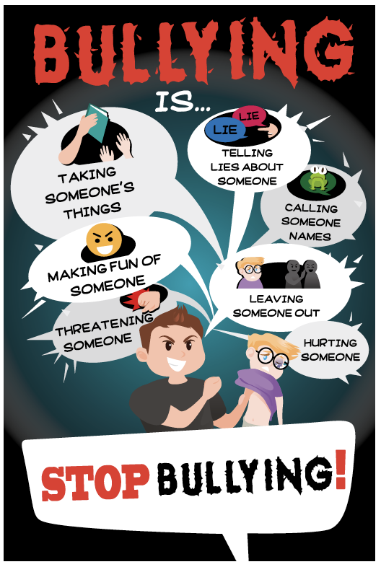
PART 3
Look at the poster made by some students.
Complete it with the words below.

• lies
• names
• someone
• fun
• things
• out
• threatening

____________________________________________________________________________________
____________________________________________________________________________________
____________________________________________________________________________________
____________________________________________________________________________________
____________________________________________________________________________________
____________________________________________________________________________________
____________________________________________________________________________________
____________________________________________________________________________________
____________________________________________________________________________________
____________________________________________________________________________________
____________________________________________________________________________________
____________________________________________________________________________________
____________________________________________________________________________________
____________________________________________________________________________________
____________________________________________________________________________________

PROGRESS TEST 6B

SCRIPT

Exercises 1 and 2
Dear Diary,
I had the best day EVER today!
When I woke up this morning, the sun was shining through the curtains and I could smell breakfast cooking downstairs.
I jumped out of my bed, threw on my school clothes and skipped down to the kitchen.
A delicious breakfast of pancakes with syrup was waiting for me on the table, and I gobbled it down as quickly as a flash.
I grabbed my school bag, shouted “Bye!” to my mum and dashed out of the door to school.
When I arrived at school, my teacher handed my homework back to me and a huge grin spread across her face. Guess what? I got 20 out of 20! I couldn’t believe it! We had my best lessons in the morning, English and geography.
Before I knew it, the bell rang for lunch. The menu today was my favourite: spaghetti Bolognese followed by chocolate pudding – yum! The afternoon flew by, and we ended the school day with a really fun game of dodgeball, and we all cheered when my team won (of course).
After school, I came home and was met with the most amazing surprise because my mum told me that we were going out to the cinema and eat pizza for dinner. We had a fantastic time!
I’m sitting on my bed writing this, remembering all the fun things that happened today. I hope tomorrow is just as good!
https://www.maidenhall.co.uk/assets/Uploads/
Ahmeds-day-at-school-diary-entry-text.pdf

ANSWERS

LISTENING

1.
6 – 1 – 5 – 2 – 3 – 4
2.
1. a
2. b
3. a
4. b
5. b

READING, GRAMMAR AND WRITING

PART 1
1.
1. b
2. d
3. a
4. c
2.
a) bullying
b) something
c) unhappy
d) School
e) banners
f) stop

PART 2
1.
a) can
b) may / might
c) can’t
d) may not
e) may / might
f) may / might
2.
a) there was / there weren’t
b) There was / there wasn’t
c) There were / there wasn’t
d) There was / there weren’t
3.
1. Did you like
2. did
3. were
4. did your group do
5. made
6. saw
7. was
8. liked

PART 3
1. things
2. lies
3. fun
4. names
5. threatening
6. out
7. someone

MATRIZ PROGRESS TEST 6B

MATRIZ LISTENING

Aprendizagens essenciais | Conteúdos | Estrutura | Cotações | Critérios de classificação
Identificar o conteúdo principal do que se ouve e vê, os intervenientes e a sequência do discurso assim como informações específicas. | Texto e vocabulário relacionados com os tópicos da unidade | 1. Ordenar eventos. | 5 × 10p = 50p | Resposta correta: 10 pontos  Resposta incorreta: 0 pontos
 | Texto e vocabulário relacionados com os tópicos da unidade | 2. Assinalar a opção correta. | 5 × 10p = 50p | Resposta correta: 10 pontos  Resposta incorreta: 0 pontos

MATRIZ READING, GRAMMAR AND WRITING

Aprendizagens essenciais | Conteúdos | Estrutura | Cotações | Critérios de classificação
Parte 1  Compreender textos sobre temas abordados no domínio intercultural. | Texto e vocabulário relacionados com os tópicos da unidade | 1. Associar palavras/ expressões à definição. | 4 × 3.5p = 14p | Resposta correta: 3.5 pontos  Resposta incorreta: 0 pontos
 | Texto e vocabulário relacionados com os tópicos da unidade | 2. Completar frases. | 6 × 3p = 18p | Resposta correta: 3 pontos  Resposta incorreta: 0 pontos
Parte 2  Aplicar itens gramaticais tratados. | Verbos modais: can, may, might | 1. Preencher espaços. | 6 × 2.5p = 15p | Resposta correta: 2.5 pontos  Resposta incorreta: 0 pontos
Parte 2  Aplicar itens gramaticais tratados. | Past simple: there to be | 2. Completar frases. | 8 × 2p = 16p | Resposta correta: 2 pontos  Resposta incorreta: 0 pontos
Parte 2  Aplicar itens gramaticais tratados. | Past simple:  verbos regulares e irregulares | 3. Completar diálogo. | 8 × 2p = 16p | Resposta correta: 2 pontos  Resposta incorreta: 0 pontos
Parte 3  Interagir de forma simples, completando mensagens. | Temático:  A escola e os amigos | Escrever mensagem em poster. | 7 × 3p = 21p | Resposta correta: 3 pontos  Resposta incorreta: 0 pontos

