PROGRESS TEST | 7A

Name ___________________________________________________ No. _______ Class _______
Date ______________________ Mark _________________________ Teacher ________________

 LISTENING
1. Decide which rooms belong to Martha’s house.
1. Living room
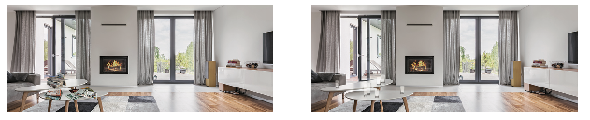
a) b)

2. Kitchen
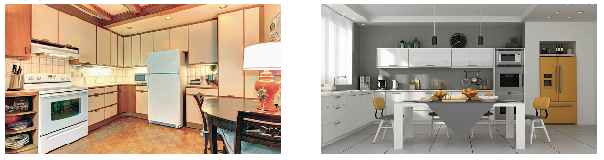
a) b)

3. Bedroom
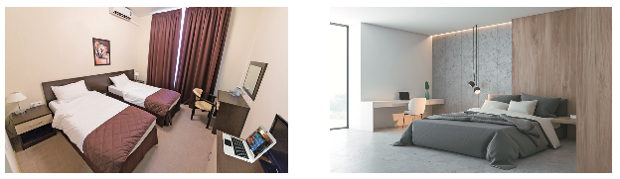
a) b)

2. Complete these sentences with 2 words each.
a) Martha lives on the _____________________________________________________________.
b) The building is facing ___________________________________________________________.
c) All her family likes ______________________________________________________________.
d) She sometimes helps her mother with ______________________________________________.
e) She shares her bedroom with _____________________________________________________.
PROGRESS TEST | 7A

Name ___________________________________________________ No. _______ Class _______
Date ______________________ Mark _________________________ Teacher ________________

READING, GRAMMAR AND WRITING

PART 1
5  10  15 |   Ariana Grande’s new luxurious home  Pop princess Ariana Grande has recently bought a 13.7 million property in Los Angeles. Placed in the hills, the three-storey home has canyon-to-ocean views in every room from its balconies and an infinity pool. The beautiful property is located in the famous Bird Streets neighbourhood, an area in the hills where many celebrities live.  Ariana’s new home is quite spacious, with four bedrooms, an office, and seven bathrooms spanning the more than 10,000 square foot home. There is also a wellness room, a 300-bottle wine cellar and a fitness studio. Hardwood floors and high ceilings add plenty of space and a modern element to the sophisticated, hillside home.  Ariana’s favourite room, her bedroom, also has wooden floors and cream walls. The windows are large to brighten up the room. There’s a big bed and a fireplace as well as a treadmill for workout. The TV is mounted on the wall in front of the bed and Ariana can take perfect selfies in a full-length mirror.  Ariana loves dogs and her house is full of cosy corners for them. From armchairs covered in plush throw blankets in the living room to dog beds spread across the house, the singer has created a luxurious home for her dogs as well.  https://www.dailymail.co.uk/tvshowbiz/article-8411389/PICTURED-Ariana-Grandes-new-13-7-million-home-  Hollywood-Hills-complete-wellness-room.html (shortened and adapted)

1. What do these words mean? Circle the correct option.

1. three-story
a) three bedrooms

b) three floors

2. spacious
a) big

b) special

3. brighten
a) turn on the light

b) give more light

4. full-length
a) showing someone’s whole body

b) showing someone’s face

5. cosy
a) warm and comfortable

b) very expensive

2. Answer the following questions.
a) How much did Ariana’s new house cost? _______________________________________________
b) Where is it located? ________________________________________________________________
c) What has she got in her bedroom? ____________________________________________________
d) What is there for her dogs? __________________________________________________________

PART 2
1. Complete the sentences with some, any or no.
a) Ariana has got ________________ pet dogs, but she hasn’t got cats.
b) Are there ________________ pictures in your bedroom? – Yes, there are ________________.
c) Ariana is very busy. She has ________________ time to answer all her messages.
2. Complete the description of this kitchen with the prepositions of place.
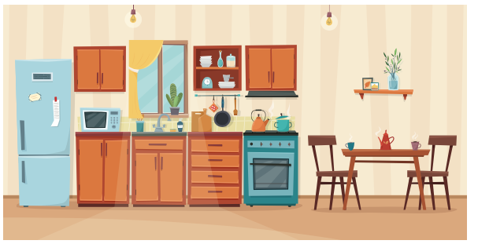

a) In this kitchen, there is a fridge ________________ and a table and two chairs ________________.
b) There is a vase of flowers ________________ the shelf ________________ the table.
c) The microwave is ________________ the fridge and the sink.
d) The skin is ________________ the window.
3. Complete the dialogue with the past simple or past continuous of the verbs in brackets.
Jennifer: What 1) ________________ (you / do) when I 2) ________________ (call) you this afternoon?
Laurie: I 3) ________________ (clean up) my bedroom. My mother 4) ________________ (not / let) me answer the phone until I 5) ________________ (finish).
Jennifer: 6) ________________ (be) it that messy?
Laurie: Er… no, but I 7) ________________ (watch) TV instead of doing homework…
Jennifer: Well, you 8) ________________ (learn) your lesson…
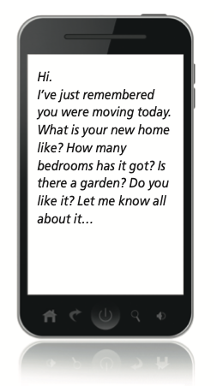
PART 3
Your friend texted you this message:

Answer his/her message in about 50 words.

____________________________________________________________________________________
____________________________________________________________________________________
____________________________________________________________________________________
____________________________________________________________________________________
____________________________________________________________________________________
____________________________________________________________________________________
____________________________________________________________________________________
____________________________________________________________________________________
____________________________________________________________________________________
____________________________________________________________________________________
____________________________________________________________________________________
____________________________________________________________________________________
____________________________________________________________________________________
____________________________________________________________________________________

PROGRESS TEST 7A

SCRIPT

Exercises 1 and 2
Hi. My name is Martha. I live with my family on the fifth floor of a block of flats downtown. The building is between a supermarket and a bank and in front of a big park.
My home has got two bedrooms and a large living room. I really like our living room because through its large windows we can see the park. Also, there is a comfortable sofa where we can watch TV together. There is a coffee table in front of the sofa and there are some books and magazines on the table. All the family likes to read. The kitchen is not big but there are modern appliances. This is great because sometimes I help my mother with the cooking.
I share my bedroom with my younger sister. There are two single beds and a wardrobe, as well as a desk where we do homework. On the desk there is a laptop both for study and entertainment.
In general, I like my home because it is comfortable and there is everything we need nearby. Living downtown can be a little noisy, but I don’t mind.

ANSWERS

LISTENING
1.
1. a
2. b
3. a
2.
a) 5th (fifth) floor
b) a park
c) to read
d) the cooking
e) her sister

READING, GRAMMAR AND WRITING
PART 1
1.
1. b
2. a
3. b
4. a
5. a
2.
a) It cost 13.7 million dollars.
b) It is located in (the hills of) Los Angeles.
c) She has got a big bed, a fireplace, a treadmill, a TV and a full-length mirror.
d) There are armchairs covered in warm blankets in the living room and dog beds all over the house.

PART 2
1.
a) some / any
b) any / some
c) no
2.
a) on the left / on the right
b) on / above
c) between
d) below
3.
1. were you doing
2. called
3. was cleaning up
4. didn’t let
5. finished
6. Was
7. was watching
8. learnt (learned)

PART 3
Open answer.

MATRIZ PROGRESS TEST 7A

MATRIZ LISTENING

Aprendizagens essenciais | Conteúdos | Estrutura | Cotações | Critérios de classificação
Identificar o conteúdo principal do que se ouve e vê, os intervenientes e a sequência do discurso assim como informações específicas. | Texto e vocabulário relacionados com os tópicos da unidade | 1. Assinalar a opção correta. | 3 × 15p = 45p | Resposta correta: 15 pontos  Resposta incorreta: 0 pontos
 | Texto e vocabulário relacionados com os tópicos da unidade | 2. Completar frases. | 5 × 11p = 55p | Resposta correta: 11 pontos  Resposta incorreta: 0 pontos  Desconto máximo para incorreções: 9 pontos

MATRIZ READING, GRAMMAR AND WRITING

Aprendizagens essenciais | Conteúdos | Estrutura | Cotações | Critérios de classificação
Parte 1  Compreender textos sobre temas abordados no domínio intercultural; identificar informação essencial em textos adaptados de jornais e revistas. | Texto e vocabulário relacionados com os tópicos da unidade | 1. Assinalar a opção correta. | 5 × 3p = 15p | Resposta correta: 3 pontos  Resposta incorreta: 0 pontos
 | Texto e vocabulário relacionados com os tópicos da unidade | 2. Responder a questões. | 4 × 5p = 20p | Resposta correta: 5 pontos  Resposta incorreta: 0 pontos  Desconto máximo para incorreções: 4 pontos
Parte 2  Aplicar itens gramaticais tratados. | Some, any, no | 1. Preencher espaços. | 5 × 3p = 15p | Resposta correta: 3 pontos  Resposta incorreta: 0 pontos
Parte 2  Aplicar itens gramaticais tratados. | Preposições  de lugar | 2. Completar frases. | 6 × 2p = 12p | Resposta correta: 2 pontos  Resposta incorreta: 0 pontos
Parte 2  Aplicar itens gramaticais tratados. | Past simple / past continuous | 3. Completar diálogo. | 8 × 2p = 16p | Resposta correta: 2 pontos  Resposta incorreta: 0 pontos
Parte 3  Escrever sobre pessoas, objetos e rotinas. | Temático:  A casa | Responder a uma mensagem. | 22p | Texto com vocabulário adequado e erros de ortografia e de estrutura irrelevantes:  19-22 pontos  Texto com vocabulário restrito e alguns erros de ortografia e de estrutura: 11-18 pontos  Texto com vocabulário restrito e/ou inadequado e muitos erros de ortografia e de estrutura: 1-10 pontos

