PROGRESS TEST | 7B

 LISTENING
1. Decide which rooms belong to Martha’s house.
1. Living room
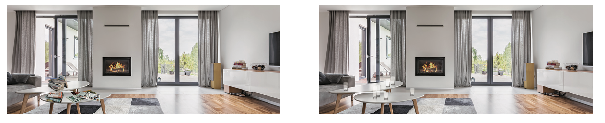
a) b)

2. Kitchen
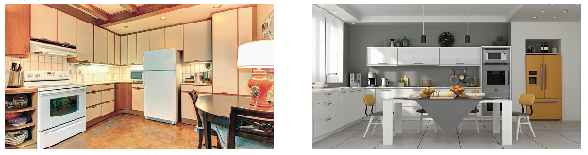
a) b)

3. Bedroom
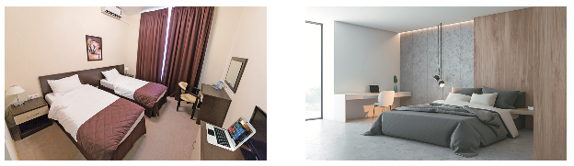
a) b)

2. Match to make sentences.
Martha lives in a flat | 1. |  | a. | with the cooking.
The building is facing | 2. |  | b. | to read.
All her family likes | 3. |  | c. | on the fifth floor.
She sometimes helps her mother | 4. |  | d. | with her sister.
She shares her bedroom | 5. |  | e. | a park.
1. _____ 2. _____ 3. _____ 4. _____5. _____
PROGRESS TEST | 7B

Name ___________________________________________________ No. _______ Class _______
Date ______________________ Mark _________________________ Teacher ________________

READING, GRAMMAR AND WRITING


PART 1
5  10  15 | Ariana Grande’s new luxurious home  Pop princess Ariana Grande has recently bought a 13.7 million property in Los Angeles. Placed in the hills, the three-storey home has canyon-to-ocean views in every room from its balconies and an infinity pool. The beautiful property is located in the famous Bird Streets neighbourhood, an area in the hills where many celebrities live.  Ariana’s new home is quite spacious, with four bedrooms, an office, and seven bathrooms spanning the more than 10,000 square foot home. There is also a wellness room, a 300-bottle wine cellar and a fitness studio. Hardwood floors and high ceilings add plenty of space and a modern element to the sophisticated, hillside home.  Ariana’s favourite room, her bedroom, also has wooden floors and cream walls. The windows are large to brighten up the room. There’s a big bed and a fireplace as well as a treadmill for workout. The TV is mounted on the wall in front of the bed and Ariana can take perfect selfies in a full-length mirror.  Ariana loves dogs and her house is full of cosy corners for them. From armchairs covered in plush throw blankets in the living room to dog beds spread across the house, the singer has created a luxurious home for her dogs as well.  https://www.dailymail.co.uk/tvshowbiz/article-8411389/PICTURED-Ariana-Grandes-new-13-7-million-home-  Hollywood-Hills-complete-wellness-room.html (shortened and adapted)

1. What do these words mean? Circle the correct option.

1. three-story
a) three bedrooms

b) three floors

2. spacious
a) big

b) special

3. brighten
a) turn on the light

b) give more light

4. full-length
a) showing someone’s whole body

b) showing someone’s face

5. cosy
a) warm and comfortable

b) very expensive

2. Find the following information in the text:
a) Price of Ariana’s house: ________________________________________________________________
b) City: _________________________________________________________________________________
c) Number of bedrooms: __________________________________________________________________
d) Her favourite animals: __________________________________________________________________

PART 2
1. Complete the sentences with some, any or no.
a) Ariana has got _______________ pet dogs, but she hasn’t got _______________ cats.
b) Are there _______________ pictures in your bedroom? – Yes, there are _______________.
c) Ariana is very busy. She has _______________ time to answer all her messages.
2. Complete the description of this kitchen with the prepositions of place in the box.
• on • between • below • on the right • on the left • above

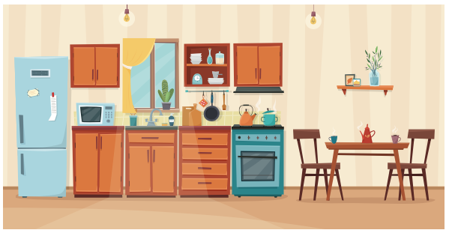

a) In this kitchen, there is a fridge _______________ and a table and two chairs _______________.
b) There is a vase of flowers _______________ the shelf _______________ the table.
c) The microwave is _______________ the fridge and the sink.
d) The sink is _______________ the window.
3. Complete the dialogue with the past simple or past continuous of the verbs in brackets.
Jennifer: What 1) _______________ (you / do) when I 2) _______________ (call) you this afternoon?
Laurie: I 3) _______________ (clean up) my bedroom. My mother 4) _______________ (not / let) me answer the phone until I 5) _______________ (finish).
Jennifer: 6) _______________ (be) it that messy?
Laurie: Er… no, but I 7) _______________ (watch) TV instead of doing homework…
Jennifer: Well, you 8) _______________ (learn) your lesson…
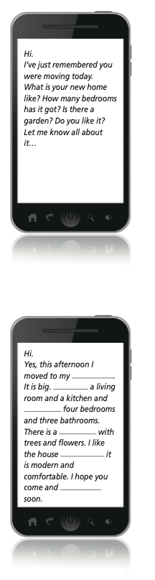
PART 3
Your friend texted you this message:

Complete the message to your friend.

PROGRESS TEST 7B

SCRIPT

Exercises 1 and 2
Hi. My name is Martha. I live with my family on the fifth floor of a block of flats downtown. The building is between a supermarket and a bank and in front of a big park.
My home has got two bedrooms and a large living room. I really like our living room because through its large windows we can see the park. Also, there is a comfortable sofa where we can watch TV together. There is a coffee table in front of the sofa and there are some books and magazines on the table. All the family likes to read. The kitchen is not big but there are modern appliances. This is great because sometimes I help my mother with the cooking.
I share my bedroom with my younger sister. There are two single beds and a wardrobe, as well as a desk where we do homework. On the desk there is a laptop both for study and entertainment.
In general, I like my home because it is comfortable and there is everything we need nearby. Living downtown can be a little noisy, but I don’t mind.

ANSWERS

LISTENING
1.
1. a
2. b
3. a
2.
1. c
2. e
3. b
4. a
5. d

READING, GRAMMAR AND WRITING
PART 1
1.
1. b
2. a
3. b
4. a
5. a
2.
a) 13.7 million dollars
b) Los Angeles
c) 4 (four)
d) Dogs

PART 2
1.
a) some / any
b) any / some
c) no
2.
a) on the left / on the right
b) on / above
c) between
d) below
3.
1. were you doing
2. called
3. was cleaning up
4. didn’t let
5. finished
6. Was
7. was watching
8. learnt (learned)

PART 3
(Suggestion)
new house / There is / there are / garden / because / see it
w house / There is / there are / garden / because / see it

MATRIZ PROGRESS TEST 7B

MATRIZ LISTENING

Aprendizagens essenciais | Conteúdos | Estrutura | Cotações | Critérios de classificação
Identificar o conteúdo principal do que se ouve e vê, os intervenientes e a sequência do discurso assim como informações específicas. | Texto e vocabulário relacionados com os tópicos da unidade | 1. Assinalar a opção correta. | 3 × 15p = 45p | Resposta correta: 15 pontos  Resposta incorreta: 0 pontos
 | Texto e vocabulário relacionados com os tópicos da unidade | 2. Ligar frases. | 5 × 11p = 55p | Resposta correta: 11 pontos  Resposta incorreta: 0 pontos

MATRIZ READING, GRAMMAR AND WRITING

Aprendizagens essenciais | Conteúdos | Estrutura | Cotações | Critérios de classificação
Parte 1  Compreender textos sobre temas abordados no domínio intercultural; identificar informação essencial em textos adaptados de jornais e revistas. | Texto e vocabulário relacionados com os tópicos da unidade | 1. Assinalar a opção correta. | 5 × 3p = 15p | Resposta correta: 3 pontos  Resposta incorreta: 0 pontos
 | Texto e vocabulário relacionados com os tópicos da unidade | 2. Identificar informação. | 4 × 6p = 24p | Resposta correta: 6 pontos  Resposta incorreta: 0 pontos  Desconto máximo para incorreções: 5 pontos
Parte 2  Aplicar itens gramaticais tratados. | Some, any, no | 1. Preencher espaços. | 5 × 3p = 15p | Resposta correta: 3 pontos  Resposta incorreta: 0 pontos
Parte 2  Aplicar itens gramaticais tratados. | Preposições  de lugar | 2. Completar frases. | 6 × 2p = 12p | Resposta correta: 2 pontos  Resposta incorreta: 0 pontos
Parte 2  Aplicar itens gramaticais tratados. | Past simple / past continuous | 3. Completar diálogo. | 8 × 2p = 16p | Resposta correta: 2 pontos  Resposta incorreta: 0 pontos
Parte 3  Interagir de forma simples, completando mensagens. | Temático:  A casa | Completar resposta a uma mensagem. | 6 × 3p = 18p | Resposta correta: 3 pontos  Resposta incorreta: 0 pontos

