CLIL WORKSHEET | 1 | Unit 1 – CLIL Geography

Name ___________________________________________________ No. _______ Class _______
Date ______________________ Mark _________________________ Teacher ________________

European Countries
Label the map.
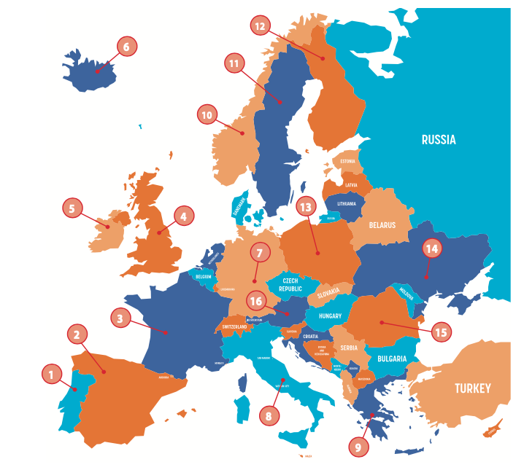

1. _______________
5. _______________
9. _______________
13. _______________
2. _______________
6. _______________
10. _______________
14. _______________
3. _______________
7. _______________
11. _______________
15. _______________
4. _______________
8. _______________
12. _______________
16. _______________

Learn more:
Europe: Countries – Map Quiz Game https://online.seterra.com/en/vgp/3007

