CLIL WORKSHEET | 2 | Unit 1 – CLIL Geography

Name ___________________________________________________ No. _______ Class _______
Date ______________________ Mark _________________________ Teacher ________________

Top Destinations
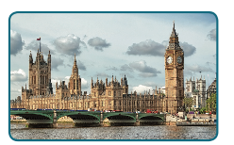
A. Where can you find these top destinations? Look at the pictures and the flags. Identify the cities and the countries. Use the Internet to help you.
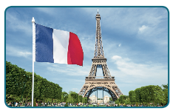

Eiffel Tower Palace of Westminster
1. City: ________________________________ 2. City: _____________________________
Country: _____________________________ Country: ___________________________
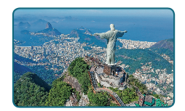
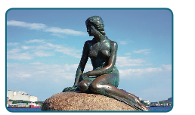

Christ Redeemer The Little Mermaid
3. City: ________________________________ 4. City: _____________________________
Country: _____________________________ Country: ___________________________
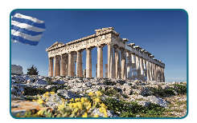
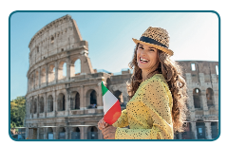

Colosseum Parthenon
5. City: ________________________________ 6. City: _____________________________
Country: _____________________________ Country: ___________________________

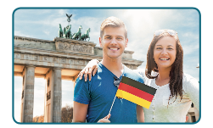
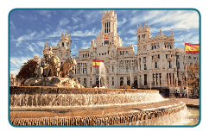

Cibeles Fountain Brandenburg Gate
7. City: ________________________________ 8. City: _____________________________
Country: _____________________________ Country: ___________________________
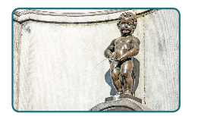


Statue of Liberty Manneken Pis
9. City: ________________________________ 10. City: ____________________________
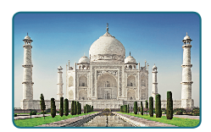
Country: _____________________________ Country: ___________________________
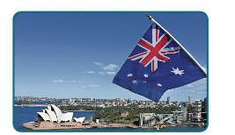

Taj Mahal Sydney Opera House
11. City: _______________________________ 12. City: ____________________________
Country: _____________________________ Country: ___________________________
B. Now match them up with the continent they are on.
Learn more:
NEW Seven Wonders of the World 2020 https://www.youtube.com/watch?v=W6AWgDrolB4&ab_channel=BEAUTIFULPLACESINTHEWORLD
A virtual tour of Lady Liberty https://www.youtube.com/watch?v=cE4UAyD9PwY&ab_channel=CBSSundayMorning
Virtual tours: See Europe’s top travel destinations without leaving your couch https://www.euronews.com/travel/2020/10/13/virtual-tours-see-europe-s-top-travel-destinations-without-leaving-your-couch

