CLIL WORKSHEET | 3 | Unit 2 – CLIL Science

Name ___________________________________________________ No. _______ Class _______
Date ______________________ Mark _________________________ Teacher ________________

Healthy Habits
A. Complete the tips.



1. Do _______________________________.
2. Don’t _______________________________.




3. Cut down on ___________________________.
4. Avoid _______________________________.

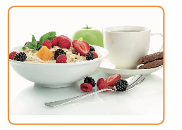


5. ___________________ at least 8 hours a day.
6. Don’t skip _______________________________.




7. Don’t stay in the ______________ for too long.
8. Reduce _______________________________.

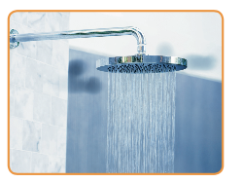


9. Eat _______________ and _________________.
10. Have a ________________________ every day.

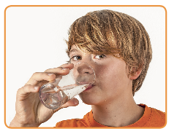
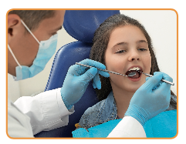

11. Go to the doctor and _______________ regularly.
12. Drink plenty of _______________ every day.

B. Over to you
How healthy are you? Tell the class about your good habits.

Learn more:
How To Be Healthy https://www.youtube.com/watch?v=wvwXxVT61O4&ab_channel=WhatsUpDude

