CLIL WORKSHEET | 4 | Unit 3 – CLIL Science

Name ___________________________________________________ No. _______ Class _______
Date ______________________ Mark _________________________ Teacher ________________

A Fingerprint Experiment
Welcome to Top Teen Lab!
The Investigation
Use fingerprint science to solve a crime!
1. The crime
Bob: I’m thirsty! I want some juice. Where’s my book?

Cindy: Orange juice! My favourite.
Bob: Hi Cindy! Where’s my juice?
Cindy: I don’t know.
2. The evidence
Bob: What’s this?
Cindy: Nothing!
Bob: It’s a fingerprint! I know what to do!
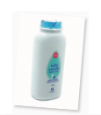
3. The equipment
Cindy: A make-up brush, baby powder, clear tape, white paper, and a pencil?
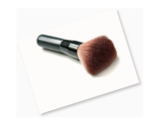
Bob: It’s everything I need to test this fingerprint.
4. The forensics
Bob: Brush the baby powder onto the glass.
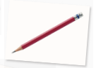
Cindy: Look! What’s that?
Bob: Aha! It’s a fingerprint!
5. The investigation
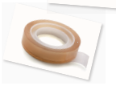
Cindy: So… Whose fingerprint, is it?
Bob: We can test it!
Cindy: How?
Bob: Draw lots with a pencil on paper. Roll your finger in the pencil.
Cindy: So, now I have a dirty finger?
Bob: Put the clear tape over your finger. Now take off the tape, and stick it to the paper.
6. The arrest
Bob: Look, the fingerprints match! You’re the thief!
Cindy: Sorry! It was me!
Click, March 2019
1. Fill in the table in note form.

What: Theft of ___________________________
Evidence: ______________________________
Confession: ____________________________
Suspect: _____________________________
Motive: ______________________________
Conclusion: ___________________________

2. Over to you
Now use the pencil and tape technique to see your fingerprint.
Stick it to this worksheet so you can compare it with your classmates.

