CLIL WORKSHEET | 5 | Unit 4 – CLIL Geography

Name ___________________________________________________ No. _______ Class _______
Date ______________________ Mark _________________________ Teacher ________________

Houses Around The World
Match each picture with the corresponding description. Which of these houses are possible to build in Portugal?
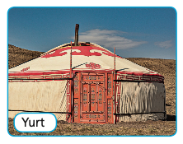
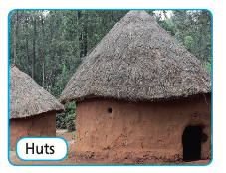
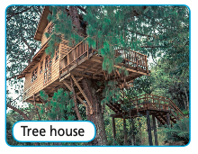

A. _____________________
B. _____________________
C. _____________________

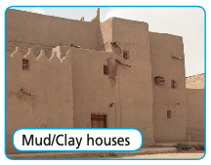
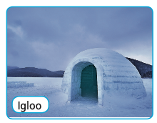
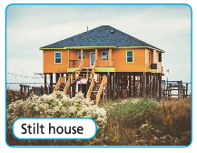

D. _____________________
E. _____________________
F. _____________________

Mud is used with materials such as straw, sticks, etc. to build a house. People living in hot and dry climates build mud houses. This type of house is found in Mexico.
These houses are found in some parts of South East Asia and West Africa because of the heavy rain and frequent floods. They are raised on stilts (legs) over the surface of the soil to protect the houses from the flood water.

The nomads of Mongolia live in round tents covered with animal skins or felt. Nomads move from place to place with their animals and the tent can be moved easily. They provide protection against bad weather.

6
5
4
1
The Inuit people of Canada and Greenland build houses by using blocks of snow in the shape of a dome. This shape helps to keep the place warm inside.
Many people in parts of Africa live in these small houses. They are often made out of stones and mud. The roof is made using branches from trees and straw.
2
Some tribes who live in the rainforests of the world live in these houses. They build their houses high up in the trees. These houses are made out of wood and have a thatched roof.

3

