CLIL WORKSHEET | 6 | Unit 5 – CLIL Geography

Name ___________________________________________________ No. _______ Class _______
Date ______________________ Mark _________________________ Teacher ________________

WebQuest: North America
Do this quiz. Then check your answers by doing an Internet search for North America. You can use this website to help you:
North America Facts for Kids | North America | Geography | Superlative (kids-world-travel-guide.com)
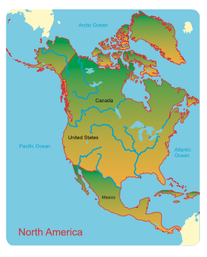
1. How many countries are on the North American continent?
a) 15
b) 19
c) 23
d) 27
2. Which is the largest country in North America?
a) Canada
b) Cuba
c) Mexico
d) USA

3. Which is the largest city in North America?
a) Atlanta
b) Mexico City
c) New York City
d) Toronto
4. Which is the highest mountain in North America?
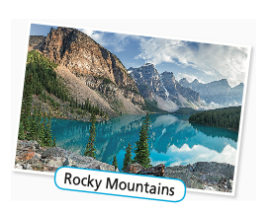
a) Denali
b) Mount Logan
c) Mount Whitney
d) Pico do Orizaba
5. What is the name of the longest mountain range of North America?
a) The Appalachian Mountains
b) The Cascades
c) The Sierra Nevada
d) The Rocky Mountains
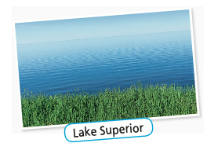
6. Which is the largest lake in North America?
a) Lake Erie
b) Lake Michigan
c) Lake Ontario
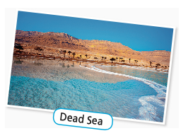
d) Lake Superior
7. Which is the lowest point of North America?
a) Dead Sea
b) Death Valley
c) Deep Lake
d) Danakil Depression
8. The longest border in North America is between
these countries:
a) Argentina and Chile

b) Mexico and Guatemala
c) Mexico and the United States of America
d) The United States of America and Canada
9. How many people live in the United States of America?
a) 227 million
b) 313 million
c) 330 million
d) 412 million
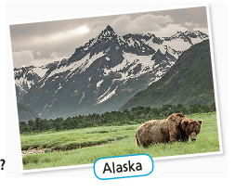
10. Which is the largest state of the United States of America?
a) Alaska
b) Arizona
c) Texas
d) Wyoming
11. Which is the most populous state of the United States of America?
a) California
b) Florida
c) New York
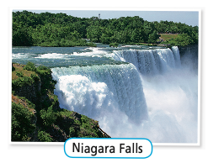
d) Texas
12. Which of these are the tallest waterfalls?
a) Della Falls
b) Niagara Falls
c) Victoria Falls
d) Yosemite Falls

