CLIL WORKSHEET | 7 | Unit 6 – CLIL History / Physical Education

Name ___________________________________________________ No. _______ Class _______
Date ______________________ Mark _________________________ Teacher ________________

The Ancient Olympic Games
A. Do you know the history of the Olympic Games? Test your knowledge by doing this quiz.
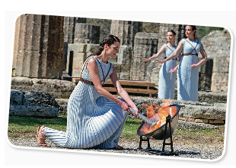
1. In ancient times, where were the Olympic Games held?
a) Olympia
b) Corinth
c) Delphi
d) Rome
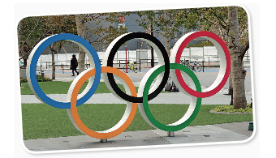
2. How many rings are there in the Olympic flag?
a) 4
b) 5
c) 7
d) 10
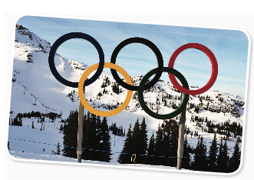
3. In what year was the first Winter Olympics held?
a) 1920
b) 1924
c) 1948
d) 1964

4. Which U.S. city was the first to host the modern Olympics?
a) Boston
b) Seattle
c) Portland
d) St. Louis

2. Which of these current Olympic sporting events
was also an event in the ancient Olympics?
a) Sailing
b) Football
c) Boxing
d) Weightlifting

3. Choose the sport that has been a demonstration
sport at the Olympics.
a) Surfing
b) Netball
c) Squash
d) Bowling

B. Fact or Fiction?
1. The colours of the Olympic rings are red, orange, yellow, gold, and blue. ______________
2. The Winter Olympics has more events than the Summer Olympics. ______________
3. Most Winter Olympic events are played on concrete. ______________
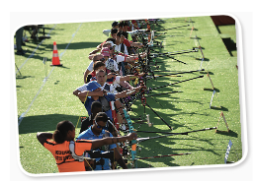
4. No Olympic Games have ever been held in a Spanish-speaking country. ______________
5. Several thousand archers participate in Olympic archery competitions. ______________
6. In Olympic women’s judo a match lasts for four minutes. ______________
7. The high jump is part of the decathlon. ______________
8. Only women are allowed to compete in the heptathlon. ______________
The Olympic Games: Fact or Fiction Quiz | Britannica
C. Over to you
What do the Olympic rings represent?
_______________________________________________________________________________________________
_______________________________________________________________________________________________
_______________________________________________________________________________________________

