Name |  | No. | Class
Date | Mark | Teacher

 Listen to William and complete the sentences about him. CD 5 Tracks 1 ● 2
A
A
1. Hello! I’m __________________ Emerson.
2. I’m __________________ years old.
3. I was born on __________________.
4. I was born in Boston. I’m __________________.
5. I’ve got an older __________________ and a __________________
called Rufus.
6. My __________________ is 35 Walker Street in Boston, USA.
7. My favourite hobby is __________________.
Listen to Mia talking about her day. Mark True (T) or False (F). CD 5 Tracks 3 ● 4
B
 | T |  | F
1. Mia’s school is in Oxford.
2. Mia goes to school on foot.
3. Mia has got a brother.
4. She’s at home at the moment.
5. Today the sun is shining.
6. Mia likes today’s lunch.

Name |  | No. | Class
Date | Mark | Teacher

Choose the correct option.
1. They are from the Netherlands. They are ___________________.
a. |  | Swedish | b. |  | Dutch | c. |  | Norwegian
2. My father’s wife is my ___________________.
a. |  | aunt | b. |  | sister | c. |  | mother
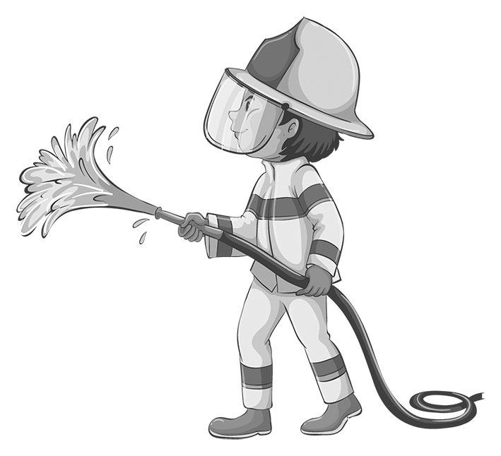
3. There is a fridge in the ___________________.
a. |  | living room | b. |  | kitchen | c. |  | bathroom
4. Our house has got two ___________________.
a. |  | downstairs | b. |  | floors | c. |  | upstairs
5. Alex has got ___________________ hair.
a. |  | moustache | b. |  | freckles | c. |  | curly
6. My father repairs cars. He is a ___________________.
a. |  | mechanic | b. |  | engineer | c. |  | firefighter
7. Julie’s favourite dessert is ___________________.
a. |  | broccoli | b. |  | roast chicken | c. |  | chocolate cake
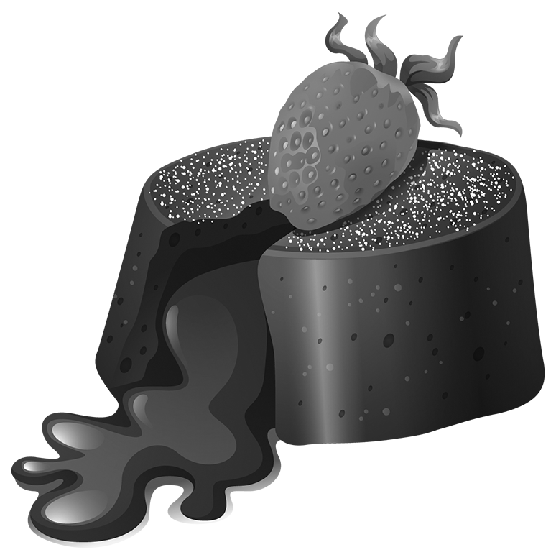
8. The opposite of hard-working is ___________________.
a. |  | rude | b. |  | lazy | c. |  | polite
9. I like learning about the past. My favourite subject is ___________________.
a. |  | art | b. |  | geography | c. |  | history
10. My neighbour’s house is on fire. I am going to call the ___________________!
a. |  | police station | b. |  | fire station | c. |  | train station
11. People go to the ___________________ to buy bread.
a. |  | baker’s | b. |  | butcher’s | c. |  | newsagent’s
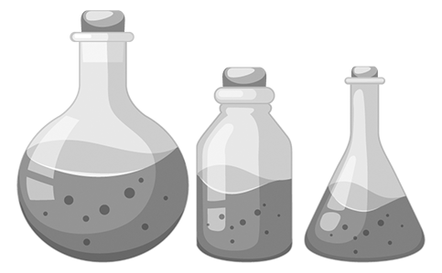
12. Tourists can buy presents at the ___________________ shop.
a. |  | souvenir | b. |  | pet | c. |  | music
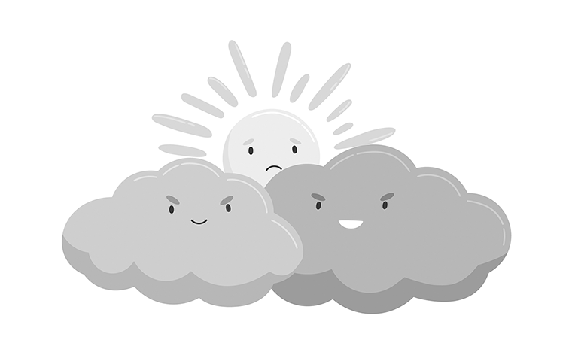
13. The students have got science in the ___________________.
a. |  | lab | b. |  | gym | c. |  | library
14. I’ve got a new book. I love ___________________.
a. |  | swimming | b. |  | running | c. |  | reading
15. There are lots of clouds in the sky. The weather is ___________________.
a. |  | sunny | b. |  | windy | c. |  | cloudy

Name |  | No. | Class
Date | Mark | Teacher

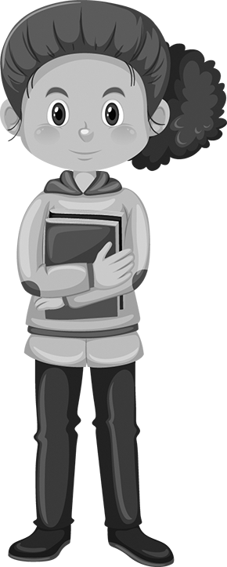
Choose the correct option.
1. I ___________________ twelve years old.
a. |  | is | b. |  | are | c. |  | am
2. ___________________ they English?
a. |  | Am | b. |  | Is | c. |  | Are
3. Susan ___________________ a new notebook.
a. |  | has got | b. |  | have got | c. |  | is

4. ___________________ he ___________________ a new maths book?
a. |  | Has… got | b. |  | Have… got | c. |  | Haven’t… got
5. Peter has got a dog. ___________________ dog is black.
a. |  | Her | b. |  | His | c. |  | Its
6. The students have got ___________________ books on the table.
a. |  | our | b. |  | her | c. |  | their
7. This is my parents’ car. It’s ___________________.
a. |  | mine | b. |  | theirs | c. |  | ours
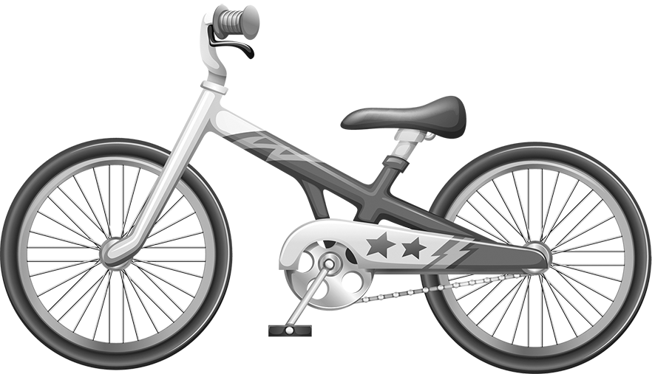
8. We’ve got new bikes. Look, these bikes are ___________________.
a. |  | theirs | b. |  | yours | c. |  | ours
9. ___________________ are you?
a. |  | What time | b. |  | When | c. |  | How old
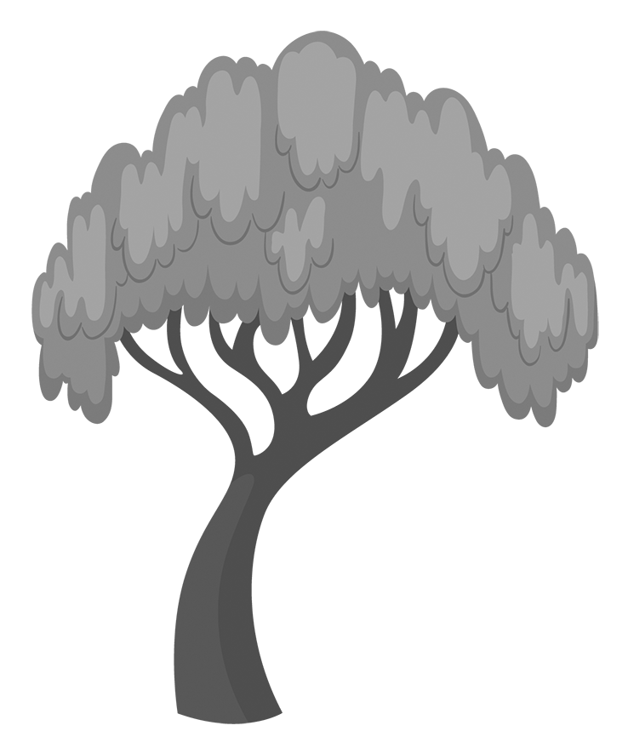
10. How many trees ___________________ in the garden?
a. |  | there is | b. |  | is there | c. |  | are there
11. This house is big but mine is ___________________ yours.
a. |  | big | b. |  | bigger than | c. |  | biggest
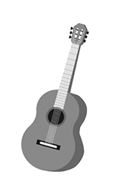
12. David is ___________________ boy in my class.
a. |  | the happiest | b. |  | happier than | c. |  | happy
13. Julie ___________________ at 7 o’clock.
a. |  | gets up | b. |  | get up | c. |  | get down
14. Where ___________________ John ___________________?
a. |  | do… live | b. |  | do… lives | c. |  | does… live
15. My brother ___________________ the guitar now.
a. |  | plays | b. |  | is playing | c. |  | play

