Name |  | No. | Class
Date | Mark | Teacher

Read the texts about Jordan and Azmina.
New in the neighbourhood
10
5
Hi! I’m Jordan Carson but my friends call me Jordy. I was born in Florida in the USA, but now I live in Brisbane, Australia with my parents and my twin brother Jacob.
Our birthday is on 27th August and we’re thirteen. We are both students in year 7 at St Patrick’s Elementary School.
I live in a nice house in 54 Carrington Road, Brisbane,
Australia. My mobile phone number is 856 735 937 and
my email address is jordy.carson@hotmail.com.
I sometimes watch football matches with my friends.
They are football fans and it’s my favourite sport.
In my free time I enjoy playing the drums, skateboarding
in the park and chatting online with friends. It’s very different from America, but I really like it here.

Hello! My name’s Azmina Safar and I’m from India. I’m sixteen years old and my birthday is on 7th February.
I live with my family in a small flat in the south of London in England. My address is 33 Leigham Court Road.
I haven’t got any brothers or sisters but I’ve got many friends, including my best friends Alison and Nicole. We do everything together!
We go to St Martin-in-the-Fields High School for
Girls and we’re in year 10. We aren’t in the same class but we meet in the playground during the breaks.
At weekends, they normally send me a text message to go for a walk in the park or go to the shopping centre.

15

20

25

Fill in the School ID Card with information about Jordan.
A
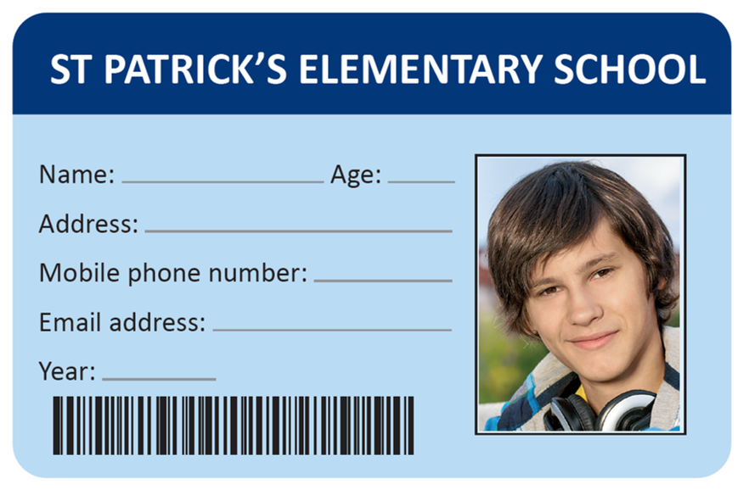
The following sentences are incorrect. Cross out the mistake and write the correct word. Follow the example.
Jordy
B
Jordan’s friends call him Jack.
1. Jordan was born in Kentucky, in the USA.
2. He has got a twin sister.
3. His birthday is in September.
4. He lives in a flat.
5. He goes snowboarding in the park.
Answer the questions about Azmina.
C
1. Where is Azmina from?

2. How old is she?

3. When is her birthday?

4. What is her address?

5. Has she got any brothers or sisters?

6. Who are Alison and Nicole?

7. What year are they in?

Name |  | No. | Class
Date | Mark | Teacher

Read the texts about Jordan and Azmina.
New in the neighbourhood
10
5
Hi! I’m Jordan Carson but my friends call me Jordy. I was born in Florida in the USA, but now I live in Brisbane, Australia with my parents and my twin brother Jacob.
Our birthday is on 27th August and we’re thirteen. We are both students in year 7 at St Patrick’s Elementary School.
I live in a nice house in 54 Carrington Road, Brisbane, Australia. My mobile phone number is 856 735 937 and my email address is jordy.carson@hotmail.com.
I sometimes watch football matches with my friends.
They are football fans and it’s my favourite sport.
In my free time I enjoy playing the drums, skateboarding in the park and chatting online with friends. It’s very different from America, but I really like it here.

Hello! My name’s Azmina Safar and I’m from India. I’m sixteen years old and my birthday is on 7th February.
I live with my family in a small flat in the south of London in England. My address is 33 Leigham Court Road.
I haven’t got any brothers or sisters but I’ve got
many friends, including my best friends Alison and Nicole. We do everything together!
We go to St Martin-in-the-Fields High School for
Girls and we’re in year 10. We aren’t in the same class but we meet in the playground during the breaks.
At weekends, they normally send me a text message to go for a walk in the park or go to the shopping centre.

15

20

25

Fill in the School ID Card with information about Jordan.
A
Correct the following sentences. Follow the example.
Jordy
B
Jordan’s friends call him Jack.
1. Jordan was born in Kentucky, in the USA.
2. He has got a twin sister.
3. His birthday is in September.
4. He lives in a flat.
5. He goes snowboarding in the park.
Complete the answers with information from the text.
C
1. Where is Azmina from?
She's from

2. How old is she?
She's

3. When is her birthday?
Her birthday is

4. What is her address?
Her address is

5. Has she got any brothers or sisters?
No,

6. Who are Alison and Nicole?
Alison and Nicole are

7. What year are they in?
They're in

Name |  | No. | Class
Date | Mark | Teacher
5
Read the text.
Michelle Obama
This is Michelle Obama! She’s an American lawyer and writer. Her birthday is on 17th January.
Her husband is Barack Obama and they live in a spectacular house near Washington D.C., in the USA.
But no, it’s not the White House!
5
Mrs Obama is tall and thin. She’s got wavy black hair and dark brown eyes. She is a very active and intelligent woman. She’s also very sociable and enjoys being around people, especially her family.
Her husband, Barack Obama, is tall and thin. He’s got dark skin and short grey hair. He’s hard-working and determined but can sometimes be stubborn. He’s good at making chili and loves collecting comics.
10
They’ve got two daughters, Malia and Natasha Obama. Malia is a student at Harvard University. She is extremely tall. She’s got long brown hair and brown eyes. Natasha, or Sasha, looks a lot like her sister, but they have got different personalities. Malia is shy and Sasha is very outgoing. Their mother says they have one thing in common: their intelligence and independence.
20
15
In her free time, Michelle Obama enjoys gardening, cooking, playing the piano, doing exercise and playing tennis against her husband.

Complete the table in note form with information from the text.
A
 | a. Physical description | b. Personality traits
1. Michelle Obama
2. Barack Obama
3. Malia
Match the beginnings with the correct endings.
B
Michelle Obama was | 1 | • |  | • | a | very outgoing.
Barack Obama | 2 | • |  | • | b | playing tennis.
Sasha is | 3 | • |  | • | c | intelligent and independent.
The girls are both very | 4 | • |  | • | d | born in the USA.
The Obamas like | 5 | • |  | • | e | loves cooking chili and collecting comic books.
Answer the questions about Michelle Obama.
C
1. What is her job?

2. When is her birthday?

3. Where is her house?

4. Is she married?

5. What are her free time activities?

Name |  | No. | Class
Date | Mark | Teacher

Read the text.
Michelle Obama
This is Michelle Obama! She’s an American lawyer and writer. Her birthday is on 17th January.
Her husband is Barack Obama and they live in a spectacular house near Washington D.C., in the USA.
But no, it’s not the White House!
5
Mrs Obama is tall and thin. She’s got wavy black hair and dark brown eyes. She is a very active and intelligent woman. She’s also very sociable and enjoys being around people, especially her family.
Her husband, Barack Obama, is tall and thin. He’s got dark skin and short grey hair. He’s hard-working and determined but can sometimes be stubborn. He’s good at making chili and loves collecting comics.
10
They’ve got two daughters, Malia and Natasha Obama. Malia is a student at Harvard University. She is extremely tall. She’s got long brown hair and brown eyes. Natasha, or Sasha, looks a lot like her sister, but they have got different personalities. Malia is shy and Sasha is very outgoing. Their mother says they have one thing in common: their intelligence and independence.
20
15
In her free time, Michelle Obama enjoys gardening, cooking, playing the piano, doing exercise and playing tennis against her husband.

Complete the table in note form with information from the text.
A
 | a. Physical description | b. Personality traits
1. Michelle Obama
2. Barack Obama
3. Malia
Complete the sentences with: Michelle, Barack, The Obamas, Malia, Sasha (x2).
B
1. __________________ Obama was born in the USA.
2. __________________ Obama loves cooking chili and collecting comic books.
3. __________________ is very outgoing.
4. __________________ and __________________ are both very intelligent and independent.
5. __________________ like playing tennis.
Answer the questions about Michelle Obama.
C
1. What is her job?
She is

2. When is her birthday?
Her birthday is

3. Where is her house?
Her house is

4. Is she married?
Yes,

5. What are her free time activities?
Her free time activities are

Name |  | No. | Class
Date | Mark | Teacher

Read the text.
Modern Family
5  10  15  20 | Modern Family is a very funny American television  show that shares the lives of three different types of families. Let’s learn a bit about one of them: the Dunphy family.  Claire and Phil Dunphy are the parents and they  are husband and wife. They have completely different personalities. Claire is a very determined and responsible person. Her husband, Phil, is a very funny person, but terrified of clowns. His favourite hobby is doing magic  tricks. Phil’s job is to sell houses.  Claire and Phil have got three children: Haley, Alex and Luke.  Haley is the oldest sister. She’s pretty, medium-height and always worried about her hair and makeup. Her favourite free time activity is shopping. Alex is the most intelligent person in the family. She’s got long black hair and she wears glasses. She loves reading books at home or even on holiday. Then there’s Luke, who is very clumsy and loves playing pranks on the family. He’s not very intelligent, so he sometimes asks his cousin Manny to help him with his homework. Luke and his father love playing video games, watching TV and playing sports together.  Phill and his kids are fans of technology. The family has great moments together.  The children also love spending time with their granddad, Jay, and his dog Stella. He has got a swimming pool in his garden and they all like having fun there.  Today is Sunday and they are all having a great time in Jay’s garden. The children are swimming, Jay and Phil are grilling hamburgers and Claire is reading a magazine.

Find out who…
A
1. doesn’t like clowns. __________________
2. likes technology a lot. __________________
3. has got a pet. __________________
4. thinks hair and makeup are important. __________________
5. helps Luke do his homework. __________________
6. enjoys magic. __________________
Are the following sentences True (T) or False (F)? Correct the false ones.
B
 | T |  | F
1. Phil and Claire have got two sons. | sdfsdfsdfsdfasdfasdfasdfasdfasdfsdfvaaaaaaggghhnnn | sdfsdfsdfsdfasdfasdfasdfasdfasdfsdfvaaaaaaggghhnnn |  | __________________
2. Haley is a tall girl. | sdfsdfsdfsdfasdfasdfasdfasdfasdfsdfvaaaaaaggghhnnn | sdfsdfsdfsdfasdfasdfasdfasdfasdfsdfvaaaaaaggghhnnn |  | __________________
3. In her free time, Haley loves shopping. | sdfsdfsdfsdfasdfasdfasdfasdfasdfsdfvaaaaaaggghhnnn | sdfsdfsdfsdfasdfasdfasdfasdfasdfsdfvaaaaaaggghhnnn |  | __________________
4. Alex and Luke have got a special relationship. | sdfsdfsdfsdfasdfasdfasdfasdfasdfsdfvaaaaaaggghhnnn | sdfsdfsdfsdfasdfasdfasdfasdfasdfsdfvaaaaaaggghhnnn |  | __________________
5. The children haven’t got a swimming pool. | sdfsdfsdfsdfasdfasdfasdfasdfasdfsdfvaaaaaaggghhnnn | sdfsdfsdfsdfasdfasdfasdfasdfasdfsdfvaaaaaaggghhnnn |  | __________________
Answer the questions about the text.
C
1. What is Modern Family?

2. What is Claire like?

3. Is Alex an only child?

4. Who is Manny?

5. What do Phil and his son like doing together?

6. Are they having fun in Jay’s garden?

7. What is Claire doing in Jay’s garden?

Name |  | No. | Class
Date | Mark | Teacher

Read the text.
Modern Family
5  10  15  20 | Modern Family is a very funny American television  show that shares the lives of three different types of families. Let’s learn a bit about one of them: the Dunphy family.  Claire and Phil Dunphy are the parents and they  are husband and wife. They have completely different personalities. Claire is a very determined and responsible person. Her husband, Phil, is a very funny person, but terrified of clowns. His favourite hobby is doing magic  tricks. Phil’s job is to sell houses.  Claire and Phil have got three children: Haley, Alex and Luke.  Haley is the oldest sister. She’s pretty, medium-height and always worried about her hair and makeup. Her favourite free time activity is shopping. Alex is the most intelligent person in the family. She’s got long black hair and she wears glasses. She loves reading books at home or even on holiday. Then there’s Luke, who is very clumsy and loves playing pranks on the family. He’s not very intelligent, so he sometimes asks his cousin Manny to help him with his homework. Luke and his father love playing video games, watching TV and playing sports together.  Phill and his kids are fans of technology. The family has great moments together.  The children also love spending time with their granddad, Jay, and his dog Stella. He has got a swimming pool in his garden and they all like having fun there.  Today is Sunday and they are all having a great time in Jay’s garden. The children are swimming, Jay and Phil are grilling hamburgers and Claire is reading a magazine.

Choose a name from the box and write it in the blanks. Find out who…
A
Manny Phil (x2) Haley Jay Phil and his kids
1. doesn’t like clowns. __________________
2. likes technology a lot. __________________
3. has got a pet. __________________
4. thinks hair and makeup are important. __________________
5. helps Luke do his homework. __________________
6. enjoys magic. __________________
Are the following sentences True (T) or False (F)?
B
 | T |  | F
1. Phil and Claire have got two sons. | sdfsdfsdfsdfasdfasdfasdfasdfasdfsdfvaaaaaaggghhnnn | sdfsdfsdfsdfasdfasdfasdfasdfasdfsdfvaaaaaaggghhnnn
2. Haley is a tall girl. | sdfsdfsdfsdfasdfasdfasdfasdfasdfsdfvaaaaaaggghhnnn | sdfsdfsdfsdfasdfasdfasdfasdfasdfsdfvaaaaaaggghhnnn
3. In her free time, Haley loves shopping. | sdfsdfsdfsdfasdfasdfasdfasdfasdfsdfvaaaaaaggghhnnn | sdfsdfsdfsdfasdfasdfasdfasdfasdfsdfvaaaaaaggghhnnn
4. Alex and Luke have got a special relationship. | sdfsdfsdfsdfasdfasdfasdfasdfasdfsdfvaaaaaaggghhnnn | sdfsdfsdfsdfasdfasdfasdfasdfasdfsdfvaaaaaaggghhnnn
5. The children haven’t got a swimming pool. | sdfsdfsdfsdfasdfasdfasdfasdfasdfsdfvaaaaaaggghhnnn | sdfsdfsdfsdfasdfasdfasdfasdfasdfsdfvaaaaaaggghhnnn
Answer the questions about the text.
C
1. What is Modern Family?
Modern Family is

2. What is Claire like?
Claire is

3. Is Alex an only child?
No,

4. Who is Manny?
Manny is

5. What do Phil and his son like doing together?
They like

6. Are they having fun in Jay’s garden?
Yes,

7. What is Claire doing in Jay’s garden?
Claire is

