Name |  | No. | Class
Date | Mark | Teacher

Find 12 sports in the word search.
A
V | F | S | M | Z | D | S | O | S | P | I | V | N | G | J
O | V | K | C | H | T | B | T | W | D | B | W | B | O | Z
L | I | I | U | F | E | A | I | I | F | A | I | W | L | D
L | T | I | W | O | N | S | L | M | L | D | Y | W | F | R
E | G | N | Q | C | N | K | S | M | S | M | G | L | E | U
Y | K | G | F | R | I | E | P | I | F | I | Y | F | Y | G
B | Z | G | T | G | S | T | W | N | Y | N | M | O | U | B
A | C | V | V | T | P | B | M | G | F | T | N | O | Q | Y
L | U | E | F | F | Y | A | A | Y | D | O | A | T | B | Z
L | P | D | P | V | D | L | D | F | K | N | S | B | D | U
I | Y | I | H | F | N | L | F | D | V | K | T | A | E | Q
Q | F | Y | L | K | I | Y | L | K | J | O | I | L | O | L
E | U | J | U | D | O | F | R | E | F | H | C | L | F | H
W | V | R | T | H | Y | U | U | F | L | L | S | E | T | G
I | C | E | S | K | A | T | I | N | G | H | S | G | K | W
Write the sports from the word search under the correct column.
B
1. play | 2. go | 3. do
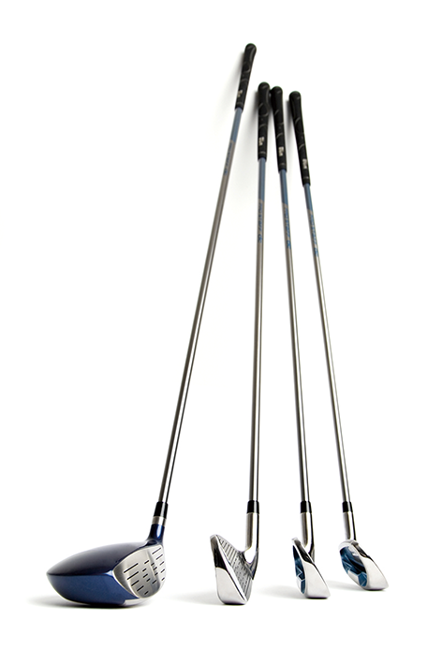
Write the missing vowels (a, e, i, o, u) of the sports equipment.
C
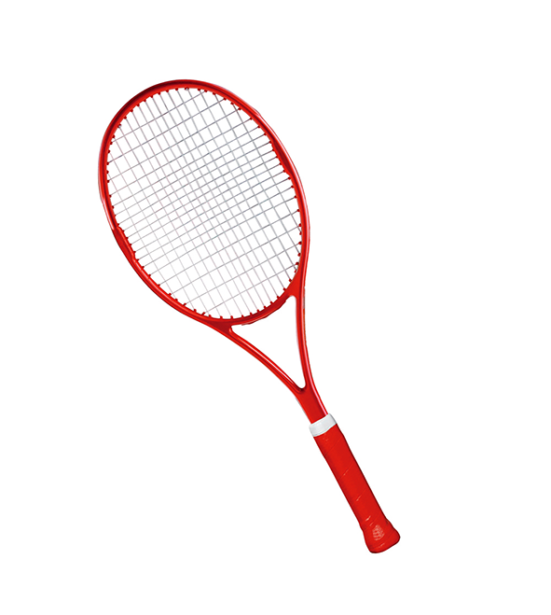 | 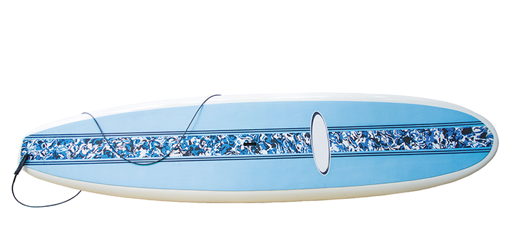
1. t_nn_s r_ck_t 2. s_rf b_ _rd 3. g_lf cl_bs

Name |  | No. | Class
Date | Mark | Teacher

Find 12 sports in the word search.
judo
football
basketball
rugby
volleyball
tennis
swimming
badminton
skiing
gymnastics
golf
ice skating
A
V | F | S | M | Z | D | S | O | S | P | I | V | N | G | J
O | V | K | C | H | T | B | T | W | D | B | W | B | O | Z
L | I | I | U | F | E | A | I | I | F | A | I | W | L | D
L | T | I | W | O | N | S | L | M | L | D | Y | W | F | R
E | G | N | Q | C | N | K | S | M | S | M | G | L | E | U
Y | K | G | F | R | I | E | P | I | F | I | Y | F | Y | G
B | Z | G | T | G | S | T | W | N | Y | N | M | O | U | B
A | C | V | V | T | P | B | M | G | F | T | N | O | Q | Y
L | U | E | F | F | Y | A | A | Y | D | O | A | T | B | Z
L | P | D | P | V | D | L | D | F | K | N | S | B | D | U
I | Y | I | H | F | N | L | F | D | V | K | T | A | E | Q
Q | F | Y | L | K | I | Y | L | K | J | O | I | L | O | L
E | U | J | U | D | O | F | R | E | F | H | C | L | F | H
W | V | R | T | H | Y | U | U | F | L | L | S | E | T | G
I | C | E | S | K | A | T | I | N | G | H | S | G | K | W
Write the sports from the word search under the correct column.
B
1. play | 2. go | 3. do
Match the photo with the correct sports equipment.
C
 | 1 | • |  | • | a | golf clubs
 | 2 | • |  | • | b | tennis racket
 | 3 | • |  | • | c | surfboard

