Name |  | No. | Class
Date | Mark | Teacher

Read the definitions and complete the table with types of holidays.
A
1. | sdfsdfsdfsdfasdfasdfasdfasdfasdfsdfvaaaaaaggghhnnn | sdfsdfsdfsdfasdfasdfasdfasdfasdfsdfvaaaaaaggghhnnn | sdfsdfsdfsdfasdfasdfasdfasdfasdfsdfvaaaaaaggghhnnn | sdfsdfsdfsdfasdfasdfasdfasdfasdfsdfvaaaaaaggghhnnn | sdfsdfsdfsdfasdfasdfasdfasdfasdfsdfvaaaaaaggghhnnn | sdfsdfsdfsdfasdfasdfasdfasdfasdfsdfvaaaaaaggghhnnn | sdfsdfsdfsdfasdfasdfasdfasdfasdfsdfvaaaaaaggghhnnn | sdfsdfsdfsdfasdfasdfasdfasdfasdfsdfvaaaaaaggghhnnn | sdfsdfsdfsdfasdfasdfasdfasdfasdfsdfvaaaaaaggghhnnn | sdfsdfsdfsdfasdfasdfasdfasdfasdfsdfvaaaaaaggghhnnn
2. | sdfsdfsdfsdfasdfasdfasdfasdfasdfsdfvaaaaaaggghhnnn | sdfsdfsdfsdfasdfasdfasdfasdfasdfsdfvaaaaaaggghhnnn | sdfsdfsdfsdfasdfasdfasdfasdfasdfsdfvaaaaaaggghhnnn | sdfsdfsdfsdfasdfasdfasdfasdfasdfsdfvaaaaaaggghhnnn | sdfsdfsdfsdfasdfasdfasdfasdfasdfsdfvaaaaaaggghhnnn | sdfsdfsdfsdfasdfasdfasdfasdfasdfsdfvaaaaaaggghhnnn
3. | sdfsdfsdfsdfasdfasdfasdfasdfasdfsdfvaaaaaaggghhnnn | sdfsdfsdfsdfasdfasdfasdfasdfasdfsdfvaaaaaaggghhnnn | sdfsdfsdfsdfasdfasdfasdfasdfasdfsdfvaaaaaaggghhnnn | sdfsdfsdfsdfasdfasdfasdfasdfasdfsdfvaaaaaaggghhnnn | sdfsdfsdfsdfasdfasdfasdfasdfasdfsdfvaaaaaaggghhnnn | sdfsdfsdfsdfasdfasdfasdfasdfasdfsdfvaaaaaaggghhnnn | sdfsdfsdfsdfasdfasdfasdfasdfasdfsdfvaaaaaaggghhnnn | sdfsdfsdfsdfasdfasdfasdfasdfasdfsdfvaaaaaaggghhnnn | sdfsdfsdfsdfasdfasdfasdfasdfasdfsdfvaaaaaaggghhnnn
4. | sdfsdfsdfsdfasdfasdfasdfasdfasdfsdfvaaaaaaggghhnnn | sdfsdfsdfsdfasdfasdfasdfasdfasdfsdfvaaaaaaggghhnnn | sdfsdfsdfsdfasdfasdfasdfasdfasdfsdfvaaaaaaggghhnnn | sdfsdfsdfsdfasdfasdfasdfasdfasdfsdfvaaaaaaggghhnnn | sdfsdfsdfsdfasdfasdfasdfasdfasdfsdfvaaaaaaggghhnnn | sdfsdfsdfsdfasdfasdfasdfasdfasdfsdfvaaaaaaggghhnnn | sdfsdfsdfsdfasdfasdfasdfasdfasdfsdfvaaaaaaggghhnnn | sdfsdfsdfsdfasdfasdfasdfasdfasdfsdfvaaaaaaggghhnnn | sdfsdfsdfsdfasdfasdfasdfasdfasdfsdfvaaaaaaggghhnnn | sdfsdfsdfsdfasdfasdfasdfasdfasdfsdfvaaaaaaggghhnnn | sdfsdfsdfsdfasdfasdfasdfasdfasdfsdfvaaaaaaggghhnnn | sdfsdfsdfsdfasdfasdfasdfasdfasdfsdfvaaaaaaggghhnnn | sdfsdfsdfsdfasdfasdfasdfasdfasdfsdfvaaaaaaggghhnnn | sdfsdfsdfsdfasdfasdfasdfasdfasdfsdfvaaaaaaggghhnnn | sdfsdfsdfsdfasdfasdfasdfasdfasdfsdfvaaaaaaggghhnnn | sdfsdfsdfsdfasdfasdfasdfasdfasdfsdfvaaaaaaggghhnnn | sdfsdfsdfsdfasdfasdfasdfasdfasdfsdfvaaaaaaggghhnnn | sdfsdfsdfsdfasdfasdfasdfasdfasdfsdfvaaaaaaggghhnnn
5. | sdfsdfsdfsdfasdfasdfasdfasdfasdfsdfvaaaaaaggghhnnn | sdfsdfsdfsdfasdfasdfasdfasdfasdfsdfvaaaaaaggghhnnn | sdfsdfsdfsdfasdfasdfasdfasdfasdfsdfvaaaaaaggghhnnn | sdfsdfsdfsdfasdfasdfasdfasdfasdfsdfvaaaaaaggghhnnn | sdfsdfsdfsdfasdfasdfasdfasdfasdfsdfvaaaaaaggghhnnn | sdfsdfsdfsdfasdfasdfasdfasdfasdfsdfvaaaaaaggghhnnn | sdfsdfsdfsdfasdfasdfasdfasdfasdfsdfvaaaaaaggghhnnn | sdfsdfsdfsdfasdfasdfasdfasdfasdfsdfvaaaaaaggghhnnn | sdfsdfsdfsdfasdfasdfasdfasdfasdfsdfvaaaaaaggghhnnn | sdfsdfsdfsdfasdfasdfasdfasdfasdfsdfvaaaaaaggghhnnn | sdfsdfsdfsdfasdfasdfasdfasdfasdfsdfvaaaaaaggghhnnn | sdfsdfsdfsdfasdfasdfasdfasdfasdfsdfvaaaaaaggghhnnn | sdfsdfsdfsdfasdfasdfasdfasdfasdfsdfvaaaaaaggghhnnn | sdfsdfsdfsdfasdfasdfasdfasdfasdfsdfvaaaaaaggghhnnn
1. A short holiday spent in the city.
2. To sail on a large ship and visit several different places.
3. A period of time where you experience living and working on a farm.
4. Holidays for doing new and exciting things like rock climbing.
5. Holidays to relax, sunbathe and enjoy the sea.
Label the photos with holiday activities.
B
1. ____________________ | 2. ____________________ | 3. ____________________
4. ____________________ | 5. ____________________ | 6. ____________________
Match the symbols about weather on the left with the words on the right.
C
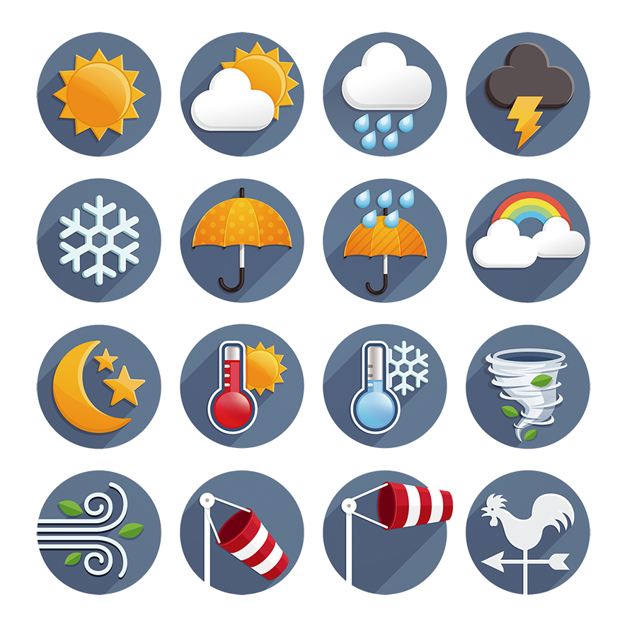 | 1 | • |  | • | a | rainy |  | 4 | • |  | • | d | acloudy
 | 2 | • |  | • | b | sunny |  | 5 | • |  | • | e | bhot
 | 3 | • |  | • | c | windy |  | 6 | • |  | • | f | csnowy

Name |  | No. | Class
Date | Mark | Teacher

Read the definitions and complete the table with types of holidays.
A
1. | c  sdfsdfsdfsdfasdfasdfasdfasdfasdfsdfvaaaaaaggghhnnn | sdfsdfsdfsdfasdfasdfasdfasdfasdfsdfvaaaaaaggghhnnn | sdfsdfsdfsdfasdfasdfasdfasdfasdfsdfvaaaaaaggghhnnn | sdfsdfsdfsdfasdfasdfasdfasdfasdfsdfvaaaaaaggghhnnn | sdfsdfsdfsdfasdfasdfasdfasdfasdfsdfvaaaaaaggghhnnn | b  sdfsdfsdfsdfasdfasdfasdfasdfasdfsdfvaaaaaaggghhnnn | sdfsdfsdfsdfasdfasdfasdfasdfasdfsdfvaaaaaaggghhnnn | sdfsdfsdfsdfasdfasdfasdfasdfasdfsdfvaaaaaaggghhnnn | sdfsdfsdfsdfasdfasdfasdfasdfasdfsdfvaaaaaaggghhnnn | sdfsdfsdfsdfasdfasdfasdfasdfasdfsdfvaaaaaaggghhnnn
2. | c  sdfsdfsdfsdfasdfasdfasdfasdfasdfsdfvaaaaaaggghhnnn | sdfsdfsdfsdfasdfasdfasdfasdfasdfsdfvaaaaaaggghhnnn | sdfsdfsdfsdfasdfasdfasdfasdfasdfsdfvaaaaaaggghhnnn | sdfsdfsdfsdfasdfasdfasdfasdfasdfsdfvaaaaaaggghhnnn | sdfsdfsdfsdfasdfasdfasdfasdfasdfsdfvaaaaaaggghhnnn | sdfsdfsdfsdfasdfasdfasdfasdfasdfsdfvaaaaaaggghhnnn
3. | f  sdfsdfsdfsdfasdfasdfasdfasdfasdfsdfvaaaaaaggghhnnn | sdfsdfsdfsdfasdfasdfasdfasdfasdfsdfvaaaaaaggghhnnn | sdfsdfsdfsdfasdfasdfasdfasdfasdfsdfvaaaaaaggghhnnn | sdfsdfsdfsdfasdfasdfasdfasdfasdfsdfvaaaaaaggghhnnn | sdfsdfsdfsdfasdfasdfasdfasdfasdfsdfvaaaaaaggghhnnn | sdfsdfsdfsdfasdfasdfasdfasdfasdfsdfvaaaaaaggghhnnn | sdfsdfsdfsdfasdfasdfasdfasdfasdfsdfvaaaaaaggghhnnn | sdfsdfsdfsdfasdfasdfasdfasdfasdfsdfvaaaaaaggghhnnn | sdfsdfsdfsdfasdfasdfasdfasdfasdfsdfvaaaaaaggghhnnn
4. | a  sdfsdfsdfsdfasdfasdfasdfasdfasdfsdfvaaaaaaggghhnnn | sdfsdfsdfsdfasdfasdfasdfasdfasdfsdfvaaaaaaggghhnnn | sdfsdfsdfsdfasdfasdfasdfasdfasdfsdfvaaaaaaggghhnnn | sdfsdfsdfsdfasdfasdfasdfasdfasdfsdfvaaaaaaggghhnnn | sdfsdfsdfsdfasdfasdfasdfasdfasdfsdfvaaaaaaggghhnnn | sdfsdfsdfsdfasdfasdfasdfasdfasdfsdfvaaaaaaggghhnnn | sdfsdfsdfsdfasdfasdfasdfasdfasdfsdfvaaaaaaggghhnnn | sdfsdfsdfsdfasdfasdfasdfasdfasdfsdfvaaaaaaggghhnnn | sdfsdfsdfsdfasdfasdfasdfasdfasdfsdfvaaaaaaggghhnnn | sdfsdfsdfsdfasdfasdfasdfasdfasdfsdfvaaaaaaggghhnnn | sdfsdfsdfsdfasdfasdfasdfasdfasdfsdfvaaaaaaggghhnnn | sdfsdfsdfsdfasdfasdfasdfasdfasdfsdfvaaaaaaggghhnnn | sdfsdfsdfsdfasdfasdfasdfasdfasdfsdfvaaaaaaggghhnnn | sdfsdfsdfsdfasdfasdfasdfasdfasdfsdfvaaaaaaggghhnnn | sdfsdfsdfsdfasdfasdfasdfasdfasdfsdfvaaaaaaggghhnnn | sdfsdfsdfsdfasdfasdfasdfasdfasdfsdfvaaaaaaggghhnnn | sdfsdfsdfsdfasdfasdfasdfasdfasdfsdfvaaaaaaggghhnnn | sdfsdfsdfsdfasdfasdfasdfasdfasdfsdfvaaaaaaggghhnnn
5. | b  sdfsdfsdfsdfasdfasdfasdfasdfasdfsdfvaaaaaaggghhnnn | sdfsdfsdfsdfasdfasdfasdfasdfasdfsdfvaaaaaaggghhnnn | sdfsdfsdfsdfasdfasdfasdfasdfasdfsdfvaaaaaaggghhnnn | sdfsdfsdfsdfasdfasdfasdfasdfasdfsdfvaaaaaaggghhnnn | sdfsdfsdfsdfasdfasdfasdfasdfasdfsdfvaaaaaaggghhnnn | sdfsdfsdfsdfasdfasdfasdfasdfasdfsdfvaaaaaaggghhnnn | h  sdfsdfsdfsdfasdfasdfasdfasdfasdfsdfvaaaaaaggghhnnn | sdfsdfsdfsdfasdfasdfasdfasdfasdfsdfvaaaaaaggghhnnn | sdfsdfsdfsdfasdfasdfasdfasdfasdfsdfvaaaaaaggghhnnn | sdfsdfsdfsdfasdfasdfasdfasdfasdfsdfvaaaaaaggghhnnn | sdfsdfsdfsdfasdfasdfasdfasdfasdfsdfvaaaaaaggghhnnn | sdfsdfsdfsdfasdfasdfasdfasdfasdfsdfvaaaaaaggghhnnn | sdfsdfsdfsdfasdfasdfasdfasdfasdfsdfvaaaaaaggghhnnn | sdfsdfsdfsdfasdfasdfasdfasdfasdfsdfvaaaaaaggghhnnn
1. A short holiday spent in the city.
2. To sail on a large ship and visit several different places.
3. A period of time where you experience living and working on a farm.
4. Holidays for doing new and exciting things like rock climbing.
5. Holidays to relax, sunbathe and enjoy the sea.
Label the following photos with the words in the box.
waterskiing
city tours
sunbathing
visit places of
interest
snorkelling
visit museums
B
1. ______________________ | 2. ______________________ | 3. ______________________
4. ______________________ | 5. ______________________ | 6. ______________________
Match the symbols about weather on the left with the words on the right.
C
 | 1 | • |  | • | a | rainy |  | 4 | • |  | • | d | acloudy
 | 2 | • |  | • | b | sunny |  | 5 | • |  | • | e | bhot
 | 3 | • |  | • | c | windy |  | 6 | • |  | • | f | csnowy

