Name |  | No. | Class
Date | Mark | Teacher

Read the definitions and write the correct type of house. Use the words in the word cloud. There are two extra words.
A
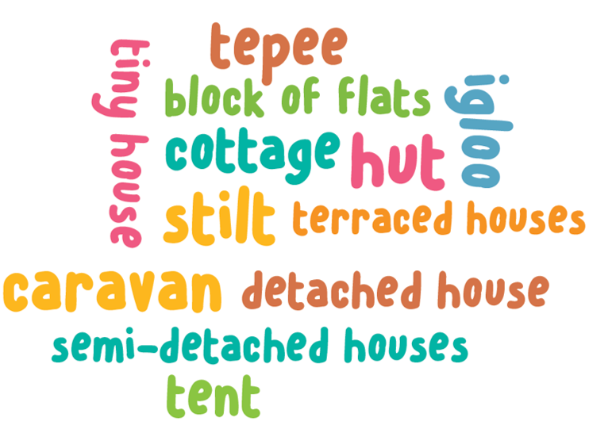
1. A row of similar houses joined together. ___________________
2. A small house usually in the countryside and surrounded by trees. ___________________
3. It is used when you go camping. ___________________
4. A house that is not joined to any other house. ___________________
5. A building with many flats on several floors. ___________________
6. A round tent of American Indians usually made from animal skin. ___________________
7. A vehicle used for living and travelling. ___________________
8. A building that has two houses side by side separated by a wall. ___________________
9. A small house with one or two rooms made of natural materials like wood or grass. ___________________
10. A house built on stilts above the surface of water. ___________________

Name |  | No. | Class
Date | Mark | Teacher

Read the definitions and choose the correct option.
A
1. A row of similar houses joined together.
a. | sdfsdfsdfsdfasdfasdfasdfasdfasdfsdfvaaaaaaggghhnnn | cottage | b. | sdfsdfsdfsdfasdfasdfasdfasdfasdfsdfvaaaaaaggghhnnn | terraced houses | c. | sdfsdfsdfsdfasdfasdfasdfasdfasdfsdfvaaaaaaggghhnnn | tiny house
2. A small house usually in the countryside and surrounded by trees.
a. | sdfsdfsdfsdfasdfasdfasdfasdfasdfsdfvaaaaaaggghhnnn | igloo | b. | sdfsdfsdfsdfasdfasdfasdfasdfasdfsdfvaaaaaaggghhnnn | cottage | c. | sdfsdfsdfsdfasdfasdfasdfasdfasdfsdfvaaaaaaggghhnnn | stilt
3. It is used when you go camping.
a. | sdfsdfsdfsdfasdfasdfasdfasdfasdfsdfvaaaaaaggghhnnn | semi-detached house | b. | sdfsdfsdfsdfasdfasdfasdfasdfasdfsdfvaaaaaaggghhnnn | block of flats | c. | sdfsdfsdfsdfasdfasdfasdfasdfasdfsdfvaaaaaaggghhnnn | tent
4. A house that is not joined to any other house.
a. | sdfsdfsdfsdfasdfasdfasdfasdfasdfsdfvaaaaaaggghhnnn | detached house | b. | sdfsdfsdfsdfasdfasdfasdfasdfasdfsdfvaaaaaaggghhnnn | terraced house | c. | sdfsdfsdfsdfasdfasdfasdfasdfasdfsdfvaaaaaaggghhnnn | block of flats
5. A building with many flats on several floors.
a. | sdfsdfsdfsdfasdfasdfasdfasdfasdfsdfvaaaaaaggghhnnn | block of flats | b. | sdfsdfsdfsdfasdfasdfasdfasdfasdfsdfvaaaaaaggghhnnn | tiny house | c. | sdfsdfsdfsdfasdfasdfasdfasdfasdfsdfvaaaaaaggghhnnn | stilt
6. A round tent of American Indians usually made from animal skin.
a. | sdfsdfsdfsdfasdfasdfasdfasdfasdfsdfvaaaaaaggghhnnn | cottage | b. | sdfsdfsdfsdfasdfasdfasdfasdfasdfsdfvaaaaaaggghhnnn | detached house | c. | sdfsdfsdfsdfasdfasdfasdfasdfasdfsdfvaaaaaaggghhnnn | tepee
7. A vehicle used for living and travelling.
a. | sdfsdfsdfsdfasdfasdfasdfasdfasdfsdfvaaaaaaggghhnnn | tiny house | b. | sdfsdfsdfsdfasdfasdfasdfasdfasdfsdfvaaaaaaggghhnnn | caravan | c. | sdfsdfsdfsdfasdfasdfasdfasdfasdfsdfvaaaaaaggghhnnn | semi-detached house
8. A building that has two houses side by side separated by a wall.
a. | sdfsdfsdfsdfasdfasdfasdfasdfasdfsdfvaaaaaaggghhnnn | semi-detached houses | b. | sdfsdfsdfsdfasdfasdfasdfasdfasdfsdfvaaaaaaggghhnnn | tent | c. | sdfsdfsdfsdfasdfasdfasdfasdfasdfsdfvaaaaaaggghhnnn | tepee
9. A small house with one or two rooms made of natural materials like wood or grass.
a. | sdfsdfsdfsdfasdfasdfasdfasdfasdfsdfvaaaaaaggghhnnn | terraced house | b. | sdfsdfsdfsdfasdfasdfasdfasdfasdfsdfvaaaaaaggghhnnn | caravan | c. | sdfsdfsdfsdfasdfasdfasdfasdfasdfsdfvaaaaaaggghhnnn | hut
10. A house built on stilts above the surface of water.
a. | sdfsdfsdfsdfasdfasdfasdfasdfasdfsdfvaaaaaaggghhnnn | cottage | b. | sdfsdfsdfsdfasdfasdfasdfasdfasdfsdfvaaaaaaggghhnnn | block of flats | c. | sdfsdfsdfsdfasdfasdfasdfasdfasdfsdfvaaaaaaggghhnnn | stilt

