TEST 2 UNIT 3 No Place Like Home
Name _____________________________________________ No. _________ Class _________
Date _____/_____/_____ Mark ___________________ Teacher __________________________

LISTENING

Celebrities at Home

A. Listen to the first part of the radio programme Celebrities at Home and number the pictures in the order they are mentioned. (4 x 1 = 4 points)
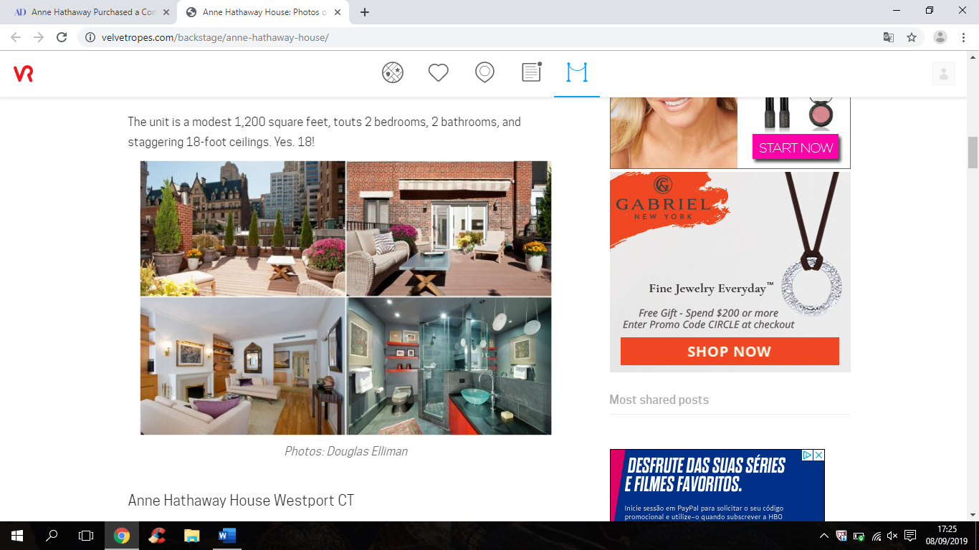
______ ______ ______ ______

B. Now, listen to the second part of the radio programme Celebrities at Home and complete the text. (8 x 2 = 16 points)
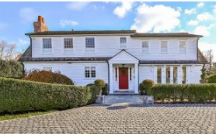
In December 2017, Anne and Adam bought a gorgeous house in Westport, Connecticut, by the seaside. The ¹____________________, built during the 1920s, was bought for over $2.79 million. It has got five ²____________________, six ³____________________ and two ⁴____________________. It is surely very spacious! One of the master bedrooms has got an open deck on the top ⁵____________________ of the house. There is also a ⁶____________________ in the backyard. Sadly, Anne and her husband have already sold the house.

In 2019, Anne and Adam bought a ⁷____________________ house in California. Are you curious about their new home? Don’t miss our next Celebrities at Home! We will tell you everything about the couple’s lovely ⁸____________________!

https://www.velvetropes.com/backstage/anne-hathaway-house/ (abridged and adapted)

TEST 2 UNIT 3 No Place Like Home
Name _____________________________________________ No. _________ Class _________
Date _____/_____/_____ Mark ___________________ Teacher __________________________

READING COMPREHENSION AND USE OF LANGUAGE

Anne Hathaway’s Country Home
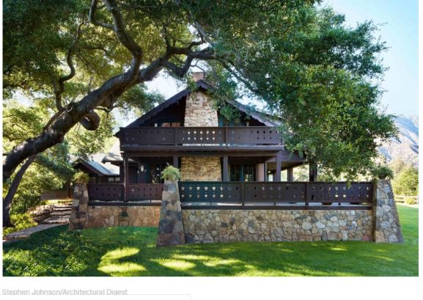
Anne Hathaway has shared a rare look inside her new home, where she lives with her husband Adam Schulman and their son Jonathan. The Oscar-winning actress, who is pregnant with the couple’s second child, lives in a unique cottage in the Californian countryside. She says they fell in love as soon as they first saw it. "It was the ideal combination of romance and great design. Our initial instinct was that this was going to be a very important place in our lives. I could really see myself raising a family here," said Anne.

The music room is Anne and Jonathan’s favourite spot in the house. The piano is there. There is also a table and comfortable seating for the couple’s guests. Anne explains: "This room is a place where the people we love can gather and our musician friends can play. It’s the heart of the house." With Kate Hudson, Emily Blunt and Matthew McConaughey among Anne’s celebrity friends, we’d love to be a fly on the wall at their gatherings!

That same spirit animates the kitchen, where a long island provides a perfect spot for guests to help with the food preparation. The kitchen opens directly onto a dreamy breakfast room.

Anne and Adam insist the true magic of their home rests in its rooms, the circular floor, and its subtle connections to the landscape. “This is a house with personality. When it’s just us and the baby, it feels very quiet. When there are lots of people around, it opens up with energy and fun,” Adam explains.

Anne says that when she has to concentrate intensely on a project, she can escape from the distractions of the outside world and find inspiration in the glorious mountains and the birds singing. There’s music inside and out.

A. Mark these sentences T (true) or F (false) according to the text. (5 x 2 = 10 points)
1. Anne lives with her husband and their son. ______
2. Anne is going to have a baby. ______
3. Anne and her family live in a flat in California. ______
4. The heart of the house is the kitchen. ______
5. There isn’t any room for the family breakfast. ______

B. Answer the questions on the text. (5 x 4 = 20 points)
1. Where does Anne live?
____________________________________________________________________________
2. What did Anne think when she first saw the house?
____________________________________________________________________________
3. What is Anne and Jonathan’s favourite place in the house?
____________________________________________________________________________
4. Why is the music room the heart of the house?
____________________________________________________________________________
5. Is the cottage the right place for Anne to concentrate herself on her projects? Why (not)?
____________________________________________________________________________
____________________________________________________________________________

C. Match the following words with their definitions. (5 x 1 = 5 points)
1. pregnant ______  2. countryside ______  3. spot ______  4. gatherings ______  5. subtle ______ |  | a. a particular place  b. parties or meetings where many people get together as a group  c. a woman that has a baby growing inside her body  d. not obvious; not easy to notice  e. the land of a rural area

D. Underline the correct option. (10 x 0.5 = 5 points)
1. Is Anne’s cottage / the Anne’s cottage in California?
2. Anne and her family want to live in a countryside / the countryside.
3. Has the cottage got an attic / a attic?
4. Are there some / any trees in the garden?
5. Is there the breakfast room / a breakfast room?
6. There are beautiful trees / the beautiful trees around the house.
7. Jonathan has got a elephant toy / an elephant toy that is very cute.
8. There is a piano / the piano in the music room.
9. Adam loves the vegetarian food / vegetarian food.
10. The cottage is in California / in the California, in the countryside.

E. Look at Anne’s living room and circle the correct answer. (10 x 1 = 10 points)
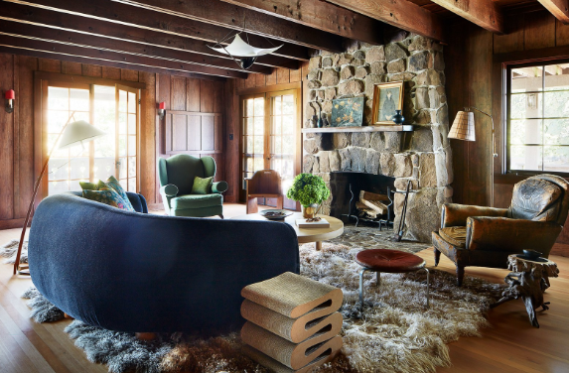
This is Anne’s living room. It’s a very cosy room with a big window and two French doors. When Anne is ¹on / at home and the weather is cold, she loves sitting ²in front of / behind the fireplace. ³Above/ Below the fireplace, ⁴in / on a shelf, there are two paintings. There’s a comfortable blue sofa and there are some pillows ⁵under / on it. There’s a coffee table ⁶behind / in front of the sofa. ⁷On / At the coffee table there are some books and a pot plant. There are also two stylish armchairs. Sometimes Anne sits ⁸under / on the sofa, reading film scripts. And she always tells Jonathan not to run ⁹across / through the room and to play quietly with his toys ¹⁰on / towards the rug.

F. Order the words and write sentences in the past simple. (5 x 2 = 10 points)
1. buy / Anne and Adam / a lovely cottage / . _________________________________________
2. they / renovate / the cottage / ? __________________________________________________
3. sign / Anne / a new contract / with Disney / . ________________________________________
4. not play / Jonathan / with his friends last weekend / . _________________________________
5. Jonathan / there to be / in the music room / ? ______________________________________

WRITING
A. In about 35-50 words, describe your dream home. (20 points)

__________________________________________________________________________
__________________________________________________________________________
__________________________________________________________________________
__________________________________________________________________________
__________________________________________________________________________
__________________________________________________________________________
__________________________________________________________________________

TEST 2 UNIT 3 No Place Like Home
Name _____________________________________________ No. _________ Class _________
Date _____/_____/_____ Mark ___________________ Teacher __________________________

SPEAKING

The speaking test is divided into two parts and there will be two students.

PART 1
5-6 minutes
In this part of the Speaking Test, each student will be asked personal questions related to the topic “No place like home”.
Suggested questions:
1. What’s your house like?
2. How many rooms are there?
3. What’s your favourite room?
4. Does your house have a garden? What’s it like?
5. Where is your house located? In the city? In the countryside?

PART 2
3-4 minutes (prompt card activity)
These photos were taken for a magazine article about Anne Hathaway’s new cottage. Student A will talk about Anne’s new kitchen and Student B will talk about Anne’s new bedroom.

Anne’s new kitchen.  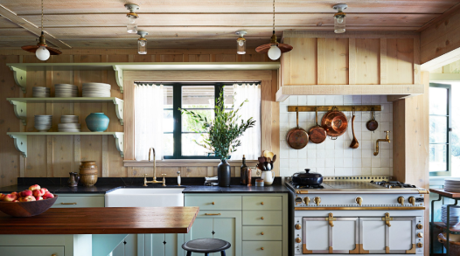 |  | Anne’s new bedroom.  