TEST 1 UNIT 1 Glad to be back!
Name ____________________________________________________ No. ___________ Class __________
Date _____/_____/_____ Mark ___________________ Teacher __________________________________

LISTENING

A. Listen and circle the words you hear. (10 x 1 = 10 points)

©Heineken https://www.heineken.com/When-you-drive-never-drink

WHEN YOU DRIVE NEVER DRINK
Heineken has a (1) new / few and very interesting campaign: “When You Drive, Never Drink”. Heineken wants people to (2) charge / change their behaviour when it comes to (3) drinking / thinking and driving. The campaign comes to (4) sight / life on television, digital and (5) social / total media platforms, and stars (6) 2006 / 2016 Formula One World Champion, Nico Rosberg. Because of his (7) experience / experiment as a racing (8) diver / driver, Nico (9) knows / says that even just one drink is too many when driving. People must be (10) respectful / responsible and always remember “When You Drive, Never Drink”.
https://www.heineken.com/za/WYDND (adapted)

B. Listen and complete the sentences about Nico Rosberg. (5 x 2 = 10 points)
1. Nico was born on ………………………………………………………………………………………………………………………………
2. He ………………………………………………………………………………………………………, but he was raised in Monaco.
3. His family is from Germany and Finland, but he considers …………………………………………………………………..
4. In his free time his passions include triathlon, ……………………………………………………………………………………
5. He also likes karaoke, ……………………………….………………………………………………………………………………………
http://www.nicorosberg.com/en (adapted)

TEST 1 UNIT 1 Glad to be back!
Name ____________________________________________________ No. ___________ Class __________
Date _____/_____/_____ Mark ___________________ Teacher __________________________________

READING COMPREHENSION AND USE OF LANGUAGE

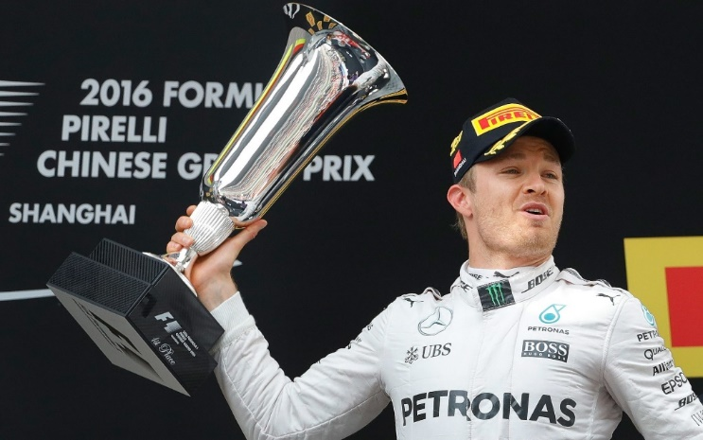  CREDIT: AP | NICO  Nico Erik Rosberg was born on 27th June 1985, in Germany. He was a Formula One racing driver and drove for Williams F1 and Mercedes AMG Petronas under the German flag.  He spent much of his youth in Monaco with his family, and he lives there now, with his wife and two daughters. He married his childhood friend and long-time fiancée Vivian Sibold in 2014. Their daughter, Alaïa, was born in 2015. Their second daughter, Naila, was born in 2017.
Apart from his native German, he speaks several languages fluently: English, French, Italian and (a little less fluently) Spanish. His father thought these languages would be important for Nico's life and racing career.
He entered Formula One in 2006 with Williams, the team with which his father had won the 1982 championship. After four years with Williams, in 2010, he joined the Mercedes team. He enjoyed his most successful period with Mercedes, winning 23 Grands Prix and earning 30 pole positions. In 2016, he became Formula One World Champion.
He announced that he was going to retire from the sport five days later, on 2nd December 2016, but that he would continue his partnership with Mercedes, as an ambassador.
https://en.wikipedia.org/wiki/Nico_Rosberg (abridged and adapted)

A. Match the halves of the sentences according to the text. (5 x 2 = 10 points)
1. Nico was born _____  2. He was _____  3. His wife is _____  4. He got _____  5. He has got _____ |  | a. Vivian Sibold.  b. married in 2014.  c. on 27th June 1985.  d. two daughters.  e. a Formula One racing driver.

B. Answer the questions on the text. (5 x 3 = 15 points)
1. Where was Nico born? ………………………………………………………………………………………………………………………….
2. Where does he live? ………………………………………………………….………………………………………………………………….
3. Who does he live with? ………………………………………………………………………………………………………………………….
4. Why did he learn so many languages? ……………………………………………………………………………………………………
5. Why was 2016 an important year to Nico? ……………………………………………………………………………………………

C. Match the following words/ expressions with their meanings. (5 x 1 = 5 points)
1. racing driver  2. youth  3. fluently  4. retire from the sport  5. partnership |  | a. very well  b. end his career  c. pilot  d. cooperation  e. adolescence

D. Complete the following paragraph about Nico. Use the words in the box and the correct verb forms.
(10 x 1 = 10 points)

be (3x) family wife daughter surname have got (3x)

Nico’s (1) …………………………… (2) …………………………… Rosberg. He (3) …………………………… blue eyes and blonde hair. He (4) …………………………… single, he is married. Vivian Sibold (5) …………………………… his (6)……………………………. They (7)…………………………… one (8)……………………………, they (9) …………………………… two nice little girls. They are a happy (10) …………………………….

E. Correct the following sentences. (5 x 2 = 10 points)
1. Vivian has got a car fast. …………………………………………………………………………………………………………………..
2. Vivian has got a pullover light green. ………………………………………………….……………………………………………..
3. Alaïa has got a yellow nice schoolbag. ……………………………………………………………………………………………….
4. Naila has got a teddy bear white. ……………………………………………………………………………………………………..
5. The children have got a room beautiful. ……………………………………………………………………………………………

F. Circle the right option. (5 x 1 = 5 points)
1. Nico has got many hobbies. His / He favourite hobby is photography.
2. Vivian is very kind. She / Her surname is Sibold.
3. Nico and Vivian have got two daughters. Their / They are Alaïa and Naila.
4. Naila has got a teddy bear. It / Its is Bo.
5. We are very happy. Our / We daughters are very happy, too.

G. Complete the paragraph, using the verbs in brackets in the present continuous. (5 x 1 = 5 points)
(1)……………… Nico and Vivian ………………..…….. (stay) at home this evening? No, they aren’t. Heineken (2)…………………………….. (give) a special party and they (3)……………………….. (have) fun at the party! They (4)…………………………….. (wear) very elegant clothes. Nico (5)…………………………….. (talk) about the campaign “When You Drive Never Drink”.

WRITING
A. In about 35-50 words, describe a person that you admire. Refer to: name, age, birthday, country, city, personality, physical appearance, occupation/ job and free time. (20 points)

…………………………………………………………………………………………………………………………………………………………………….
…………………………………………………………………………………………………………………………………………………………………….
…………………………………………………………………………………………………………………………………………………………………….
…………………………………………………………………………………………………………………………………………………………………….
…………………………………………………………………………………………………………………………………………………………………….
…………………………………………………………………………………………………………………………………………………………………….
…………………………………………………………………………………………………………………………………………………………………….
…………………………………………………………………………………………………………………………………………………………………….
…………………………………………………………………………………………………………………………………………………………………….
…………………………………………………………………………………………………………………………………………………………………….

TEST 1 UNIT 1 Glad to be back!
Name ____________________________________________________ No. ___________ Class __________
Date _____/_____/_____ Mark ___________________ Teacher __________________________________

SPEAKING

The speaking test is divided into two parts and there will be two students.

PART 1
5-6 minutes
In this part of the Speaking Test, each student will be asked personal questions: hometown, favourite subjects, sports, hobbies, etc.
Suggested questions:
1. Where do you live?
2. What’s your hometown like?
3. What are your favourite subjects?
4. What are your favourite sports?
5. What are your hobbies?

PART 2
3-4 minutes (prompt card activity)
Heineken’s Marketing Director is being interviewed because of the campaign “When You Drive, Never Drink”.
Student A: interview Heineken’s Marketing Director.
Student B: pretend to be Heineken’s Marketing Director.

INTERVIEWER
Hello / ! / how / you / be / ?
What / you / do / at / Heineken / ?
You / have / new / campaign / . / What / its objective / be / ?
Where / we / can see / campaign / ?
Why / Nico Rosberg / be / the star / of / campaign / ?
Thank / for / interview / !

HMD
I / be/ fine / . / Thank / you / !
I / be / Marketing Director / .
Heineken / want / people / not to drink / if / they / drive / .
You / can see / it / on television and on digital and social media platforms / .
Because / he / be / 2016 Formula One World Champion / and because of his experience as a pilot / .
You / be / welcome / !

