TEST 2 UNIT 3 No Place Like Home
Name _____________________________________________ No. _________ Class _________
Date _____/_____/_____ Mark ___________________ Teacher __________________________


LISTENING

A. Listen and match the halves of the lyrics. (8 x 1 = 8 points)

We keep this love in a photograph  1. We made these _____  2. Where our eyes _____  3. Hearts _____  4. And time's forever _____  5. So you can _____  6. Inside the pocket _____  7. Holding me closer _____  8. You won't ever be alone, _____ | a. are never broken  b. keep me  c. 'til our eyes meet  d. wait for me to come home  e. memories for ourselves  f. frozen still  g. are never closing  h. of your ripped jeans  Ed Sheeran, “Photograph” (shortened)

B. Listen and complete the paragraph. (6 x 2 = 12 points)

This is a photo of young Ed Sheeran playing the piano. It was taken in the cosy (1) l_____________ r___________ of his parents’ (2) h_______________. The piano is beautiful! On the piano there are some family photos. Next to the piano, on the right, there’s a comfortable (3) s_______________. On the left, there’s a small round table and on the table there’s a white (4) l_______________. Near the table there’s a (5) c_______________. Ed Sheeran is wearing a blue T-shirt and blue jeans, and he seems very happy. Probably, this “piano room” was his (6) f_______________ room in the house.

TEST 2 UNIT 3 No Place Like Home
Name _____________________________________________ No. _________ Class _________
Date _____/_____/_____ Mark ___________________ Teacher __________________________

READING COMPREHENSION AND USE OF LANGUAGE

“Sheeran-ville”
Ed Sheeran grew up with his family in Suffolk, a village just two hours outside London.
He is now a famous singer and songwriter, a superstar, but he still wants to live and raise his family in his quiet hometown. His love for Suffolk is not a secret and it was in this peaceful village that he found the perfect place to live with his future wife, Cherry Seaborn.
‘Ed is a super guy and really friendly. He is just a Suffolk boy at heart – so who can blame him for wanting to live here? It is a lovely part of the world.’, said one villager.
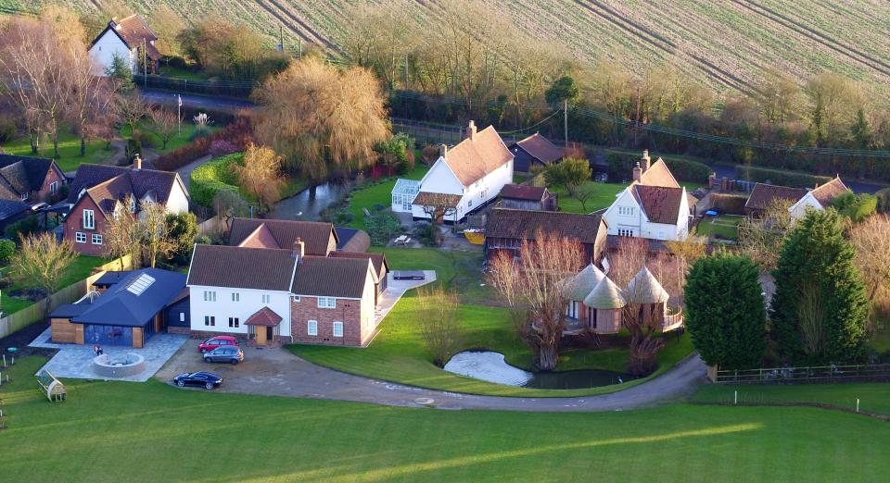 | The fact is that this Suffolk boy bought a large property with many houses: a country mansion, a large modern farmhouse, a detached house with four bedrooms, a giant treehouse and a bungalow. Sheeran also built a covered swimming pool, a pub (which was an old barn) and a new garage with space for four cars.
The lawn around the houses is very nice. The singer also has plans for two entertainment rooms – a cinema and a music room.
Ed Sheeran’s neighbours call this large property Sheeran-ville and say that as ‘he bought all the properties next door, there is nobody to complain if he plays his music too loudly.’
https://www.dailymail.co.uk/tvshowbiz/article-5302461/Ed-Sheeran-purchases-two-houses-mansion.html (abridged and adapted)

A. Mark these sentences T (true) or F (false). (5 x 2 = 10 points)
1. Suffolk is a village in London. ______
2. Ed Sheeran wants to raise his family in London. ______
3. Ed Sheeran’s property is quite small. ______
4. The pub was an old barn. ______
5. Ed Sheeran can park four cars in his new garage. ______

B. Answer the questions on the text. (5 x 4 = 20 points)
1. Where does Ed Sheeran want to live and raise his family?
…………………………………………………………………………………………………………………
2. What types of houses are there in “Sheeran-ville”?
…………………………………………………………………………………………………………………
3. How many bedrooms are there in the detached house?
…………………………………………………………………………………………………………………
4. Is there a swimming pool?
…………………………………………………………………………………………………………………
5. What rooms does the singer want to build?
…………………………………………………………………………………………………………………

C. Match the following words with their meanings/ definitions. (5 x 1 = 5)
1. barn ______  2. entertainment ______  3. property ______  4. complain ______  5. loudly ______ |  | a. noisily  b. express dissatisfaction about something  c. a large farm building used for housing animals and keeping grain, straw, as well as farm tools and equipment  d. amusement  e. a building or buildings and the land belonging to it or them

D. Find one mistake in each sentence and correct it. (5 x 1 = 5 points)
1. Where is the Ed Sheeran’s farmhouse?
…………………………………………………………………………………………………………………
2. He wants to live in a Suffolk.
…………………………………………………………………………………………………………………
3. Has the country mansion got a attic?
…………………………………………………………………………………………………………………
4. Are there some flowers in the garden?
…………………………………………………………………………………………………………………
5. There are any cars in the street.
…………………………………………………………………………………………………………………

E. Circle the correct answer . (10 x 1 = 10 points)
Ed Sheeran is (1) on / at home. He is (2) in / behind the study. It’s a very cosy room with one big window. There’s a desk and a bookcase. (3) Onto / On the desk there’s a laptop and a lamp. There’s a comfortable sofa and two armchairs, and there’s a coffee table (4) under / in front of the sofa. There’s a big painting (5) above / in the sofa and there are some photos (6) under / on the wall. Ed Sheeran is sitting (7) under / on the sofa, singing and playing the guitar. Some teenagers are outside the house, listening to the singer. Suddenly, they decide to run (8) across / through Sheeran’s lawn (9) towards / across his study. They knock on the window and wave. The nice singer invites them to come (10) onto / into the study.

F. Order the words and write sentences in the past simple. (5 x 2 = 10 points)
1. buy / Ed Sheeran / many houses / . …………………………………………………..…………………
2. he / renovate / the barn / ? ….……………………………………………………………………………
3. write / the singer / beautiful lyrics for a new song / . ……………………………………………………
4. not visit / he / his parents last weekend / . ……………………………………………….……………...
5. many teenagers / there + to be / outside the singer’s house/ ? ……………………………………….

WRITING
G. In about 35-50 words, describe your favourite room in the house. (20 points)

…………………………………………………………………………………………………………………
…………………………………………………………………………………………………………………
…………………………………………………………………………………………………………………
…………………………………………………………………………………………………………………
…………………………………………………………………………………………………………………
…………………………………………………………………………………………………………………
…………………………………………………………………………………………………………………
…………………………………………………………………………………………………………………

TEST 2 UNIT 3 No Place Like Home
Name _____________________________________________ No. _________ Class _________
Date _____/_____/_____ Mark ___________________ Teacher __________________________

SPEAKING

The speaking test is divided into two parts and there will be two students.

PART 1
5-6 minutes
In this part of the Speaking Test, each student will be asked personal questions related to the topic “No place like home”.
Suggested questions:
1. What’s your house like?
2. How many floors are there?
3. How many rooms are there?
4. Does it have a garden? What’s it like?
5. Where is your house located? In the city? In the countryside?

PART 2
3-4 minutes (prompt card activity)
Student A and Student B are interior designers and they will talk about their design projects for a new living room and bedroom.

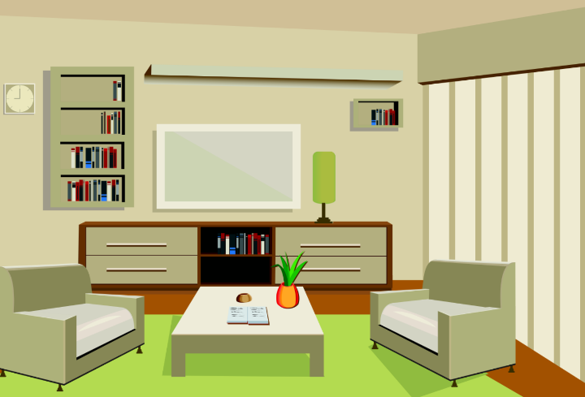  STUDENT A: Talk about your design project for a new living room. |  |   STUDENT B: Talk about your design project for a new bedroom.

