TEST 3 UNIT 5 My World
Name _____________________________________________ No. _________ Class _________
Date _____/_____/_____ Mark ___________________ Teacher __________________________

LISTENING

A. Listen to the song and order the lyrics. (4 x 2 = 8 points)
Penny Lane
1. ……………………………………………………..…………………………………………………..
the barber/ shaves / in Penny Lane / another customer

2. ………………………………………………………………………………………………..………..
waiting for a trim / the banker sitting / we see
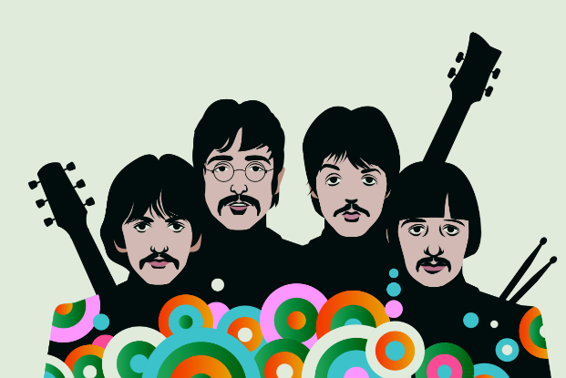
3. ………………………………………………………………………………………………..………..
the fireman / and then /rushes in
From the pouring rain, very strange
4. ……………………………………………………..…………………………………………………..
in my ears / is / Penny Lane / and in my eyes
There beneath the blue suburban skies
I sit, and meanwhile back
Penny lane is in my ears and in my eyes
There beneath the blue suburban skies
Penny Lane

The Beatles, “Penny Lane” (shortened)
https://www.thebeatles.com/videos/penny-lane

B. Listen and complete the paragraph. (6 x 2 = 12 points)
Penny Lane is a street in the (1) c…………………….. of Liverpool in the north of England. The (2) s…………………….. became popular in 1967 when the English rock group The Beatles released their song “Penny Lane”, written because the band members grew up in Liverpool. The Penny Lane area is nowadays very trendy and there are many university students in Liverpool who want to (3) l…………………….. there. There are many (4) t…………………….. shops in the street, such as Clarke's cake shop, as well as new businesses – healthy food (5) s…………………….., cafés, bars and (6) r……………………...
https://en.wikipedia.org/wiki/Penny_Lane,_Liverpool (abridged and adapted)
TEST 3 UNIT 5 My World
Name _____________________________________________ No. _________ Class _________
Date _____/_____/_____ Mark ___________________ Teacher __________________________

READING COMPREHENSION AND USE OF LANGUAGE

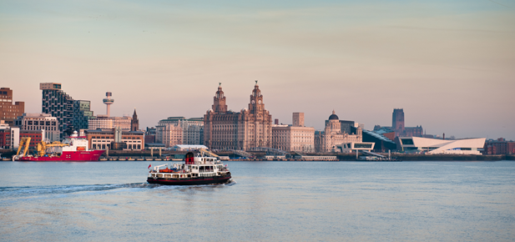
Liverpool

The Beatles and their popular songs are probably the first things to pop into your head when you think of Liverpool. But did you know that Liverpool is a Unesco World Heritage City and that Liverpool FC is the only British football club to win five European Cups? Not to mention all the fantastic attractions, museums, art galleries, restaurants, bars and afternoon tea hotspots.

The Museum of Liverpool is the right place to visit if you want to know more about this fabulous city, its rich history and culture. The Royal Liver Building is the city’s most famous landmark. The Merseyside Maritime Museum provides fun for all the family. You can also go on a ferry tour across Liverpool’s river; you’ll get a great view of the city.
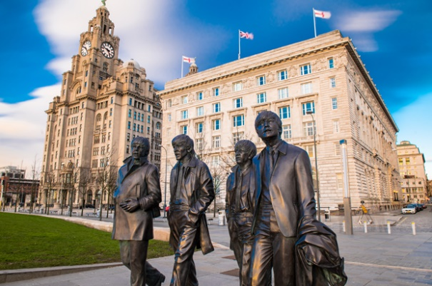
If you want to know more about the Beatles, you must visit the Beatles Story Experience Museum. You can also go on a walk tour and visit some places which were important to the band. You will find several shops selling Beatles souvenirs.

If you’re a football fan, make sure you visit Anfield stadium - Liverpool Football Club’s home stadium.

Sefton Park is the right spot for you if you love green spaces. There are also caves and waterfalls to discover if you're feeling adventurous.

And don’t miss the fun at Echo Arena! There are concerts, live sporting events, comedy shows and family-friendly performances waiting for you. You will have a great time there!

https://www.timeout.com/liverpool/things-to-do/best-things-to-do-in-liverpool (abridged and adapted)

A. Mark these sentences T (true) or F (false). (5 x 2 = 10 points)
1. When people think of Liverpool, they immediately think of the Beatles. _____
2. Liverpool FC and Everton won five European Cups. _____
3. Liverpool has a rich history and culture. _____
4. The Merseyside Maritime Museum is a nice place to go with your family. _____
5. It’s not possible for you to go on a ferry tour across Liverpool’s river. _____

B. Complete these sentences about the text. (5 x 4 = 20 points)
1. Tourists can find many ………………………………………………………….………… in Liverpool.
2. Liverpool’s most famous landmark………………………………………………………….…………..
3. If you want to know more about the Beatles, …...………………………………………………………
4. If you like green spaces, …...…………………………………………………….………………………
5. At Echo Arena there are ……………………………………………………………………….…………

C. Match the following words/ expressions with their definitions. (5 x 1 = 5)
1. World Heritage City _____  2. hotspots _____  3. landmark _____  4. souvenirs _____  5. waterfalls _____ |  | a. a building or monument of historical importance  b. things you buy to help you remember a holiday  c. a city that has special importance and should be protected  d. cascades of water falling from a height  e. popular places of entertainment

D. Circle the correct indefinite pronoun. (5 x 1 = 5 points)
1. The songs recorded by the Beatles are very popular. No one / Everyone knows them.
2. They’re going to ask someone / anyone for directions.
3. Did you take photos of anything / something during the ferry tour?
4. Somewhere / Everywhere in Sefton Park is green and quiet.
5. The concert at Echo Arena was a huge success. Nobody / Everybody was there.

E. Will, be going to or present continuous? Write the correct future form of the verbs in brackets. (5 x 2 = 10 points)
1. You ………………………………………. (find) fantastic attractions in Liverpool.
2. She ………………………………………. (buy) lovely Beatles souvenirs.
3. He ………………………………………. (take) a ferry trip tomorrow, at 10am.
4. I think Liverpool FC ………………………………………. (win) tonight.
5. They ………………………………………. (go) to a concert at Echo Arena tomorrow evening.

F. Complete these conditional sentences (type 1) with the correct form of the verbs in brackets. (5 x 2 = 10 points)
1. You will have a great time if you ………………………………………. (visit) Liverpool.
2. If they have time, they ………………………………………. (go) to the Merseyside Maritime Museum.

3. She ………………………………………. (get) a great view of Liverpool if she goes on a ferry tour across Liverpool’s river.
4. He ………………………………………. (not have) to queue anywhere if he buys a tourist pass.
5. If she ………………………………………. (go) on the Beatles walk tour, she will visit some places which were important to the band.

WRITING

G. Would you like to live in Liverpool? Why/ Why not? Write about 35-50 words. (20 points)

…………………………………………………………………………………………………………………
…………………………………………………………………………………………………………………
…………………………………………………………………………………………………………………
…………………………………………………………………………………………………………………
…………………………………………………………………………………………………………………
…………………………………………………………………………………………………………………
…………………………………………………………………………………………………………………
…………………………………………………………………………………………………………………
……………………………………………………………………………………………………………………………………………………………………………………………………………………………………
…………………………………………………………………………………………………………………
…………………………………………………………………………………………………………………

TEST 3 UNIT 5 My World
Name _____________________________________________ No. _________ Class _________
Date _____/_____/_____ Mark ___________________ Teacher __________________________

SPEAKING

The speaking test is divided into two parts and there will be two students.

PART 1
5-6 minutes
In this part of the Speaking Test, you will be asked some questions about your shopping habits.
Suggested questions:
1. Do you enjoy shopping? Why/ Why not?
2. Do you prefer small local shops or big shopping centres? Why?
3. How often do you go shopping?
4. What was the last thing you bought for yourself?
5. Are you saving to buy something? If so, what are you planning to buy?

PART 2
3-4 minutes (prompt card activity)
Student A will be a tourist who wants to go to Echo Arena and is asking for directions and Student B will be a nice police officer who is going to help the lost tourist.

STUDENT A - Tourist |  | STUDENT B – Police officer
- Excuse / please. / I / tickets / concert / Echo Arena. / Can / tell / how / can get there?  - it / far? / I / have to go / bus?  - Thank / you / much. |  | - along / street. At the end / street / the second turning / left and then / right.  - No, it / not far. /can go / foot. Echo Arena / next / the Wheel of Liverpool.  - You / welcome.

