Listening Test
Name No.: ______ Class: ________ Date: _____/ _____/ _____
Mark: ________________ Teacher: __________________________________ Enc. Educação: ______________________
1A6

- Listen and tick (✔) the correct answer to the questions.

- What inspired Lily to start skateboarding?
- A classmate taught her how to skate.
- She saw people skateboarding in the park.
- She watched a film that had an influence on her.

- What does Noah mean when he says, “I can’t survive a minute on a skateboard”?
  - He is too lazy to try.
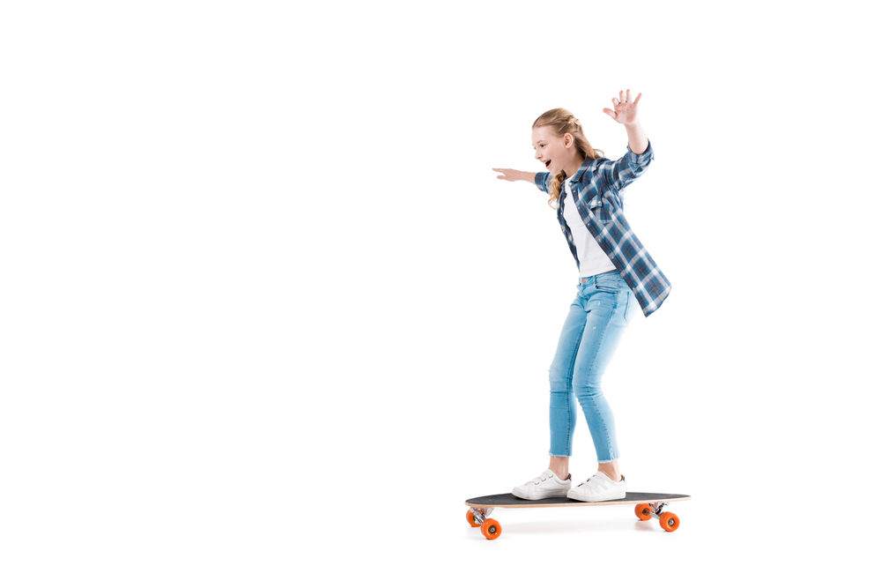
  - He thinks skateboarding is very difficult.
  - He has no interest in learning anything new.

- What does Lily suggest about falling while skateboarding?
- It’s part of the learning process.
- It is embarrassing and not fun.
- It makes her feel like a professional.

- What is Noah doing as a new hobby?
- Making videos for YouTube.
- Designing websites.
- Creating a computer game.

- What do both Lily and Noah say about their new hobbies?
- They are useful for school.
- They are better than doing nothing online.
- They help them become famous.

- Listen to two friends. Are the sentences true (T) or false (F)? Tick (✔) the correct column.
T
F

- Mia wants to meet up with Lucas instead of just chatting online.
- Lucas spent six hours on his phone.
- Mia spent the morning watching a TV series.
- Lucas only watched one short video on YouTube.
- Mia started a routine where she avoids using her phone in the evenings.
- Mia says that avoiding her phone after 7 p.m. helped her sleep better.
- Lucas is excited to try a full week without his phone.
- Mia tells Lucas to make small changes, not big ones.
Good work! 

Listening Test
Name No.: ______ Class: ________ Date: _____/ _____/ _____
Mark: ________________ Teacher: __________________________________ Enc. Educação: ______________________
1B6

- Listen and tick (✔) the correct answer to the questions.

- What inspired Lily to start skateboarding?
- She saw people skateboarding in the park.
- She watched a film that had an influence on her.

- What does Noah mean when he says, “I can’t survive a minute on a skateboard”?
- He is too lazy to try.
- He thinks skateboarding is very difficult.

- What does Lily suggest about falling while skateboarding?
- It’s part of the learning process.
- It makes her feel like a professional.

- What is Noah doing as a new hobby?
- Creating a computer game.
- Making videos for YouTube.

- What do both Lily and Noah say about their new hobbies?
- They are useful for school.
- They are better than doing nothing online.

- Listen to two friends. Are the sentences true (T) or false (F)? Tick (✔) the correct column.
There are THREE false sentences.
T
F

- Mia wants to meet up with Lucas instead of just chatting online.
- Lucas spent six hours on his phone.
- Mia spent the morning watching a TV series.
- Lucas only watched one short video on YouTube.
- Mia started a routine where she avoids using her phone in the evenings.
- Mia says that avoiding her phone after 7 p.m. helped her sleep better.
- Lucas is excited to try a full week without his phone.
- Mia tells Lucas to make small changes, not big ones.
Good work!

Reading Test
Name No.: ______ Class: ________ Date: _____/ _____/ _____
Mark: ________________ Teacher: __________________________________ Enc. Educação: ______________________
1A6

Read the article.

Three unique teen hobbies

Disc golf

Lacey Brugler is a 16-year-old high school student from Ohio. She spends her free time playing disc golf, a sport in which individual players throw a flying disc at a target to traverse¹ a course in the fewest number of throws of the disc. “It’s an awesome sport, and you can get a lot of exercise,” she says. Lacey’s family supports her hobby. She learned how to play disc golf 11 years ago with her dad and her sister and has loved it ever since. Lacey is on three disc golf teams, won 57 tournaments, is a national champion and a two-time world champion! Her secret? “I study the courses before I play them!”
5

10

15

20

25

Robotics

Haley Donovan is a 14-year-old student from South Carolina. In eighth grade, she joined the First Lego League (FLL). “Robotics gave me a new experience,” she says. “It taught me about programming and engineering and it’s my first time on a team working together with others to achieve a goal². We learned together, we celebrated together and we accepted loss together.” Haley now competes in the First Robotics Competition (FRC) and is on team FIRE. She meets with her team three times a week. Because Haley spends so much time building with her team, her experience with robotics gave her strong communication skills.

Woodworking
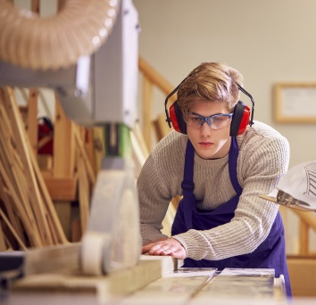
Mason is a 16-year-old student from Ohio. When he was 14, he was having a class at a Woodcraft Store when he first realised how great that hobby could be. He likes that he “can make his own stuff with professional quality.” Mason learned measuring, planning, safety and various finishing techniques as well as fine carpentry skills. He advises someone who wants to start woodworking to “invest in quality tools.” Mason also practises knife making, sharpening blades and leather work.

https://learningliftoff.com/curriculum/reading-and-writing/three-unique-teen-hobbies-that-might-surprise-you/
(adapted; accessed in August 2025)
Vocabulary:
¹ traverse = cross; ² achieve a goal = get to an objective

- Match each description with the correct teenager. Tick (✔) the correct name.

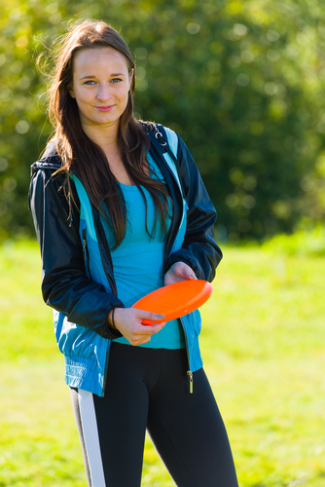


Lacey

Haley
Mason

- He/She won many tournaments.
- He/She was fourteen years old when he/she had the first contact with the hobby.
- He/She enjoys woodworking and learned carpentry in a class.
- He/She studies the courses carefully before playing.
- He/She competes in robotics competitions such as FLL and FRC.

- Answer the questions about the article.

- How old was Lacey when she first started playing disc golf?
________________________________________________________________________
________________________________________________________________________

- How often does Haley meet with her robotics team?
________________________________________________________________________
________________________________________________________________________

- What skills did Haley gain from her robotics experience besides programming and engineering?

________________________________________________________________________
________________________________________________________________________

- What advice does Mason give to beginners in woodworking?
________________________________________________________________________
________________________________________________________________________

Good work!

Language Test
Name No.: ______ Class: ________ Date: _____/ _____/ _____
Mark: ________________ Teacher: __________________________________ Enc. Educação: ______________________
1A6

- Label the pictures with hobbies and free time activities.
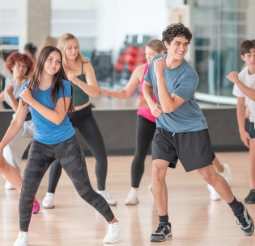




1. _________________ 2. _________________ 3. _________________ 4. ________________

- Complete the text with the words/expressions from the box. There are three extra words/expressions.
oven wake up have breakfast go to school laundry room
do homework brush my teeth go to bed lift

I usually ¹ ___________________ at 7 o’clock. Then I go to the bathroom to
² ___________________. After that, I sit with my family to ³ ______________________.
At 8 o’clock, I leave home and ⁴ ______________________. In the afternoon, I often
⁵ ________________________ before watching TV.
In the evening, my mum prepares dinner in the kitchen. Finally, I usually ⁶ ____________
at around 10 p.m.


- Circle the correct pronoun/determiner to complete the sentences.

- Lacey studies the disc golf courses before playing. Studying them helps her / she / hers win more tournaments.

- Haley’s robotics team meets regularly. Theirs / Their / Them teamwork makes them stronger.

- Mason makes furniture in the workshop. That table is his / him / he.
- I usually wake up early and have breakfast in me / mine / my kitchen.
- My brother hates doing homework, but I don’t mind doing his / my / mine.
- Look! The lights are on. Can you turn it / them / their off, please?

- Tick (✔) the correct present simple or present continuous verb form to complete the sentences.

- Lacey usually _________________ to the park after school.
a) is going b) goes c) going

- Look! Mason __________________ a new chair in his workshop right now.
a) makes b) is making c) make

- Haley’s team always ___________________ three times a week.
a) meets b) meeting c) is meeting

- I __________________ my outfit for tomorrow at the moment.
a) prepare b) prepares c) am preparing

- Complete the sentences with the past continuous of the verbs in brackets.

- Yesterday at 6 p.m., I ___________________ (do) my homework in the kitchen.
- Mason ___________________ (work) on a new wooden chair yesterday at 5 p.m.
- While we ___________________ (walk) to school, it suddenly started to rain.
- Haley _____________________ (not pay) attention because she ___________________ (think) about the robotics competition.

- Complete the sentences with the past simple or past continuous form of the verbs in brackets.

- I ____________________ (watch) TV when the lights suddenly ______________ (go) off.
- Yesterday at 5 p.m. Mason _____________________ (measure) the wood while his friend ________________ (hold) the tools.
- Lacey ________________ (play) disc golf when she _______________ (hurt) her hand.
- We ________________________ (not study) in the living room when my mum ________________ (come) in with some snacks.
- Haley _____________________ (work) on the robot when one part suddenly ________________ (break).

Good work!

Writing Test
Name No.: ______ Class: ________ Date: _____/ _____/ _____
Mark: ________________ Teacher: __________________________________ Enc. Educação: ______________________
1A6

Choose ONE of the following topics and write a short text about it (50-90 words).

- Write about one hobby you enjoy or would like to try. Include details such as:
- how/when you started (or why you want to try it);
- how often you do it and who with;
- what materials or equipment you need;
- what you like about it and what is sometimes difficult;
- how this hobby makes your life better.

- Your school newspaper is asking students to write about “How I spend my free time.” Write an article following the guidelines below:

- describe your favourite hobby and when you usually do it;
- compare it with another hobby you don’t like;
- explain why hobbies are important for teenagers.

Topic: ________
_____________________________________________________________________
_____________________________________________________________________
_____________________________________________________________________
_____________________________________________________________________
_____________________________________________________________________
_____________________________________________________________________
_____________________________________________________________________
____________________________________________________________________
_____________________________________________________________________
_____________________________________________________________________
_____________________________________________________________________
_____________________________________________________________________

Good work!

Reading Test
Name No.: ______ Class: ________ Date: _____/ _____/ _____
Mark: ________________ Teacher: __________________________________ Enc. Educação: ______________________
1B6

Read the article.

Three unique teen hobbies

Disc golf
Lacey Brugler is a 16-year-old high school student from Ohio. She spends her free time playing disc golf, a sport in which individual players throw a flying disc at a target to traverse¹ a course in the fewest number of throws of the disc. “It’s an awesome sport, and you can get a lot of exercise,” she says. Lacey’s family supports her hobby. She learned how to play disc golf 11 years ago with her dad and her sister and has loved it ever since. Lacey is on three disc golf teams, won 57 tournaments, is a national champion and a two-time world champion! Her secret? “I study the courses before I play them!”
5

10

15

20

25

Robotics
Haley Donovan is a 14-year-old student from South Carolina. In eighth grade, she joined the First Lego League (FLL). “Robotics gave me a new experience,” she says. “It taught me about programming and engineering and it’s my first time on a team working together with others to achieve a goal². We learned together, we celebrated together and we accepted loss together.” Haley now competes in the First Robotics Competition (FRC) and is on team FIRE. She meets with her team three times a week. Because Haley spends so much time building with her team, her experience with robotics gave her strong communication skills.

Woodworking
Mason is a 16-year-old student from Ohio. When he was 14, he was having a class at a Woodcraft Store when he first realised how great that hobby could be. He likes that he “can make his own stuff with professional quality.” Mason learned measuring, planning, safety and various finishing techniques as well as fine carpentry skills. He advises someone who wants to start woodworking to “invest in quality tools.” Mason also practises knife making, sharpening blades and leather work.

https://learningliftoff.com/curriculum/reading-and-writing/three-unique-teen-hobbies-that-might-surprise-you/
(adapted; accessed in August 2025)
Vocabulary:
¹ traverse = cross; ² achieve a goal = get to an objective

- Circle the teenager that matches each description.

- He/She won many tournaments: Mason / Lacey
- He/She was fourteen years old when he/she had the first contact with the hobby: Haley / Mason
- He/She enjoys woodworking and learned carpentry in a class: Lacey / Mason
- He/She studies the courses carefully before playing: Haley / Lacey
- He/She competes in robotics competitions such as FLL and FRC: Mason / Haley

- Tick (✔) the correct answer to the questions.

- How old was Lacey when she first started playing disc golf?
- She was five years old.
- She was fifteen years old.
- She was fourteen years old.

- How often does Haley meet with her robotics team?
- They meet every month.
- They meet twice a week.
- They meet three times a week.

- What skills did Haley gain from her robotics experience besides programming and engineering?

- She gained carpentry skills.
- She gained communication skills.
- She gained robotics skills.

- What advice does Mason give to beginners in woodworking?
- Beginners should invest in quality tools.
- Beginners should have measuring skills.
- Beginners should be patient.
Good work!

Language Test
Name No.: ______ Class: ________ Date: _____/ _____/ _____
Mark: ________________ Teacher: __________________________________ Enc. Educação: ______________________
1B6

- Circle the correct hobby/free time activity to label the pictures.

1. sleeping / reading 2. dancing / drawing 3. gaming / relaxing 4. playing the guitar /
listening to music

- Complete the text with the words/expressions from the box.

wake up have breakfast go to school
do homework brush my teeth go to bed

I usually ¹ ___________________ at 7 o’clock. Then I go to the bathroom to
² ___________________. After that, I sit with my family to ³ ______________________.
At 8 o’clock, I leave home and ⁴ ______________________. In the afternoon, I often
⁵ ________________________ before watching TV.
In the evening, my mum prepares dinner in the kitchen. Finally, I usually ⁶ ____________
at around 10 p.m.

- Circle the correct pronoun/determiner to complete the sentences.

- Lacey studies the disc golf courses before playing. Studying them helps her / she win more tournaments.

- Haley’s robotics team meets regularly. Theirs / Their teamwork makes them stronger.

- Mason makes furniture in the workshop. That table is his / him.
- I usually wake up early and have breakfast in mine / my kitchen.
- My brother hates doing homework, but I don’t mind doing mine / him.
- Look! The lights are on. Can you turn it / them off, please?

- Tick (✔) the correct present simple or present continuous verb form to complete the sentences.

- Lacey usually _________________ to the park after school.
a) is going b) goes

- Look! Mason __________________ a new chair in his workshop right now.
a) makes b) is making

- Haley’s team always ___________________ three times a week.
a) meets b) is meeting

- I __________________ my outfit for tomorrow at the moment.
a) prepare b) am preparing
- Circle the correct option to complete the sentences with the past continuous.

- Yesterday at 6 p.m., I were doing / was doing my homework in the kitchen.
- Mason is working / was working on a new wooden chair yesterday at 5 p.m.
- While we were walking / was walking to school, it suddenly started to rain.
- Haley wasn’t paying / wasn’t pay attention because she was think / was thinking about the robotics competition.
- Circle the correct option to complete the sentences with the past simple or past continuous.

- I was watching / watched TV when the lights suddenly were going / went off.
- Yesterday at 5 p.m. Mason was measuring / measured the wood while his friend was holding / held the tools.
- Lacey played / was playing disc golf when she hurt / was hurting her hand.
- We didn’t study / weren’t studying in the living room when my mum was coming / came in with some snacks.

- Haley worked / was working on the robot when one part suddenly was breaking / broke.

Good work!

Writing Test
Name No.: ______ Class: ________ Date: _____/ _____/ _____
Mark: ________________ Teacher: __________________________________ Enc. Educação: ______________________
1B6

Complete the text about a hobby you enjoy. Follow the instructions in brackets.

A hobby I really enjoy is __________________________ (hobby you enjoy). I started when I was ____________________ (your age when you started the hobby) because _____________________________________ (reason why you started). I usually practise it ______________________ (how often you do it) with _________________________ (who you do it with).
All I need is ___________________________________________________ (what you need to do it).
I like it because _____________________________________ (what you like about it).
_______________________ (your hobby) makes my life __________________________ (how this hobby makes your life).

Good work!

Reading Test
Name No.: ______ Class: ________ Date: _____/ _____/ _____
Mark: ________________ Teacher: __________________________________ Enc. Educação: ______________________
1C6

Read the article. (Lê o artigo.)

Two unique teen hobbies

Disc golf
Lacey Brugler is a 16-year-old high school student from Ohio. She spends her free time playing disc golf, a sport in which individual players throw a flying disc at a target to traverse¹ a course in the fewest number of throws of the disc. “It’s an awesome sport, and you can get a lot of exercise,” she says. Lacey’s family supports her hobby. She learned how to play disc golf 11 years ago with her dad and her sister and has loved it ever since. Lacey is on three disc golf teams, won 57 tournaments, is a national champion and a two-time world champion! Her secret? “I study the courses before I play them!”
5

10

15

Robotics
Haley Donovan is a 14-year-old student from South Carolina. In eighth grade, she joined the First Lego League (FLL). “Robotics gave me a new experience,” she says. “It taught me about programming and engineering and it’s my first time on a team working together with others to achieve a goal². We learned together, we celebrated together and we accepted loss together.” Haley now competes in the First Robotics Competition (FRC) and is on team FIRE. She meets with her team three times a week. Because Haley spends so much time building with her team, her experience with robotics gave her strong communication skills.

https://learningliftoff.com/curriculum/reading-and-writing/three-unique-teen-hobbies-that-might-surprise-you/
(adapted; accessed in August 2025)
Vocabulary:
¹ traverse = atravessar
² achieve a goal = atingir um objetivo

- Tick (✔) the correct answer to the questions. (Assinala a resposta correta às perguntas.)

- How old was Lacey when she first started playing disc golf?
- She was five years old.
- She was fifteen years old.
- She was fourteen years old.

- How does Lacey prepare before playing in disc golf tournaments?
- She practises with her coach.
- She studies the courses before playing.
- She watches videos online.

- What does Haley enjoy most about robotics?
- Building robots alone.
- Travelling to competitions.
- Working together with her team.

- How often does Haley meet with her robotics team?
- They meet every month.
- They meet twice a week.
- They meet three times a week.

- What skills did Haley gain from her robotics experience besides programming and engineering?

- She gained carpentry skills.
- She gained communication skills.
- She gained robotics skills.

Good work!

Language Test
Name No.: ______ Class: ________ Date: _____/ _____/ _____
Mark: ________________ Teacher: __________________________________ Enc. Educação: ______________________
1C6

- Circle the correct hobby/free time activity to label the pictures.
(Rodeia o passatempo/atividade de tempo livre correta para legendares as imagens.)

1. sleeping / reading 2. dancing / drawing 3. gaming / relaxing 4. playing the guitar /
listening to music

- Circle the correct word/expression to complete the text.
(Rodeia a palavra/expressão correta para completares o texto.)
I usually ¹ wake up / go to bed at 7 o’clock. Then I go to the bathroom to
² have breakfast / brush my teeth. After that, I sit with my family to ³ have dinner /
have breakfast.
At 8 o’clock, I leave home and ⁴ go to school / do my homework. In the afternoon,
I often ⁵ have lunch / do homework before watching TV.
In the evening, my mum prepares dinner in the kitchen. Finally, I usually ⁶ make my bed / go to bed at around 10 p.m.

- Circle the correct pronoun/determiner to complete the sentences.

(Rodeia o pronome/determinante correto para completares as frases.)
Possessive determiners
my
your
his
her
its
our
your
their

Possessive pronouns
mine
yours
his
hers
its
ours
yours
theirs

Object pronouns
me
you
him
her
it
us
you
them

The book is
mine.

Give me the book.
This is my
book.

- Lacey studies the disc golf courses before playing. Studying them helps her / she win more tournaments.

- Haley’s robotics team meets regularly. Theirs / Their teamwork makes them stronger.

- Mason makes furniture in the workshop. That table is his / him.

- I usually wake up early and have breakfast in mine / my kitchen.

- My brother hates doing homework, but I don’t mind doing mine / him.

- Look! The lights are on. Can you turn it / them off, please?
- Tick (✔) the correct present simple or present continuous verb form to complete the sentences.
(Assinala a forma verbal correta do present simple ou present continuous para completares as frases.)

- Lacey usually _________________ to the park after school.
a) is going b) goes

- Look! Mason __________________ a new chair in his workshop right now.
a) makes b) is making
Present simple:
Action that happens regularly.

Present continuous:
Action happening now.

- Haley’s team always ___________________ three times a week.
a) meets b) is meeting

- I __________________ my outfit for tomorrow at the moment.
a) prepare b) am preparing
- Circle the correct option to complete the sentences with the past continuous.
(Rodeia a opção correta para completares as frases com o past continuous.)

- Yesterday at 6 p.m., I were doing / was doing my homework in the kitchen.
- Mason is working / was working on a new wooden chair yesterday at 5 p.m.
Past continuous
Affirmative: Subject + was/were + -ing verb
Negative: Subject + wasn’t/weren’t + -ing verb
Interrogative: Was/Were + subject + -ing verb + ?

- While we were walking / was walking to school, it suddenly started to rain.

- Haley wasn’t paying / wasn’t pay attention
because she was think / was thinking about
the robotics competition.
- Circle the correct option to complete the sentences with the past simple or past continuous.
(Rodeia a opção correta para completares as frases com o past simple ou past continuous.)

- I was watching / watched TV when the lights suddenly were going / went off.
- Yesterday at 5 p.m. Mason was measuring / measured the wood while his friend was holding / held the tools.

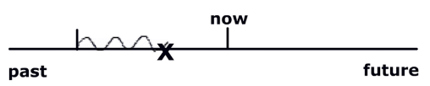

- Lacey played / was playing disc golf when she hurt / was hurting her hand.
Past simple: Action that interrupted an action in progress. X

Past continuous: Action in progress.

- We didn’t study / weren’t studying in the living room when my mum was coming / came in with some snacks.

- Haley worked / was working on the robot when one part suddenly was breaking / broke.

Good work!

Writing Test
Name No.: ______ Class: ________ Date: _____/ _____/ _____
Mark: ________________ Teacher: __________________________________ Enc. Educação: ______________________
1C6

Complete the text about a hobby you enjoy. Follow the instructions in brackets and use the words/expressions from the Language box.
(Completa o texto com um passatempo de que gostes. Segue as instruções entre parênteses e usa as palavras/expressões da Language box.)

A hobby I really enjoy is ¹____________________________ (hobby you enjoy). I started when I was ²________________________ (your age when you started the hobby) because
³ _____________________________________ (reason why you started). I usually practise it ⁴ _______________________ (how often you do it) with ⁵ _________________________ (who you do it with).
All I need is ⁶ ___________________________________________________ (what you need to do it).
I like it because ⁷_____________________________________ (what you like about it).
⁸ _______________________________ (your hobby) makes my life ⁹ _________________ _________________ (how this hobby makes your life).

- playing the guitar, reading books, playing football, …
- twelve, ten, five, …
- my uncle gave me his old guitar, my teacher encouraged me to read, my father took me to a football match, …
- three times a week, every day, once a week, at the weekend, …
- alone, a friend from school, friends, my parents, my brother/sister, …
- a guitar and music sheets, interesting books, a ball and football shoes, …
- it helps me relax, it teaches me new things, it keeps me healthy and active, …
- playing the guitar, reading books, playing football, …
- more beautiful, easier, happier, more exciting, more interesting, …

Language box

Good work!

