Unit 2
Reading Worksheet
2B6
Name No.: ______ Class: ________ Date: _____/ _____/ _____
Read the text carefully.
The guide to healthy eating
in real life
 |  | 5  10  15  20  25 |   Depending on whom you ask, “healthy  eating” may take any number of forms.  Healthcare professionals, wellness  influencers, co-workers and family  members – everyone has an opinion on the  healthiest way to eat. The truth is: healthy  eating doesn’t have to be complicated.  Food is meant to be enjoyed – not feared,  counted or weighed. In general, eating  healthy has nothing to do with diets or  certain dietary rules. “Healthy eating”  simply means prioritising your wellness  by fuelling your body with nutritious foods.  Some tips to make your diet healthier:  • vary your diet and try to mostly eat foods that are high in nutrients like protein, fibre,  healthy fats, vitamins, and minerals. These foods include veggies, fruits, nuts, seeds,  beans, fatty fish and eggs.  • cut back on ultra-processed foods – you should limit your intake of junk food and drinks  like candy, soda, and sugary cereals, but that doesn’t mean that you have to eliminate  these items from your diet.  • slow down – food is one of the many puzzle pieces of your day-to-day life, so you should  eat slowly to control your appetite and give your brain time to get the message that  you’re full.  • avoid food restrictions and dieting on your own.  • cooking at home, grocery shopping, eating a lot of plant foods, choosing snacks can  help you create and maintain a healthy eating pattern.  Try this today: check the foods you have in your fridge and pantry. If you’re low on  veggies, whole grains, or protein sources, it’s time to run to the store… with a list and after  eating a snack!!!
https://www.healthline.com/nutrition/how-to-eat-healthy-guide#bottom-line
(adapted and abridged)

A. Look at the pictures of tips mentioned in the text. Choose the correct option to label them.
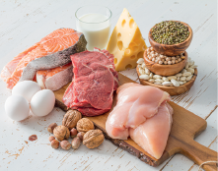
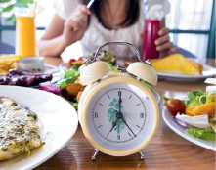
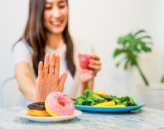


- avoid dieting / eat
foods that are high
in nutrients
- eat slowly/cut back
on processed food
- eat foods that are
high in nutrients /
avoid dieting
- cut back on
processed food /
eat slowly

B. Tick (✔) the words from the first paragraph (ll. 1-13) that mean the same as…
1. people you work with a) influencers b) co-workers

2. a belief about something or someone a) opinion b) way

3. difficult to do or understand a) healthy b) complicated

4. putting something on the top of your list a) prioritising b) fuelling

C. Are the sentences true (T), false (F)?
1. People should feel pleasure while they eat.

2. Junk food and soda should never be included in our diets.

3. Food restrictions and diets are always a good idea.

4. Homemade food is a good alternative to eat healthily.

D. Tick (✔) the correct option to answer the questions about the text.
1. According to the text, what does healthy eating mean?
a) It means going on a diet and following dietary rules.

b) It means taking care of your well-being and eating nutritious foods.

2. Look at the examples of nutritious and ultra-processed foods. Which is correct?
a) Nutritious foods – fruits and nuts; ultra-processed foods – candy and sugary cereals.

b) Nutritious foods – candy and sugary cereals; ultra-processed foods – fruits and nuts.

3. Why should we eat slowly?
a) We should eat slowly to have more appetite and eat more.

b) We should eat slowly to control our appetite and eat less.

