Unit 3
Reading Worksheet
3A6
Name No.: ______ Class: ________ Date: _____/ _____/ _____
Read the posts below from famous fashion bloggers.
TEXT B
TEXT A

How to have a designer
wardrobe on a college budget
In fashion, paying the retail price is a big
mistake. For example, I wouldn’t buy a $300 designer top at a department store when I could buy it for $70 at a discount or outlet store. Here are some ways to shop till you drop (without spending too much):
Discount stores
This week, I went to Saks Fifth Avenue OFF
5TH (their retail outlet) for a pair of flats, but they were out of stock. Suddenly, I saw an awesome leather jacket that I wanted for ages. Now it was on sale plus an extra 60% off! Patience pays off!
Sale seasons
Then there are the department store sales. As a smart shopper, I don’t just buy anything. When I go to a department store my purpose can just be window shopping or simply check the trends out.
Consignment stores
You can find cool vintage or designer items. My favourite consignment shop is Poshmark, an online market place where users buy and sell clothes that are either new or gently used.
ONE DAPPER STREET

Actively blue
There isn’t anything like a good amount of
stretch¹ in your jeans – oh how I envy you,
women, having had the comfort of stretch
jeans for years before us men could dream of it.
All of this talk because of a new pair of
stretch jeans I picked up at Express last week, which makes my habit of jumping around on scaffolding² so much easier. I wore them with a casual shirt and a beautiful cotton coat.
Do note that I bought an extra small pair of
jeans, when I would usually get a medium, so you’re aware if you go shopping for yourself.
A nice pair of trainers and a few carefully
selected accessories complete this look – great for anywhere you want to be comfortable but stylish.

The teen
runaway

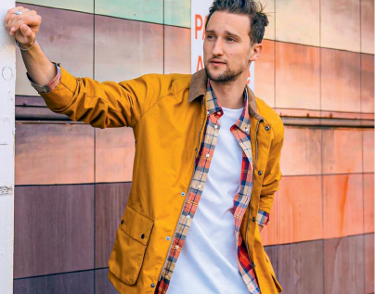

Lauren Hochnman
College student, blogger
and fashion influencer
MARCEL FLORUSS
Menswear blogger and
influencer, businessman,
named in the 2020 Forbes
“30 under 30” list

5

10

15

20

25

5

10

15

http://onedapperstreet.com/actively-blue/
(abridged and adapted)
https://theteenrunway.com/shopping-designer-on-a-budget/ Vocabulary: ¹ stretch = elasticidade;
(abridged and adapted) ² scaffolding = andaime
A. Label the pictures with the three shopping alternatives suggested by Lauren in text A.
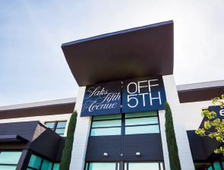

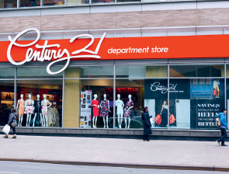

1. ______________________ 2. ______________________ 3. ______________________

B. Match the words/expressions taken from text A with their meaning.
There is one extra option/definition.
a) you spend time looking at the goods in the windows
of shops without intending to buy anything
1. retail price (parag. 1)

2. shop till you drop (parag. 1) b) someone addicted to fashion

3. smart shopper (parag. 3) c) do a large amount of shopping

4. window shopping (parag. 3) d) the latest styles

5. trends (parag. 3) e) the price of items for individual customers

f) someone who looks for good promotions

C. Read text B again. Are the sentences below true (T) or false (F)?

1. Marcel likes denim with some stretch.

2. Only women wore stretch jeans.

3. He bought his stretch jeans a long time ago.

4. Marcel usually wears medium size.

5. His look is formal and classic.

D. Answer the questions about texts A and B.
1. What did Lauren buy at Saks Fifth Avenue OFF 5TH?

2. What is Poshmark? What can you do there?

3. According to Marcel, why did this talk about men wearing stretch jeans begin?

4. What is Marcel wearing? Describe the look he talks about in his post.

