Unit 4
Reading Worksheet
4B6
Name No.: ______ Class: ________ Date: _____/ _____/ _____
Read the text.
5  10  15  20  25 | The effects of factory farming  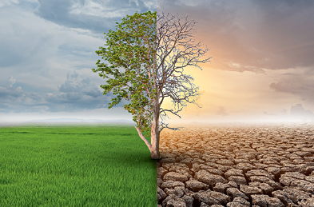  1. Climate change  Factory farming is contributing to climate change, as it  produces a lot of carbon dioxide and methane. We need to  reduce greenhouse gas emissions in developed countries  by at least 80% by 2050 to have a chance of stopping the  temperature from rising more than 2 °C. Factory farming  makes substantial greenhouse gas emissions – 14.5% of our  total emissions in fact, which is more than all the transport in  the world. These emissions are intensifying climate change  and making the world more and more difficult to live in.  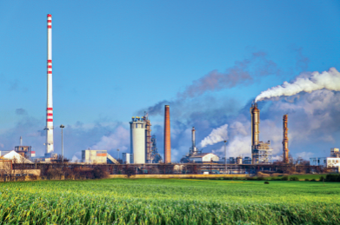  2. Pollution  With hundreds or often thousands of farm animals together,  factory farms create pollution problems. Factory farming  uses huge amounts of grain and protein-rich soya. These  crops often receive pesticides and fertilizers to grow quickly.  Pesticides and fertilizers are toxic and they can get into our  water, so the quality and quantity of clean water decreases.  Besides, this can kill plants and animals, and even leave  huge “dead zones”, where nothing can survive.  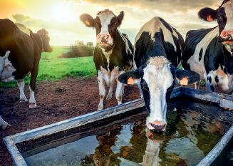  3. Use of resources  Because so much food is needed for factory farming, other resources are needed to grow it. One of these is land – more land is needed to produce meat or dairy products than to produce vegetables, cereals or fruit. Then there's water, which is often used in agriculture, particularly in countries which have less rainfall. According to the World Wildlife Fund (WWF), farming animals uses around 23% of all water used in agriculture – equivalent to more than 1,150 litres per person per day.  https://www.ciwf.org.uk/factoryfarming/environmentaldamage (adapted and abridged)

A. What do these numbers refer to in the text? Match.
1. 80% (parag. 1) a) The water used for farming animals from all water used in agriculture.

2. 14.5% (parag. 1) b) The reduction of greenhouse gas emissions needed by 2050.

3. 23% (parag. 3) c) The contribution of factory farming to greenhouse gas emissions.

B. Three of the sentences below are false. Which ones? Tick (✔).
1. Factory farming produces low quantities of carbon dioxide and methane.

2. Factory farming pollutes more than the transport industry.

3. Pesticides and fertilizers used to produce food for animals contaminate water.

4. Most land is used to produce vegetables, fruit and cereals.

5. Water is specially needed for agriculture in countries where it rains a lot.

C. Tick (✔) the correct words from the text that mean the same as the expressions below.
1. Plants that are cultivated on farms a) crops b) factory farming

2. Rapidly a) large b) quickly

3. Harmful to one’s health, causing death a) watercourses b) toxic

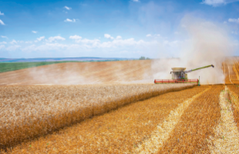
4. Becomes less a) decreases b) quantity

D. Tick (✔) the correct answer for each question.
1. How does factory farming contribute to climate change?
a) It produces methane and carbon dioxide emissions.

b) It makes temperatures rise 2 °C.

2. Why are pesticides and fertilizers used in grain and soya crops?
a) They are used to produce large quantities of food for animals fast.

b) They are used to contaminate water.

3. What are the two main resources needed to produce food for animals in the factory farming
industry?
a) The two main resources are meat and dairy products.

b) The two main resources are land and water.

